PEPA
Programmable Electronic Prosthetic Appendage

Group 10



4/25/2016

Tim McCarthy
Eric Baysinger
Elton Trimon
Pascal Freij

Table of Contents
1. Executive Summary 1
2. Project Description 2
2.1. Constraints 3
2.2. Related Standards 3
2.3. Motivation 4
2.4. Goals and Objectives 6
2.5. Requirements Specifications 7
2.6. Block Diagrams 9
2.7. Incorporation of Similar Projects 11
3. Background 11
3.1. Electronics 13
3.1.1. Theoretical 13
3.1.2. Images and Schematics 15
3.2. Current Code 18
3.2.1. General Program Flow 20
3.2.2. Functions 23
3.2.3. Problems/Issues 26
3.3. Current Usage 26
3.3.1. Future Development 27
4. Research 29
4.1. Power (Voltage/Current generator) 29
4.1.1. Low Voltage Components 29
4.1.2. Medium Voltage Components 30
4.2. Charging 30
4.2.1 Batteries 32
4.2.2 Close Range Charging 36
4.2.3 Charging Schematic 37
4.3. Servos 38
4.3.1. Control 39
4.3.2. Precision 40
4.3.3. Servo Choice 40
4.3.4. Servo Schematic 42
4.3.5. Stepper Motor 42
4.4. Comparing Signals 43
4.4.1. GSM 43
4.4.2. Wi-Fi 45
4.4.3. Bluetooth 47
4.5. Implementations of Wireless Communications 49
4.5.1. Wi-Fi Module 49
4.5.2. Bluetooth 52
4.5.3. Chosen Wireless Communication Module and Schematic 54
4.6. Microcontroller 56
4.6.1. Requirements 56
4.6.2. MSP430 58
4.6.3. MSP432 60
4.6.4. Chosen Microcontroller 61
4.7. Sensors 63
4.7.1. Analog Signals 64
4.7.1.1. Input/ output 65
4.7.1.2. Circuits Needed 66
4.8. Code and Software 67
4.8.1. Flowchart 68
4.8.2. Functions Used 75
4.8.3. Libraries Used 78
4.8.4. Hardware 80
4.8.5. Components Sourcing 82
4.9. INMOOV Open Source Project 83
4.9.1. A Look Inside 84
4.9.1.1. Physical Strength of the arm/Endurance 86
4.9.1.2. Hardware Protection/3-D printed Prosthetic 86
4.9.2. Protection of circuits 87
4.9.3. Coating the material 88
4.9.3.1. Heat 89
4.9.3.2. Appearance 89
4.9.3.3. Silicone Appearance 90
4.10. LCD Touchscreens 91
4.11. Heat Sensor 92
4.12. Pressure Sensor 93
5. Compatibility 94
5.1. Software 95
5.2. Hardware 97
6. Prototype 99
6.1. Power 99
6.2. Charging 101
6.3. Microcontroller Prototyping 102
6.4. Wireless Technology 102
6.5. EKG/EMG 103
6.6. Physical Endurance 106
6.7. LCD Touchscreen 108
6.8. 3-D Arm Assembly 110
7. Testing 114
7.1. Testing Every Prototype 114
7.1.1. Power 114
7.1.2. Charging 115
7.1.3. Microcontroller 115
7.1.4. Wireless Programming 116
7.1.5. EKG/EMG Sensor 118
7.1.6. Physical Endurance 119
7.1.7. Proximity Sensor Testing 120
7.1.8. Heat Sensor Testing 120
7.1.9. Servo Motors Testing 121
7.2. Materials Needed 121
7.3. Test Results Conclusion 122
8. Final Design 123
8.1. Parts Gathered 124
8.2. PCB Design and Schematic 124
9. Administrative 128
9.1. Milestone Chart 128
9.2. Budget 130
9.2.1. Total cost Table 130
10. Conclusion 130
Appendix A 134
Appendix B 134
Appendix C 136

1. Executive Summary
The purpose of this project is to implement several electronic components and devices to produce a fully functional prosthetic appendage. In this paper, we will be discussing all the different varieties of electronic devices and elements which may be integrated to produce the complete design.
One of our main aims is to deliver a completely functioning prosthetic appendage that can be used by any mature person to perform basic arm functions such as hand gestures and movement, as well as grabbing a multitude range of objects of different sizes. This project’s objective is to implement various sensors while being monitored by a microcontroller simultaneously to produce a bionic arm that allows any user to be able to use it without any difficulty. The last objective is to incorporate several electronic devices, parts, and elements to produce a product that can be economically attainable by middle to lower class citizens.
The specifications have been set out by the authors were the arm itself will be 3-D printed to provide a custom made physical look as well as an affordable method of production of the arm, which will act as a host to several sensors, including a microcontroller and an LED screen that will be implemented in the design. A microcontroller will be first implemented into the arm itself to act as the ‘brain’ of this appendage. The microcontroller will analyze user data, and then perform the necessary tasks needed to control most of the functions. The microcontroller will be powered by a portable battery. The flexion and extension of all the five fingers will be performed using five motors that will rotate clockwise or counter-clockwise according to which motion is required. A durable wire or line would be ideal in this scenario as to connect each motor to a specific finger individually and back to result in 5 different meshes. A muscle sensing circuit will be designed and integrated to provide the tension needed, basically act as an indicator, to notify the microcontroller as to when to perform a grabbing or release gesture as well as to flex or extend any finger exclusively. Other sensors, such as proximity sensors, may be integrated as well to add to the technological aspects of the arm itself. An LED/LCD screen will be added to provide an easy-to-use user interface for an individual. Some parts, such as the servo motors, will need more power than the microcontroller can provide, and as such, a current generator circuit will be designed and added to provide sufficient power to all the elements that require it. The integration of all these features will result in a fully functioning arm that will perform basic hand and arm motor actions in addition to gestures.
The requirements of this project fall into 4 categories:
- Economic
- User Friendly
- Advanced Electronics
- Motor Ability
The project postulates a production of a custom and affordable prosthetic arm that incorporates several different sensors and advanced technology, to produce an easy-to-use and user friendly arm. The project also entails the prosthetic arm to perform basic arm gestures, such as pointing, as well as motor functions to aid an adult person with an amputated arm with their daily lives.
After some research, it became clear that designing a prosthetic appendage would have been a time consuming task and as it is mainly a mechanical aspect of the project, we opted out of designing it and instead, looked for other sources to obtain STL files of an arm that was either an open source or the owners provided permission for using it. After obtaining the files, the arm itself needs to be printed, and buying a 3-D printer or using private owned printers has been proved to be costly as purchasing a printer requires a good monetary investment, while private companies that 3-D print object for consumers charge each project by the 3 dimensions (x, y, and z) and the total weight of the object as well as the total amount of time it took for the project to be completed. After thorough research, the American Society of Mechanical Engineers (ASME) at UCF provided us with the best opportunity to 3-D print the arm at minimal cost. Motors needed to be considered as well. Whether servo motors, or geared motors, research for both begun, and as a result, we narrowed it down to using a servo motor, as it would perform the necessary task, and the affordability of the motor itself played a part into choosing it. Research into durable lines was concluded by having to either decide between using fishing lines or guitar strings as a mean to connect the servo motors to the fingers individually.
The LED screen has been researched, and it remains to be seen whether we decide to go with a resistive or a capacitive screen. Further investigation must be done into muscle sensors, circuits, and designs to obtain a specific overview of what needs to be achieved in order to have a fully functioning Electromyogram (EMG) circuit. Furthermore, inquiry into which microcontroller to use will be essential as there are several designs on the market today that may work with the requirements and constraints of this project. Finally, additional analysis is necessary to obtain information on several sensors, such as proximity or heat sensors, in order for us to decide if it could be implemented into the project or not.

2. Project Description
The continuity in advancement of 3-D printing techniques and technology has created a new and vast section in the mechanical industry that makes it possible for the average person to be able to utilize these technologies and create any product physically at the fraction of the cost as compared to ordering and buying it from suitable vendor. Our project will employ a 3-D printer that will be used to print all physical aspects of the arm itself; the arm will be printed from the elbow all the way to the finger tips with a special design that will allow the incorporation of electric and electronic devices and circuits. With accordance to that, this project will apply most of the knowledge gained in several courses to create a programmable, technological, and sustainable prosthetic appendage. To begin this section, we will be discussing the constraints that may affect this project followed by any related standards that may be beneficial to our design.

2.1. Constraints
One of the main goals of this project is to minimize the total cost of creating the technological prosthetic appendage. Our main goal is to have it all achieved by spending as little as possible, such as only spending a maximum of $500. Needless to say, the process of printing the arm would account for the bulk of the total cost, and as such, we may need to reduce the number of sensors or elements embedded and integrated into the project.
3-D printing the arm presents a whole new set of constraints, as the material used in the printing process needs to provide a durable prosthetic that can withstand a minor fall. After performing some minor research, both PLA and ABS filaments, which are the two leading filaments used in 3-D printing today, produce both reliable and sturdy objects. They will not be as durable as metal for instance; however, they do produce a sustainable, light weighed object.
Another constraint is the target customers, as the arm will be designed and printed for a full grown person, not a child. So far, there doesn’t seem to have any health or safety issues, but needless to say, circuits are not immune to hardware issues and as such, there is a chance that an electronic part or circuit, whether a manufacturer defect or designer caused, may cause the electronics to burn and eventually affect the arm physically. Heat can also be an issue, due to a combination of hot weather as well as heat dissipated from the battery.
The printing process is anything but efficient. We have requested the arm to be printed over a month ago, and we are still waiting for a finished prototype. The constraint is having the arm prototype available and ready to be experimented on before the semester ends. There will not be any political constraints as this design will help people, and therefore affect them in a positive way. Socially speaking, the arm itself needs to look somewhat presentable, as it will not be accepted as a technological product by consumers if it lacks physical dexterity and appearance. Ethically speaking, this project will not be targeting specific individuals or religious groups and as a result, this project will not have any ethical constraints. Lastly, the manufacturing process has certainly changed over the years were the industry has implemented several electronic devices to help decrease the manufacturing time. We do not anticipate a huge delay, as in months, in the manufacturing process; however, every manufacturer has their own schedule for requesting an order, creating that order, and then handling and shipping it back to the consumer. We will have ordered all our parts from this semester and everything should be available and ready to be implemented and integrated by the next semester.

2.2. Related Standards
There are multiple standards set as of today by governments, IEEE, or by private companies. Standards exist as a way to minimize hazards, or to uphold safety and health concerns. Our project will not affect millions of people, yet there are many related standards that we can attend to. With regards to safety, the United States Department of Labor’s Occupational Safety and Health Administration (OSHA) reports that, “accidents do not occur under normal operating conditions, but rather during programming, adjustment, testing, cleaning, inspection, and repair periods.” (OSHA STD 01-12-002, 1987) This relates to us as we will be dealing with programming and circuits, therefore testing current, voltage, and the prototype is unavoidable.
There are also many standards learned during labs from multiple courses we have taken that will help us during our prototype testing phase of this project. For example, grounding one’s self before dealing with charges circuit elements; another would be to deal with low currents, less than 6mA, to avoid a deadly electric shock. There are also some standards that do not apply to this particular project, as this project will not design a robotic arm for industrial use. International Organization for Standardization (ISO) claims that, “Technical Specification specifies safety requirements for collaborative industrial robot systems and the work environment, and supplements the requirements and guidance on collaborative industrial robot operation given in ISO 10218-1 and ISO 10218-2;” (ISO 15066, 2016) however, they then proceed to add that, “it does not apply to non-industrial robots.” (ISO 15066, 2016)
Furthermore, there are several standards applied to the use of 802.11 wireless technologies which we may adhere to in order to implement into our project. To work around that, we may end up buying a fully designed and produced PCB board of a working wireless module, that already obeys the standards set, and integrate it into our very own MCU. In addition to the standards on Wi-Fi, there are several standards for the use of Bluetooth. We are leaning towards using a Bluetooth module which adheres to all the standards set as of today.

2.3. Motivation
Our group consists of three electrical engineers and one computer engineer. Our motivation was simple; come up with an idea that will incorporate the knowledge acquired throughout our extensive educational careers individually combined with having an idea that will associate all of our interests simultaneously. The idea of designing a fully functioning prosthetic arm is much more complex than it seems to be. To simplify it, we looked at minimizing the concept of the project into four main aspects that we look set out for this particular project:
- Physical Aspect
- Mechanical Aspect
- Electronics Aspect
- Programing Aspect
The physical aspect is the design and the printing process of the physical arm itself. After some research, the design part would be the most time consuming phase of the project. The designer needs to have intimate knowledge and details about designing an arm that will be utilized in a project that will incorporate electric and electronic devices into the design. The creator of the design needs sketch in 3-D using software, such as Solid Works, and account for the total length of the arm as well as the height and width. These dimensions will only be the beginning as the creator also needs to account for the size of the electronics, wires, and motors as well as the size ratio of the arm to the size of a person’s natural arm. Needless to say, after several hours of researching, we deduced the simplest way to attain a professionally designed arm. Basically, what we deduced was to avoid designing our own prosthetic arm, as since all group members are Electrical and Computer Engineering majors, we opted to just using an open-source design, or to get permission from an artist to be able to use their design.
The mechanical aspect was a much simpler task as compared to the physical aspect as after obtaining the complete prosthetic arm, it needed to perform basic motor functions, such as grabbing and releasing, or basic gestures, such as pointing. Therefore the arm needed a mechanism which would allow such basic motor movement. This is where a DC motor would fit in as, combined with a line of some sort, it will give this project the fundamentals needed to produce such basic movements. Essentially, the motors would either turn clockwise or counter-clockwise, or in other words, when the motors are combined with a line, that connects the motors the fingers, the motors would either push the lines to perform a grabbing motion, or the motors would pull the lines to perform a release motion. Controlling the motors would then fall into the electronics phase of this project.
The electronics aspect is what would determine the final overall capabilities of the prosthetic arm. First off, we need to choose which microcontroller to use. Once we chose one, we then had to map out what other electronic devices we needed for the rest of the project. Since the microcontroller acts as the “brain,” we essentially have to design the “body” for it to obtain the Micro Controller Unit (MCU). The MCU will have multiple input and output pins to connect different electronic elements in order to create a communication bridge between itself and the other elements, which will be embedded into the design.
Furthermore, the MCU requires power, and as such we will have an external power supply, whether a couple of 9V batteries, the portable cell phone batteries, or the lithium Ion batteries found in laptops today, to power up the MCU. The microcontroller will control everything, and as such, it will be sending and receiving analog and digital signals. One of these signals would be from the muscle sensor module, which will transmit analog signals to the MCU. We will also look to add an LED/LCD screen; the screen itself would need to transmit digital signals to the MCU. Other sensors, such as proximity sensors, will also need to be connected to the MCU in order to transmit and receive signals accordingly. Needless to say, most of the electronics embedded will need to communicate with the MCU one way or another, and as such, the microcontroller in the MCU will be programmed accordingly.
The last aspect is the programming section. As electrical engineers, we are not best suited for this task; however, we are molded through several classes into being able to handle simple to complex coding, and if we can’t handle it ourselves, then we will find something online or through someone’s help. The simple answer as to why we need to be able to code is that nothing robotic related can be done without some sort of, if not mostly, programming. Regardless, this project will require intensive coding as we need to make the MCU handle converting analog to digital signals and vice versa. Furthermore, the MCU would need to control the motors, assign power to a specific motor, to communicate with the LED/LCD screen, and to receive signals from other sensors and act accordingly. The LED/LCD itself has its own unique set of program to be written, and whether the screen is resistive or capacitive would determine the complexity and uniqueness of that.
Combining all those aspects would create our group’s vision of this project, where each section would have one or more links to any other section. The purpose of these sections is to give an overall general idea of what our motivation and where our commitment lies.

2.4. Goals and Objectives
The main goal is to obviously achieve this project by Senior Design II; however, to achieve that goal, we have laid down a set of minor goals of several objectives to meet throughout the duration of both, Senior Design I and II. The objectives are as follows:
- Prosthetic Arm
- Power Supply
- Muscle Sensor
- Motors and Connectors
- LED/LCD screen
- MCU
The process of 3-D printing requires patience as the more complex the design is, the more time it would need to be printed. The prosthetic arm is classified under a complex design, and as such will require some time to be printed, especially when some previously printed parts have turned out to be faulty. As a result of that, we have submitted our design to the American Society of Mechanical Engineers (ASME) in early February and, with accordance to them, we estimate having all the physical and mechanical aspects of the arm completely printed by the end of March.
The power supply was an easy decision that we have made in February, as even though there are multiple power supply options and pathways that we can take, we ended up choosing the one that fits all of our criteria. We wanted a battery that can be recharged using either a portable charger or using a wall mount. We also considered the weight, as we did not want to end up with a rather heavy final product. The charging capacity also played a part as that would determine how long the battery will last and how much power it will deliver. And finally, the last criteria we have defined to restrict the number of available battery products, was the actual physical size of the battery.
One of the group members had previously been made to design a simple muscle sensor for a class that he has taken. To simplify the process, the muscle sensor would have an electrode to allow the signal to travel through it to the signal amplifier circuit from a specific muscle, and then the amplifier circuit would eventually be connected to an Oscilloscope to view the input signal. On paper, the muscle sensor module seems to be a much easier task than it really is, as we need to connect that module and allow it to communicate with the MCU. Therefore more research will be done on it and our goal is to have a circuit schematic by mid-April.
Another group member had prior experience when dealing with motors. We had to decide between using servo motors or gears motors. The decision heavily depended on the precision, accuracy, and price of the individual types of motors. The decision has already been taken in early March. The connectors, which will pass through the whole of the arm, are what we will use to link the motors to the finger tips and back to the motors. Depending on what direction the motors will spin, a specific arm function will occur. Needless to say, the connectors need to be sturdy and need to be sustainable over time. We have not yet decided upon a specific connector; however, our options include fishing lines and guitar strings.
The LED/LCD screen is what will allow the user to interface with the arm directly. The amount of possibilities available to the user is yet to be determined as the more options we add, the more complex the programming will be. Needless to say, we have narrowed down our screen options in mid-February to two distinctive ones; a capacitive and a resistive LED/LCD screen. The final choice would be taken near the end of March as the selection depends on what type of microcontroller we will use.
The last goal is to meet the objective of designing our own MCU. At the present, we have only determined which microcontroller we will use. Since the MCU will contain input and output pins to connect, link, and control all other objectives listed above, we will have to determine the number of pins needed along with other electronic elements that will be desired. We are hoping that by the end of April we will have a fully drawn schematic of what the MCU will contain as well as a PCB layout and design ready to be built in order to start testing procedures in Senior Design II.

2.5. Requirements Specifications
Beginning with design of the arm, an online open-source project called INMOOV has a complete design of the arm and fingers that can be used. Because we’re focused more on the electrical components, finding an open source project that can easily print the arm, allows us to focus more on the functionality of the arm. To control the arm, approximately 2 and a half meters of connecting lines to connect all motors to the fingers and back would be required.
A maximum of two rolls of 3-D printing filaments would also be needed. ASME only uses PLA filament, and as such we will have the arm printed in that material. Servo motors can be found online and are significantly cost-effective.
Writing voice recognition (VR) software is a daunting task, as it requires great understanding of speech recognition as well as integrating several concepts to create a fully functioning VR software. Therefore, our only other solution would be to use an already existing module. VR modules, however, have their own set of constraints.
For example, the cheaper they are, the less accurate they may be. We found that the cheaper the VR chip, the less functionality and options it includes. The cheapest one on the market is the easy VR module, which would provide about 60% to 70% accuracy in a quiet room using a microphone. The percentage would be much lower for that in a busy, crowded room and without using a microphone and as such, the VR functionality could prove to simply be a redundant and ultimately, a useless feature.
The LED/LCD screen would need advanced level programming or someone who has had experience in programming a screen before. Adding the layer of “touch” only compounds the level of difficulty. Therefore, we’re slightly limited to use an already existing module that aids users with lack of programing skills.
Ultimately, if required, programming an LCD/LED touch screen could prove to be a possibility, but the focus of the project would shift to a touch screen. Since we will use a microcontroller, the voltage and current would be limited. The servo or gear motors need to be functioning at a higher power limit than the microcontroller can provide. Therefore we would need a current generating circuit to give us the energy needed to power the motors individually.
Another option would be a relay circuit. Both options can be considered a constraint as we have not done any previous work on them before. The motors also have to be able to sustain long periods of contracting and releasing without fault. It’s critical that the motors don’t have any points of failure as this could prove to be detrimental to the user. Due to servos lacking in the precision area, gears motors seem to be the more likely choice at this point.
The microcontroller will be the main control unit that controls everything as well as accept both analog and digital signals from multiple inputs and work simultaneously to achieve the desired output. Designing a microprocessor would be “reinventing the wheel” so by using an already existing MCU such as the Arm, MSP430, or a Raspberry Pie microcontroller, we find a solution that still requires engineering experience, but allows for more customization. The other option would be to use only a microcontroller, such as the MSP432, and then proceed to design and draw a circuit schematic for it to eventually create our very own and custom MCU.
The microcontroller must also be able to sense muscle signals which can be a difficult task, especially when one considers how minor these signals can be. The signals are very faint, but with the aid of a signal amplifier circuit this should be avoided. To summarize what was mentioned in this section, figure 2.5.a. below displays the specifications in a simple and concise method:

Arm | Provide room for all electronics and be sustainable
LED/LCD | Provide UI and duplex connection with MCU
MCU | Provide entire device control
Battery | Provide sufficient power for all electronics
Motors | Provide precision, Control, and finger mobility
Figure 2.5.a. Summarized Basic Table of Specifications

2.6. Block Diagrams
Now that we have described the project in a general overview, we will now look at the project from a visual perspective along with some in-depth details on how this project will be assembled and created. To start off, we will discuss the muscle sensor module and how it will work. Figure 2.6.a. shows the muscle sensor module overview function below:
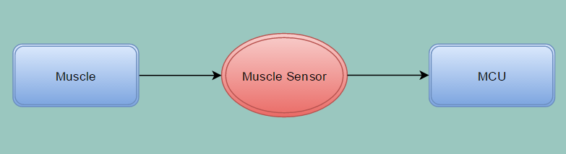
Figure 2.6.a. Muscle sensor module overview function
The muscle sensor module will only have a simplex communication with the muscle itself and with the MCU. The definition of simplex implies a single direction. The muscle sensor would therefore receive a signal from the muscle where the electrodes are placed, and then the Muscle sensor would transmit that analog signal to the MCU. The next diagram is the communication between the user and the LED/LCD screen which can be seen in figure 2.6.b. below:
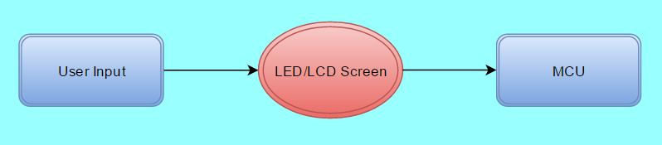
Figure 2.6.b. LED/LCD screen overview function
The LED/LCD screen is what gives the user power of what the arm would do. The user will have the option to make the arm perform a gesture such as to point, to grab an object, to release an object, or to power on and off the system. The user will be able to choose his/her wanted action using the user interface (UI), which will be available on the screen, which would then transmit the input from the screen in the form of a digital signal to the MCU where the MCU would determine what action to take next from the obtained signal.
The motors section would also have a simplex connection to the MCU; however, it is the MCU that would communicate to the motors. Once the MCU receives a signal from the LED/LCD screen, along with the signal from the muscle sensor, the MCU would then determine if some or all of the five motors would need to perform an action. The simple process can be viewed in figure 2.6.c. on the following page. For example, pointing would only need one motor to be turned on compared to grabbing which would need all five motors to turn on. To control this mechanism, the MCU would use actual current generation circuit to either open or close switches according to what action needs to be taken. Once the switch is closed, the specified motors would then have the power needed to turn on and be able to function. Once power is received, depending if positive or negative voltage, the motors would either run clockwise or counter-clockwise to achieve either a push or a pull on the connectors.
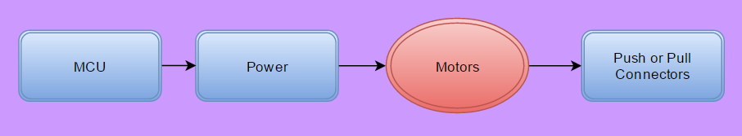
Figure 2.6.c. Motors overview function
The MCU be the most complex element in this design. As mentioned before, the MCU would be essential to everything the arm would eventually do. As a result, it will have multiple connections to its subparts via input and output nodes as can be viewed in figure 2.6.d. below:
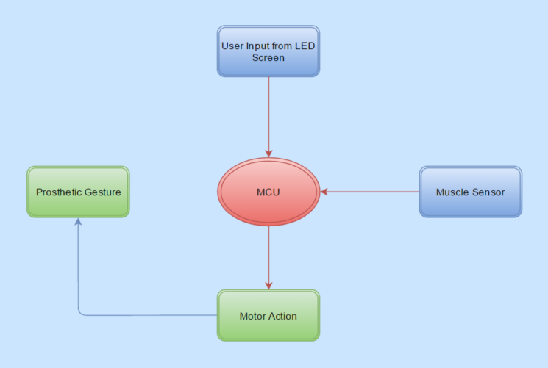
Figure 2.6.d. MCU overview function
Describing the system generally, the MCU would await an order from the LED/LCD screen, after receiving an order it will determine which motor to power up and then wait for an input from the muscle sensor. The signal transmitted from the muscle sensor to the MCU would be an analog signal, and as such the MCU would need to convert it to a digital signal, and in turn, the MCU would then interpret the signal. Essentially, the muscle sensor input signal to the MCU is what would give the MCU the go ahead to close or open the switch or switches to power up the motors to perform the necessary action.

2.7. Incorporation of Similar Projects
There are plenty of similar projects out there. The most notable one would UCF’s very own “Limbitless” project. It is mainly designed for children. The team at UCF has certainly went above expectation to help children that are in need of a prosthetic arm, at a low cost, and most notably, at no profit to them. Obviously, there are several other bionic hands that are much more sophisticated in design such as “Be bionic.” Their design is, as they describe it, “Sleek, elegant, and cutting-edge in both design and technology, our flagship be bionic range pushes the boundaries of multi-articulating myoelectric hands.
As the world’s most lifelike, functional, and easy to use myoelectric hand commercially available today.” (Steeper Group, 2015) The closest one to our design would be INMOOV’s own starter pack, where they use their own arm and hand design. They have designed two versions that either uses the ARDUINO UNO or the Mega microcontroller. They have used three types of servo motors; the HK15298B, the HITEC HS805BB, and lastly the MG996. They also use two software platforms, my Robot Lab and Python scripting, to write their programming codes and scripts.
Another company that creates bionic arms is Open Bionics. What they do is more complex than what we will be doing; however, they 3-D print their arms, and make it customizable according to the consumer. The company claims that, “It can scan an amputee and build a custom –fitted prosthetic forearm and hand in less than two days.” (Nayar, 2016) Open Bionics offer several different arms and styles that match each person’s wants and needs.
They also have low to high end arms depending on the monetary situation of the person in need. Needless to say, these are a few of many designs that exist in the world as of today, all of which competing against each other while working towards the same one goal; providing amputees with an alternative chance of having a better life.

3. Background
Electrical, Electronics, and Computer engineering disciplines have come to grow over the past decades due to the large expansion of the technology industry. The difference between electrical and electronic engineering, according to Ryder, “is based on the comparative strength of the electric currents used.” (Ryder) Ryder expanded his statement by claiming that, “Electrical engineering is the branch dealing with “heavy current,” electric light and power systems and apparatuses, whereas electronics engineering deals with such “light current” applications as wire and radio communication, the stored-program electronic computer, radar, and automatic control systems.” (Ryder)
Over the years, electric and electronic devices as well as the manufacturing process had developed and as a result, shaped the world we live in today. With this development, it allowed multiple disciplines to interconnect; work with each other towards one common goal. “The largest of the specialized branches of electrical engineering, the branch concerned with the electronic computer, was introduced during World War II.
The field of computer science and engineering has attracted members of several disciples outside electronics.” (Ryder) The integration of electric, electronic, and computer engineering has created the need for a more advanced and powerful computer systems and electronics.
It is easy to see the connection between electrical and electronics engineering, as the actual meaning of the two disciplines are closely related; however, the two are very different. “The main difference between electrical and electronic circuits is that electrical circuits have no decision making (processing) capability, whilst electronic circuits do.” (Chandler) By that definition, all an electrical circuit should do is provide the system with power through the induction of current, whether direct or alternating depends on the complexity of the system.
An electronic circuit, on the other hand, “can interpret a signal or an instruction, and perform a task to suit the circumstance.” (Chandler) The difference between the two can also be determined by the actual scale of their respective components. Chandler stated that perfectly when he mentioned that, “A single microprocessor, which will fit on the end of your finger, may contain hundreds or thousands of tiny components, some of which are only a few atoms wide. Electrical components tend to be larger.” (Chandler) He went on further to explain that, “The link between electronic and electrical circuits is typically provided by relays or transistors.” (Chandler)
Furthermore, the association between computer based systems and electronics has had emerged, forming a new area in engineering called Embedded Systems. John Davies stated that, “Microcontrollers were originally developed from microprocessors for use in embedded control systems. They include a processor and most or all of the memory, clock, and other systems needed to support it. Everything is inside a single package, which is why a microcontroller is often described as a computer on a chip.” (Davies, 2008, p. 1)
The two fields have become so reliant on each other that it is virtually impossible to create a product in one of them, such as incorporating ideas, devices, elements, or systems, without the other. Davies went on to say that, “There is hardly an electrical consumer product nowadays that does not rely on digital control.” (Davies, 2008, p. 1)
The purpose of introducing the incorporation of the three mentioned disciplines is that this project will require it. This project will entail the use of electrical designs and circuits, which will intermittently connect, as well as send and receive data and signals, to electronic devices and elements, and the entirety of that system, will be controlled by a microcontroller.

3.1. Electronics
The definition of electronics, according to the dictionary, is “The science dealing with the development and application of devices and systems involving the flow of electrons in a vacuum, in gaseous media, and in semiconductors.” While performing a series of tests on electrons in a vacuum might appeal to a physicist, this project will solely rely on the fluctuation of current and voltage resulting from the electrons that travel inside semiconductors.
Basically, electrons flow to create electricity and electrical signals. “An electric signal is simply an electric current or voltage modified in some way to represent information, such as sound, pictures, numbers, letters, or computer instructions. Signals can also be used to count objects, to measure time or temperature.” (Electricity and Electronics) In this project, we will heavily rely on electrical signals, such as analog and digital signals, to have the microcontroller operate efficiently and communicate properly with the other electronic devices and elements that will be embedded into the MCU. Furthermore, we will intentionally cause the voltage to fluctuate and attenuate at a desired level in order to be able to control power, or current flow, to the motors.

3.1.1. Theoretical
As electrical engineers, we are forced to take several classes that teach the basics and fundamentals of electronics. The easiest approach to electronics is to introduce the most basic electronic elements, such as DC voltage input, resistors, capacitors, and inductors, and to teach students how to simplify a linear circuit by reducing the number of elements by finding the equivalent resistance, capacitance, or inductance in series or in parallel.
The next step would be to introduce the concepts of current and voltage dividers along with the technique of solving problems with multiple input sources using superposition. After that, amplifiers are introduced along with the methods of how to calculate its gain. Soon after, finding the power received and delivered will be taught. Knowing power and how to calculate it, transformers come into play.
Transformers are used to either “transform” the voltage into a higher or lower level. There are various other techniques and electrical elements that we are taught, which when combined with other elements, would produce different designs and outputs. One of the most notable achievements, though, would be the contents of a chip, such as an MCU.
“Electronics depend on certain highly specialized components, such as transistors and integrated circuits.” (Electricity and Electronics) These electronics are the building block of almost everything technological today. One of their purposes is to control and change signals rapidly. “Manufacturers create millions of these microscopic electronic components” (Electricity and Electronics), which when put together, would form a microprocessor. A single MCU could contain over a billion of these transistors, and, just as Moore predicted, the size of these transistors has been halved around every two years. In semiconductors, we were taught how a silicon wafer is designed a created as well as how the wafer is then purified in order for us to be able to utilize most of it.
The wafers are then used to host these tiny transistors, and after a series of adding other materials and elements, testing the integrity and functionality of the wafer, refining or cutting out a piece that is damaged or has an error in it, one wafer may contain many chips which can be used in different applications.
This chip, combined with some of the many other electronic elements that we have been taught, will create our very own integrated circuit whose functionality is what we desire it to be. What we will design is our very own MCU, which will contain hundreds and thousands of these minuscule transistors working synonymously with the other elements that were integrated to receive input, manipulate the data and decode it, and to eventually control our project through the means of an output.
Nevertheless, all of this would need to occur and as such, the microcontroller inside it would need to be properly coded using one of the programming languages that we have attained though our education.
There is no easy way to expand one’s mind on the knowledge of computer programming for the sole fact that each computer programming language is, in fact, a completely defined language in its own right. What is mostly taught is the logic needed to make someone able to write a program to perform a specific task in a similar approach as the method used in the logical reduction of a first-order linear equation by using the means of “order of operations” in mathematics.
In fact, the only way to master any programming language is to start writing simple algorithms and programs to eventually, through rigorous practice and repetition of specific syntax, semantics, as well as commands, to expand one’s knowledge and ability to program a much more sophisticated programming script. Throughout our educational careers, we have only been taught four programming languages; MIPS, Assembly, C and C++.
For the purpose of this project, the best approach towards programming the microcontroller would be to use either Assembly or C languages. Furthermore, each programming language is written on a specific integrated development environment (IDE). Some IDEs can support several languages, such as Code Composer Studios (CCS). In addition to supporting several language scripts, CCS has a built in tool to allow the user to transfer the written programming code to a microprocessor which is exactly what we will ultimately exploit.

3.1.2. Images and Schematics
Now that we have discussed several electronic elements along with their uses, we will now discuss some circuits containing the combination of these different electronic elements to produce a unique output. All the circuit designs discussed in this section may be used in the final design of this project.
To start off, we know we will be using a muscle sensor module, whose input is a signal from a muscle, and whose output would, ideally, be an analog signal. For the MCU to control and manipulate the incoming analog signal, it has to be converted to a digital one. Figure 3.1.2.a. shows a simple circuit design that takes in an analog input and converts it to a 4-bit digital output signal.

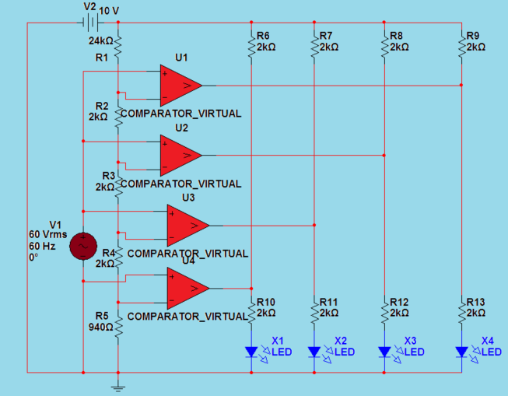
Figure 3.1.2.a. Analog to digital converter circuit design

The circuit is comprised of 4 comparators, in which the negative terminal of them is connected to a DC voltage input from a power supply while the positive terminals are connected to the input analog signal from a function generator. The output is then connected to an oscilloscope to allow us to view the digital output signal realized. The LED’s connected also light-up to show if the analog signal is a digital 1 or 0. The signal viewed would be a square signal, where the high would represent a 1 and the low would represent a 0. Obviously, this is not a complex circuit, and its output is on 4-bits. This project would need to produce an output that is either an 8 or 16-bits, and as a result, we may end up designing multiple phases of this circuit.
Since we talked about an analog to digital converter circuit design, we will now discuss the muscle sensor that we may be able to implement into our design. This particular muscle sensor, the Muscle Sensor V3, is designed and sold by “Advancer Technologies.” Figure 3.1.2.b. shows Muscle Sensor V3’s design schematic, where the output of the whole circuit connects to a microprocessor. This design is specifically intended for use with an “Arduino.”
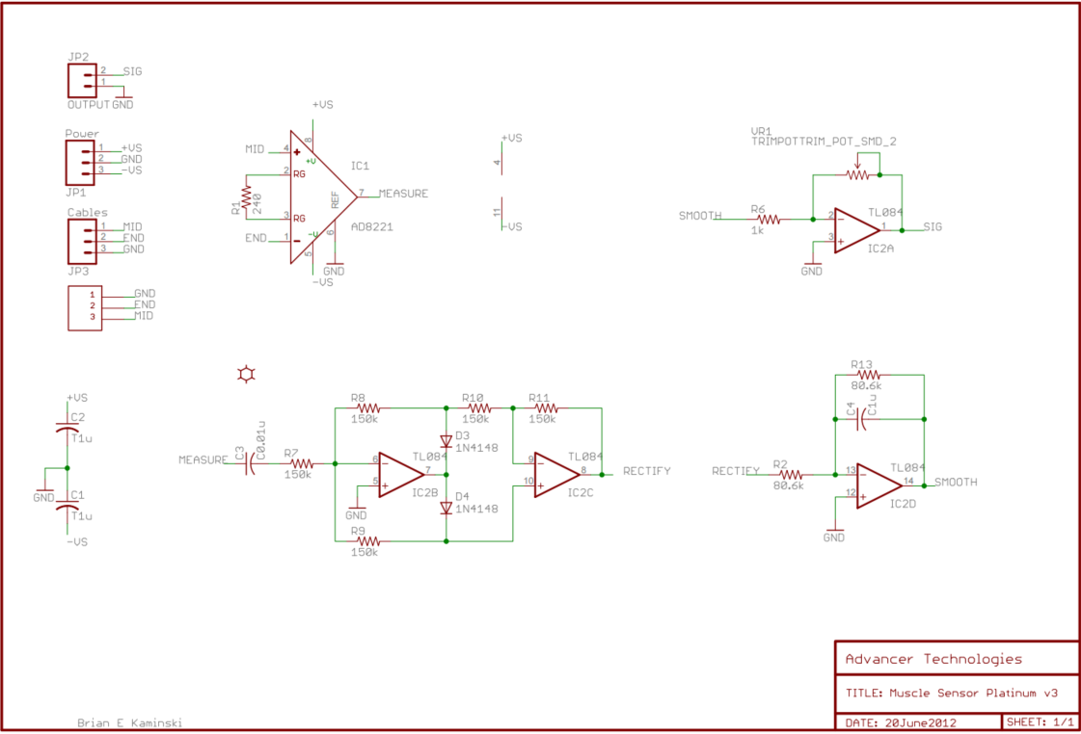
Figure 3.1.2.b. Advancer Technologies Muscle Sensor V3 Schematic

The circuit schematic applies the use of four operational amplifiers, as the signals interpreted from any muscle is very faint and small, therefore the use of amplifiers would magnify the signal in order for it to be viewed clearly on an oscilloscope.
Obviously, this is a muscle sensor module; therefore the whole of the circuit would be purchased from “Advancer Technologies” and implemented, as a small portion, into our complete design. The final form of the schematic can be viewed in figure 3.1.2.c. where the whole of the schematic fits onto a 1 inch by 1 inch PCB board and can be purchased directly from Advancer Technologies.
The V3 module itself is an older design, and the newer design is called “Myoware” design and distributed by Advancer Technologies as well where the circuit is placed on the bicep of the wearer and is completely exposed to skin contact. This makes the Myoware a little more risky as it is exposed on a skin that secretes sweat and is susceptible to water exposure.
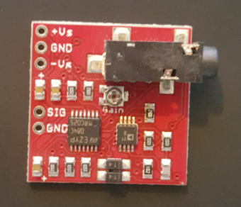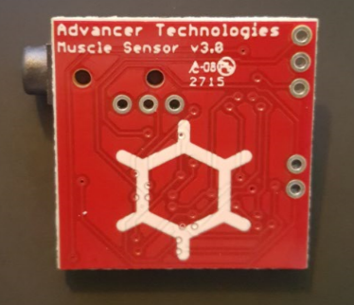
Figure 3.1.2.c. Advancer Technologies Muscle Sensor V3 PCB Board (Front and Back)

The third circuit design that may be implemented into our project would be a circuit that controls and provides power to the motors that will be used. This specific design is created by Giorgos Lazaridis from PCB Heaven. His design schematic can be viewed in figure 3.1.2.d.

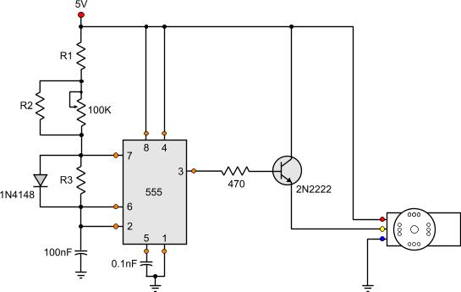
Figure 3.1.2.d. RC Servo motor circuit schematic, with permission from Giorgos Lazaridis

As shown in the figure above, the circuit is designed having three main components; the circuit control, the feedback potentiometer, and actual servo motor. The circuit control is “responsible to read the user’s input signal (pulses) and translate it into a motor revolution.
The shaft of the potentiometer is attached to the drive shaft of the servo. When the drive shaft rotates, so does the potentiometer.” (Lazaridis, 2009) Lastly, the motor itself is connected to the whole of the circuit and would produce a rotation according to the output from the circuit.
“The circuit is a 555 connected as a stable multi-vibrator. The servo is controlled through a 2N2222 transistor directly connected to its signal wire.” (Lazaridis, 2009) Nevertheless, our project would implement the DC motors in such a way that they are controlled by a microcontroller. In contrast, this design is clearly intended to run a motor without an MCU.
The last circuit design to discuss would be the MCU. There are various unique designs, modules, and launch pads available in the market today. The MCU that we have used in a couple of our classes would be the MSP430FG4618 where it was used to be programmed in both C and Assembly languages.
It was mainly used to teach us on how to generate interrupts, light up LEDs, use the ASCII table along with the Hyper Terminal, show multiple characters on an eight-segment display, and other simple programmable features. The MSP430 is clearly a great candidate for our project’s purposes; however, it is a complete microprocessor whose PCB board can be bought directly from Texas Instruments and ready to be used in large number of projects and designs. Needless to say, this won’t be a possibility for us as we will be designing our very own MCU for our purposes. To show the complexity of a microprocessor’s design schematic, we will be using TI’s MSP430F5438.
Its circuit schematic can be viewed on TI’s website. They clearly mention how it is undoubtedly a much more powerful MCU than the MSP430FG4618 and, according to Texas Instruments it also has much more feature and capabilities. This design contains several electronic elements interconnected to accomplish any task a user desires.
Regardless, the MSP430F5438 is a much more complex MCU than we will be aspiring to and implementing, as the project’s requirements are a lot simpler in relation to the features and overall function outputs of this particular MCU.

3.2. Current Code
In order to implement the controls for the arm the microcontroller must be programed to do the following actions:
- The program must initialize and run the touchscreen driver.
- The program must continually check the touchscreen for any updates due to user input.
- The program must continually check the arm sensors for any updates due to user input.
- The program must run the servo motors in order to move the arm to the user inputted position.
- The program must maintain a real time clock display
In order to fulfill the requirements thee program will run as an infinite for loop that will continually check both the touchscreen and the arm sensors inputs and respond accordingly.
In addition to the infinite for loop the program will also have interrupts enabled for the user to stop it from reacting to inputs for a time and to go into a sleep mode until woken up by the user. For instance if the user needs the arm to stay in a specific position for a time and does not want it to be move due to accidental motion or contact with a surface.
The main purpose for the program being written as an infinite loop is to allow both ease of programming and functionality. On the programming side the infinite loop enables us to ensure a higher quality of code. This is because the code will be easier to write and will flow more logically than if written in an interrupt driven format. If we did choose to write the program in an interrupt driven format the organization of the code and the timing of events would become increasingly difficult as the arm will have many interrupt enabled I/Os.
These include the servo motors, the sensors, the touchscreen, and other hardware components such as a switch to put the arm to sleep. Because of all of the interrupts that could be triggered, and based on the timing of them, the handling of them would be very difficult as they need to be handled in a specific order to ensure the arm run properly. Or else we could have the arm going to one position when it thinks it is a different one. In addition to potential issues an interrupt driven format would also cause the arm to become potentially locked up on a command if it resolved a different interrupt that triggered the same interrupt flag for some reason.
On the functionally side coding in an infinite loop format allows for easier switching between power modes and will enable easier addition of more features in the future. The power modes can be switched between easier due to being able to just change them at the end of loop and by just turning off certain I/O checks and functions that are in the main loop. In addition because the power mode switching occurs at the end of the loop we don’t then have to go back and check all of the interrupt flags before changing something; we can just change it and not have to worry.
In addition to changing power modes easily the infinite loop format also allows us to add additional features easily in the future. If the program was written in an interrupt format, not only would we have to add the new feature’s controlling functions in, but we would also have to go back in and change how the flags are handled to ensure that new errors do not occur. Where as in the infinite loop format program we can simply add the controlling functions for the new feature into the main loop itself and not have to worry about them causing issues.
In addition to being written as an infinite loop the program will also be written to minimize memory usage. Variables and other numbers that are needed for the presets will be written in the code itself, and the memory will consistently be cleared up at the end of the main loop. The things that are going to be hard coded into the program itself are going to be, the preset arm positions, the base position of the arm, base settings for the touchscreen, the base settings for the sensors, and the base settings for the servo motors.
In addition numbers needed for any math done by the program are going to be hard coded as much as possible to save memory space. In addition to hard coding numbers and variables the program will also clear up unused memory at all times so that memory can be used by other parts of the program and doesn’t get tied up for no gain. This would also remove the risk of memory leaks. The memory cleanup will run every time something in memory changes or as much as possible if it would impact performance.
In addition to auto clearing memory and hard coding variables; the amount of user defined presets and settings will be kept low in order to prevent filling up the memory. The limits will be based on how much memory is used up with the program and is needed for other parts of the program.
The program will also be written to run as fast as possible while not removing features or reducing functionality. This will be done by not only writing the code is such a way as to avoid unnecessary operations from being performed but also through writing efficient and effective code that takes as few clock cycles and memory changes in order to accomplish the task needed.
Once completed the program should run the arm quickly and efficiently while still providing adaptability, user friendliness, and as close to an error/crash/bug free product as possible.

3.2.1. General Program Flow
The general Program Flow is fully described and can be fully viewed in the images as well as the statements below:
Figure 3.2.1.a. shows the general layout of the program for the arm and how it will run once completed. As shown the program will always start with the power up sequence shown in figure 3.2.1.b. After the power up sequence the sensors and touchscreen are initialized and the program enters its main loop.
The first thing the program checks at all times in the main loop is the touchscreen as the screen is acting as the main input medium for the user. After the touchscreen is checked for input, it is adjusted accordingly. After the touchscreen is adjusted the program checks the sensors for any input, if there is input then the arm will perform the task as inputted by the user on the touchscreen. After the arm is moved by the servo motors the program checks if the power state is going to change.
If the state is not going to change then it goes back to checking the touchscreen and sensors for input continuing the loop. If a change in power settings is requested the program breaks out of the loop and performs the request in the order shown in figure 3.2.1.c.
Figure 3.2.1.a. General Program Operation Flow Chart
Power-Up Sequence:
Figure 3.2.1.b. shows the power up sequence used in the program. The first thing that is done is the microcontroller is powered up via an external power source. After that is done the program starts and powers up the touchscreen. After the touchscreen is powered up the sensors and servo motors are powered up. After all of those things are powered up the I/O is tested to make sure it works. Once the I/O is tested the arm is moved to its base position and put into a sleep mode until the user wakes it up.
Figure 3.2.1.b. Power-Up Sequence
Power down Sequence:
Figure 3.2.1.c. shows the power down sequence used by the program when shutting the arm down or putting it into sleep mode. The first that happens is the program receives a request from the user to go to sleep or power down. After this request is received the program resets the arm to the base position. Then after the arm is in the base position the servo motors, sensors, and touchscreen are shut down in that order. Once the touchscreen is powered down, the microcontroller will either switch into a low power mode or shut down the power source based on the request.
Figure 3.2.1.c. Power-Down Sequence

3.2.2. Functions
In order to fulfill the requirements the following functions will be implemented in the code:
PowerUp: The power up function will be what is run when the microcontroller is first powered on by an external source, in this case a button. It will run all of the individual functions associated with powering up all components of the arm, including the touchscreen controller, sensors, and servo motors. After this function is run it will then put the arm in to sleep mode by running the PutToSleep function. This function will be unable to be changed by the user at all, and will be run as soon as power is applied to the microcontroller.
InitializeTouchScreen: This function is responsible for initializing the touchscreen by powering up its drivers and setting up the initial display for the touchscreen. The function will also check to make sure all I/O pins are responding. In order to power up the touchscreen the function will first apply power to the screen and allow time for the screens drivers to start correctly. After the screens drivers are started the function will then set the screen to the starting screen for the arm, and enable touch controls for the arm. It will be called when waking the arm up from sleep and on initial power up.
InitializeSensors: This function will initialize the sensors for the arm and check to make sure they are still functioning. The sensors will be checked by applying some output to their assigned pin and waiting for a response, if any, from the sensors. The output used will vary based on the drivers for the sensors themselves. If the sensors fail to respond after a given time or there is a problem then the arm will notify the user there is a problem with the sensors and shut off. Troubleshooting will be not be done by the program itself. This function will only be run on initial power up and when waking up the arm from sleep mode.
ResetArm: This function will reset the arm to its initial state. It will move the motors to their initial state, reset the touchscreen to its initial state, and reset all sensors. The reset position will be programmed in the arm and will be unchangeable by the user. If the arm fails to reset properly the arm will let the user know that it is out of position and needs to be reset. This function will be run on initial power up, power down, at request from the user, and if there is a problem that requires a reset.
MainLoop: This function will serve as the main function for the program and will be running at all times while the arm is on. This function will constantly check all of the I/O for both the touchscreen and the sensors and will update the arm’s position, and the touchscreen as needed. The main loop will not be a single function in itself it will be a loop made up of many other functions. The user will have no control over this function being run and will always be running at all times including sleep mode. The main loop will also clear up unused memory ever iteration as to avoid filling up memory, and other possible issues.
PutToSleep: This function will put the arm to sleep when called by either the main loop or on power up. After being called the function will shut off all I/O except for the ability to wake the arm back up. This will turn off all external I/O except for a button which will wake the arm up from the sleep mode. While in sleep mode the only things that will be ran are the arm’s current position, and the real time clock.
LockArm: This function will lock the arm into its current state and prevent any updates until the arm is unlocked by the user. In order to do this the all of the I/O and servo motors will be turned off (the touchscreen will be left on). The arm can then be unlocked from the touchscreen at a later time. This function can only be called from the main loop.
PowerDown: This function calls the reset function and then powers down the arm. The arm is powered down in a specific order and over a set amount of time. The first thing that is done is the sensors are turned off then the arm is reset to its base position. After the arm position is reset the servo motors are turned off, then the touchscreen followed by the board itself is turned off. The power down sequence cannot be modified by the user in any way.This function can be called at any time by the user.
MoveArm: This function activates the servo motors to move the arm from the current position to the next position. The position that the arm moves too is chosen from the touchscreen by the user and can be changed at any time. The arm’s current position is also saved and he servo motors will be moved to the new position based on the current one. This function is called by the reset function, and the main loop.
CheckIO: This function checks all of the I/O devices to make sure they are responding. This function will check to make sure the I/Os are working by checking the pins each I/O will be assigned to. This is done by changing them to a specific value and checking for a response. The type of response and how each pin will be checked is based on the drivers for the individual pieces of hardware themselves and can vary greatly. Results will be displayed to the touchscreen unless it is not working in which case the arm will be shut off.
NewPreset: This function allows the user to save a new preset position for the arm that can be used at a future time. In order to create one the user will input numbers to that correspond to the desired position that the preset will be in. This new position will them receive a newly allocated preset location in memory. From there it can be modified to the user’s specifications from the ModifyPreset function. In order to save memory the usage of this function will be limited based on number of presets current saved in memory. This function can only be called from the main loop.
DeletePreset: This function allows the user to delete a preset position from the arm. The function will also has the ability to delete all presets currently stored in the arm. To delete the presets the function will clear the memory space used for them and fill them with the base position of the arm. This is done as to avoid the memory space needed for presets being filled by other functions and causing memory issues that would need the board to be reflashed in order to fix. This function can only be called from the main loop.
ModifyPreset: This function enables the user to modify a preset position for the arm. In order to modify the preset the user will be given the option to adjust, speed of arm movements, final position through a set of sliders displayed on the touchscreen, and the user will also be able to change the name of the preset. All of the changes to the preset will written over the old preset and will delete it from memory. If the user wants to revert back to the old preset it will need to be recreated by hand, unless it is a preprogrammed one in which case the arm can be reflashed back to its original settings. This function can only be called from the main loop.
SetTime: This function allows the user to modify the date and time displayed on the touchscreen by the arm. The time will be stored in memory and maintained using the real time clock built into the board either from the microcontroller itself or by an external component. The main issue that this function will have is that due to the lack of a wireless connection if the power is turned off completely the current time will be lost and will have to be reentered by the user. This function can only be called from the main loop.

3.2.3. Problems/Issues
The main problems and issues that could be encountered when implementing the code for the arm are as follows:
Possibly creating an infinite loop that cannot be changed: One of the main problems that could arise during the creation and testing of the code for the arm is the creation of a loop that cannot be escaped from. Though it is highly unlikely to occur by using good coding techniques the possibility is still there. In addition to it possibly occurring if it does it is very possible that the cause of it will not be easily found or remedied. If this does occur the only fix is to very likely have to disconnect the power source from the board and then go back and reflash the program to the board.
Memory Leaks: Though extremely unlikely to occur, a memory leak from the functions to add and delete presets is possible. The main issue that a memory leak would cause is very quickly filling up all of the memory for the arm which would cause the program to crash before the problem was even recognized. If this occurs as with an infinite loop the main way to handle it would be to disconnect the power, go back to the code to find the problem, and reflash the board. If the problem is undetectable due to the program crashing before it can be identified the best solution would be to run a simulation of it off the board and search for a possible memory leak. But due to limited memory the programming for the arm will be done in such a way as to avoid a memory leak at all costs.
Loosing track of the current position: There is a possibility that the program could lose track of the current positions of the fingers and servo motors. This could be cause by a coding error but it is more likely to be caused by a component being moved by hand. If this occurs and it is not a coding issue the fix would be to power down the arm and reset the arm to its starting position by hand. There is no code fix for this.
Other than these 3 main problems and other general programming problems a majority of the problems that would be encountered are hardware based; such as a joint coming undone, or a component failing. Even though the other problems are not programming problems the program will still attempt to diagnose if these problems occur and prevent any permanent damage from being done to components. But even with code to try to diagnose these problems it is more than likely that they will go undetected until a recurring fatal error occurs at which time the problem will have to be troubleshot by taking the arm apart a checking the components manually.

3.3. Current Usage
The intended use of the arm will be enabling people who have lost theirs to have a usable arm that can perform many daily tasks from picking up objects, shaking someone’s hand, and using devices like door knobs. This will allow these people to have a higher standard of living than they currently have and it will enable them to live closer to how they lived before the loss of their arm.
Currently the arm has the following uses and features built into it:
Multiple Useful Positions: The arm will have multiple preprogrammed positions that can be called from the touchscreen when needed. These include, a hand shake, a high five, and pointing. In addition to the preprogrammed positions there will also be the ability for the user to save additional costume ones as needed. These could include things such as holding specific objects.
Long battery life: The arm also currently will have a long battery life due to the low power requirements of all components except the servo motors. In addition to the low power requirements the implementation of a sleep mode and the motors only being powered when being used will also help to increase the battery life of the arm further.
Durable: The arm will be built such that it can withstand everyday use and possible accidents such as dropping it, hitting something such as a wall. In addition to the general construction being durable the electronics will also be well secured so as to not be impacted by impacts and the like. But the arm will still not be able to withstand too much punishment due to the materials used in construction and weight limits.
Adaptable: The arm will also be adaptable in its design to allow variation and customization to the user’s requirements. In addition to the ability to easily program in custom arm positions the arm will also allow for the addition of possible upgrades from voice recognition, to flashlights and other basic tools such as screw drivers (power tools will not be supported).
Affordable: The arm will also be affordable. Due to being 3D printed and the usage of minimal yet effective electronic components the arm will be very affordable while still maintaining a high quality of construction
These features that are currently built into the arm were chosen based on other arms out there and based on what we would want in a product of this nature. That is something that is inexpensive and very reliable, while still having all of the features that would make it a useful tool over all. And that is the true current usage of the arm; it is a tool plain and simple. And like other household tools it needs to be durable, affordable, have multiple uses, and last for a long duration of continue use.

3.3.1. Future Development
Even though the arm currently has many features there are multiple improvements that can be made with future work.
Increase Battery Life: One of the first things that can be worked on in the future is increasing the battery life even further. This can be done by replacing the servo motors with ones that take less power to run, and by looking for further power improvements in the other components as well. Another way that the battery life could possibly be increased is looking to implement power saving options that will turn off components when not needed. With an increase of battery life more components and features can be added while still maintaining a reasonable battery life over all for the arm.
Add more features: Another thing that can be worked on in the future is the implementation of additional features into the arm. One of the main ones that will be looked at is the addition of voice recognition. Currently the arm can only be controlled via the touch screen which can be an issue when there is no way to use it currently, such as holding something in your other hand. Voice recognition would allow the arm to be controlled by the user’s voice enabling hands free control of the arm giving the arm more versatility. Another feature that could be added is the waterproofing of the arm. This would enable the user to not have to worry about getting the arm wet; which currently could be devastating to the arm’s electronic components. Waterproofing the arm would also add to its versatility and the overall survivability of it as well. Other features could include things such as a built in flashlight, and other useful everyday devices.
Decrease Build Cost: One of the major improvements we will be looking into for the arm is reducing the build cost even further. In order to do this we would reduce materials used and also decrease build time. In addition to reducing materials usage and build time we will also look into increasing the adaptability of the electronic hardware of the arm to allow the same board to be used in multiple arm variations with no major changes outside of a few peripherals. Other things we are doing to reduce build costs is to reduce the total amount of components used in the construction of the board and the arm. Components we could remove or possibly reduce are things such as resistors on the board and busses between the chip and other components by changing I/O formats. Other places we can decrease build costs are by using less materials in the 3d printing of the arm or by switching to a different less expensive but still durable material. Other ways to decrease build costs while still maintaining quality would also be to switch from a touchscreen to voice commands only. This would allow us to remove all of the touchscreen components and drivers in exchange for a single voice module which would reduce the overall size and weight of the arm as well.
Improve Durability: Another future improvement that we are looking to make is the improvement of the overall durability of the arm. This will be done in multiple ways; the first being the use of a non-plastic metal frame for the internal structure of the arm. Even though a metal frame would possibly increase the weight based on what type of metal was used; the increase in structural durability would be noticeable. In addition to being more durable this would allow us to redesign the arm so that the plastic outer components could be clip on allowing for easy and quick replacement. In addition to building a metal frame another durability increase that we are looking into is the waterproofing of the internal components of the arm. This would not only allow the arm to be used in wet environments but would also prevent accidental drops into water from killing the electrical components that make up the arm. In addition to waterproofing the arm we are also going to look into possible cooling options to prevent overheating do to either contact with the battery or do to a lock of air flow caused by the waterproofing. By adding additional cooling capacity for the electronics we would increase the life span of the electronics in the arm thus further increasing the arms overall durability. Another option that is also open to increase the durability of the arm is, the use of drop resistant components so the arm can better withstand being dropped or impacts from falling options. The drop resistant components would including thing as shocks for the board, and a shatter resistant touchscreen along with a case for the touchscreen.

4. Research
In this section, we will be exploring the options available in today’s market. This is the section where most of the abstract ideas, that have been mentioned so far, transfer from being theoretical concepts and designs to actual models that can be precise, manageable, and eventually physically built. In addition, this section will exclusively comprise of emphasis on what can be electrical and electronic devices as well as elements which can be integrated into this project. Furthermore, the building blocks of the entire project, where each block is comprised of a specific function or set of functions, will be discussed in much more details.

4.1. Power (Voltage/Current generator)
Power is essential to any electrical and electronic device or element as without power, nothing would run properly. After doing some research, it is clear to see that we would rather use a portable power supply rather than using the power outlet from a wall socket. In addition to that, we may need to add a current generating circuit as to be able to ultimately have the servo motors realize enough power in order to run properly. Nevertheless, all the components will be discussed as to whether they will be classified as a low voltage component or a medium voltage component.

4.1.1. Low Voltage Components
Low voltage components are a necessary element of any electronic device available on the market as of today. With regards to that, the arm will make use of several low voltage components. All low voltage components will require a voltage regulator in order to operate. The supplied voltage to the arm will be a 7.2 Volt battery. The EMG will use 3.3 volts when installed in the prosthetic arm. The EMG will need a voltage regulator in order to work. Furthermore, the LCD touchscreen will use a max of 3.3 volts. The regulator used for the EMG can regulate the voltage for the touchscreen. Also, the microprocessor will use 3.3 volts with all its components on the PCB board. Essentially, all the electrical and electronic elements and devices that will be implemented and integrated in this design will either require low voltage or consume low current.
The arm will make use of several low voltage components. All low voltage components will require a voltage regulator in order to operate. The supplied voltage to the arm will be a 7.2 Volt battery. The EMG will use 3.3 volts when installed in the prosthetic arm. The EMG will need a voltage regulator in order to work. Furthermore, the LCD touchscreen will use a max of 3.3 volts. The regulator used for the EMG can regulate the voltage for the touchscreen. Also, the microprocessor will use 3.3 volts with all its components on the PCB board.

4.1.2. Medium Voltage Components
The only medium voltage component in the prosthetic arm is the servo motors. The servo motors have a range of 3.3 volts to 7.2 volts. The servo motors do not require a voltage regulator; however, a 7.2 regulator will be put in. Five servo motors will be used to control the all the fingers in the hand. Another servo motors could have been placed to control the wrist movement.

4.2. Charging
One of the important features for the bionic arm is the charging capability. Research was done on several types of 9 volt rechargeable batteries and other batteries in order to see which one would best suit the project. In order for the battery to even be considered, the battery had to be rechargeable and have a low toxicity level. The battery has to be rechargeable since the user will need the arm charged every day. The toxicity level of the battery is also important since it might pose a risk to a user. For instance, if the battery leaked, the material coming out of the battery can cause serious injuries to a person's skin. Furthermore, the electronic components might be at risk if the battery acid touches anything. A leak will probably cost the user a lot of money to repair the arm; therefore, it is very important that the battery put into the arm is safe for both the user and the arm itself. Research was done on a couple of batteries in order to see which ones were rechargeable. There a number of batteries that are rechargeable; however, only a select few batteries will meet the standards for the bionic arm. For instance, some batteries have a high toxicity level and cannot be used in the arm. The rate of charge is also an important factor for the charging. In addition, the total amount of times that the battery can be charged before losing its capacity plays a big role since the prosthetic arm might be used every single day.
Also, our group looked into finding a good charger for the battery. The user needs to be able to charge the arm as fast as possible in order to use the bionic arm throughout the day. The best way to optimally use the arm is to have two sets of batteries ready. One set of batteries would be inside the bionic arm, and the second set of batteries would be either fully charged or charging on the side. It is important to remove the batteries from the charging station after a full charge in order to increase the battery life. The removal of the battery from the charger depends on what kind of charger is used. Certain chargers are better than others and can stop charging the battery when the battery is full. The charging time would depend on what kind of charger is used to charge the battery. A battery that was considered by our was a Lithium-Ion battery with a capacity of 600 mAh. In this case, our group would had to use a charger that charges 400 mAh; therefore, the time needed to charge 1 battery would be 1 hour and 30 minutes.
Furthermore, these kinds of batteries can be recharged over 1200 times which makes it a great choice for extended use. The only reason that this battery was excluded was due to the low capacity. For demonstration purposes, our group decided to look for a battery with a battery capacity. After looking for a battery with a bigger capacity, a good charger had to be researched in order to properly charge it. Whenever the user starts to notice that the arm is discharging too fast, a new battery should be considered for the Bionic Arm. A rechargeable battery can only be recharged so many times before it loses its effective capacity. Figure 4.2.a shows the charging time for all the batteries that were researched in hours. An RC battery is included in this figure in order to compare it with all the other 9 volt batteries. The graph clearly shows the charging time increases as the capacity increases. The charging time might be a little higher; however, the battery will last much longer than the 9 volt batteries that were researched.
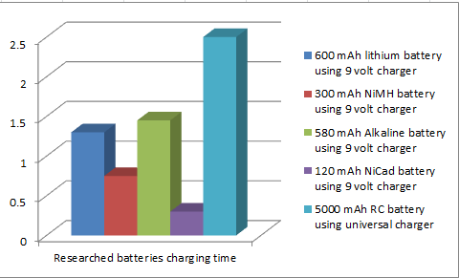
Figure 4.2.a A Graph showing the charging time for the researched batteries
Our group is looking into installing a sensor that senses the condition of the battery. For instance, if a person looked at the status of his computer, that person would be able to see the life of the battery. This feature would be really good for the Bionic arm because the user would be able to see the status on the installed LCD touchscreen. The battery gauge will always be displayed on the touchscreen. Since our group has decided to buy a high capacity RC battery, a good charger that can charge batteries with a capacity of 5000 mAh had to be purchased. The Tenergy charger can charge the RC battery that our group has chosen for the all the electronics components. The charger can charge 33.33 mA per minute when it is set to 2 amps. This setting is for batteries of 2000 mAh to 5000 mAh. For this charger, overcharging is not a problem. The battery that will be used is 5000 mAh and 7.2 V. Because the charger is a universal charger, it will be able to work with most batteries below 5000 mAh. The price for the universal charger was really good since it could work with most RC batteries under 5000 mAh. The charger has two settings for all batteries below 5000 mAh. The first setting is the 1 A setting. By using this setting, the user can charge all batteries under 2000 mAh. When a battery between 2000 and 5000 needs to be charged, the2 A setting will charge those higher capacity batteries. The charger will not work batteries over 5000 mAh capacity. The user should take great care if a new battery is purchased. If a higher capacity battery is bought, the user should buy a charger that can charge the new battery.

4.2.1 Batteries
When our group looked at batteries, we had to make sure that the battery had the specifications for the arm. Our group based our decision on toxicity, capacity, and the overall cost of the battery. A lot of batteries are toxic and have to be properly disposed. For instance, Alkaline batteries contain potassium hydroxide or sodium hydroxide. If the chemicals came out of the battery, the compounds can cause liquefaction necrosis of the skin. These batteries are immediately ruled out since they can cause harm to the user of the Bionic Arm. If these batteries leaked in the arm it could cause damage to important components in the arm. Since the bionic arm is connected to an area where a person had an amputation, the toxicity level could affect the user more if the battery was pierced for any reason. Furthermore, the capacity of the battery plays a major role when a battery was picked. Figure 4.2.1.a shows the capacity of all the 9 volt batteries that were researched for the arm. By looking at the graph, our group could see that two batteries had very low capacity, and two had very high capacity. Even though the Lithium Ion had the highest capacity, our group decided that it would not last long enough for normal use or demonstration purposes. These 9 volt batteries were smaller than the RC batteries.
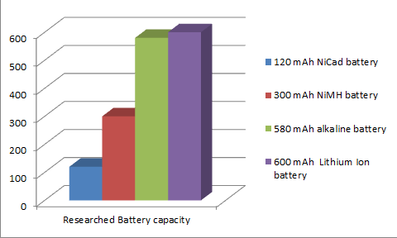
Figure 4.2.1.a A Graph showing the capacity of all the 9 volt batteries
Since the project involves 5 servo motors, multiple sensors, and an LCD screen, the capacity requirements needs to be really high. Research had to be done to determine which battery had the right capacity for the project. During our research, batteries were found to have a lot of capacity; however, these batteries had a certain level of toxicity. Some batteries had bad reviews due to their fast discharge rate. The battery had to be able discharge at a good rate. Moreover, the cost of the battery was looked at too when picking a suitable battery. Batteries can be really expensive; there, our group looked at the cost of buy certain batteries. Even though some batteries had the same price, the group ruled them out based on capacity and toxicity. Seven types of battery types were looked at during our research. Table 4.2.1a shows the different types of 9 V batteries that were researched.
Chemistry of Battery | Rechargeable | Capacity(9volts) | Cost:  Amazon.com
Alkaline | Yes | 500-580.00 mAh | $7.98
NiMH | Yes | 200-300 mAh | $23.30
Lithium-Ion | Yes | 500-600 mAh | $16.99
NiCad | Yes | 100-120 mAh | $20.99 ($2.62/Count)
Table 4.2.1a A table shows 9 Volt battery considerations
An Alkaline battery was looked at by the group; however, the short life span of the alkaline battery ruled it out as a possible choice for the prosthetic arm. The battery would lose charge too fast even when not used and would not be an ideal choice for the arm. The Alkaline batteries had capacity between 500 and 580.00 mAh. Even though the alkaline battery had a high capacity, it was not considered due to its discharge rate. A 9 volt alkaline battery was looked at on Amazon.com to see the specifications of the battery. The cost of this battery was very high for just 1 battery making it very expensive. A separate charging station would have to be bought in order to charge the batteries. We would have used two batteries in order to double the lifespan of the battery. These alkaline batteries can run from 8 to 9 hours continuously when 40 to 50 mA is being used.
- Pros: - High Capacity
- Commonly used battery
- Long run time
- Rechargeable
- Cons: - High discharge rate
- Expensive
- Very prone to leaking

The second choice was the NiMH 9 volt battery. This battery had a relative low toxicity level and had good performance; however, the NiMH had a capacity of rate at between 200 and 300 mAh. This was the second lowest capacity compared to the other three batteries. The arm needs a battery that can hold a lot of charge for extended use. For this reason, we decided not to use this kind of battery. A bundle was looked at using Amazon.com. The cost was higher than the alkaline battery; however, the bundle had a charger and two NiMH batteries. This battery can be recharged over 1000 times. On Amazon, the buyer can buy 2 batteries and the charger for one good price. The charging time depends on the battery used. The charging time for the 1 and 2pcs Ni-MH 9V 160mAh is 1.8 hours, 180mAh 2.0 hours, 200mAh 2.2 hours, and 220mAh 2.5 hours. The charger is a smart charger just like the RC battery charger. This will prevent overcharging of the battery.
- Pros: - Low toxicity level
- Rechargeable
- Cons: - Low capacity
- Expensive
- Low run time

Another choice was the Lithium-Ion battery. This battery had a no toxicity level and had good performance compared to the other three. The recharge rate for this battery made it a really good choice. The Lithium-Ion was considered a great choice due to its good recharge rate and because it had no toxicity levels. The toxicity level was important because the bionic arm would come into contact with the user. The Lithium-Ion battery has a capacity between 500-600 mAh. This made a much better choice than both the other three batteries that we looked at. An EBL battery was looked at on Amazon.com. It comes with its charging station which makes it a better choice than the other three batteries. This choice comes with two batteries making it a great deal. Despite the cost, the battery has two pairs of batteries and is more efficient than the other two choices.
- Pros: - No toxicity
- High capacity
- Slow discharge rate
- Long run time
- Rechargeable
- Cons: - Expensive

Another battery that our group looked at was NiCad. This battery is a common used household rechargeable battery. One drawback for this battery was its rapid discharge rate. This ruled it out as a possible choice for the Bionic Arm. If a battery discharged so fast in the prosthetic arm, the user would not be able to perform multiple tasks. Another drawback was its high toxicity level. This made the battery the worst possible choice for the Bionic arm. The bionic arm needs to have a safe battery for the user. The battery needs to be quickly ruled out as a possible choice for the prosthetic arm if there is even a small chance of harming the user. This battery’s capacity was the worst on the list since it had a range in between 100-120 mAh. This would have been the worst choice for the servo motors and all the other electronic components inside the bionic arm. This battery would have lasted less than 10 minutes if used in the prosthetic arm.

- Pros: - Rechargeable
- Best smoke detectors
- Good bundle price
- Cons: - Expensive
- Low capacity
- Rapid discharge rate
- High toxicity
Even though the 9 volt lithium seemed like the best choice, we looked at even more batteries since the servo motors needed operate for longer periods. Batteries with more mAh are commonly used in RC cars. The only issue here with this battery is that the size of the battery component. The battery had a size of 136mm x 47.5mm x 24.5mm. This size was for perfect for the printed prosthetic arm. The battery would need to fit inside the 3d printed prosthetic arm without any issues.
This battery is a 7.2 volt battery that has a 5000 mAh capacity. The chemistry of the battery was NiMH. So, this battery would be a good choice for the bionic arm. Figure 6.1.a. shows the battery that is being considered for the servos in the Bionic arm. The overall weight of the RC battery plays a major role. Since there are so many batteries in this battery pack, a lot of research had to be had to narrow down a battery with an ideal weight for the prosthetic arm. The group agreed that a 1 pound battery was a good weight for the prosthetic arm. After research was done on this battery, our group believes that this battery meets the requirements for our prosthetic arm battery.
In order to compare more batteries for this project, a table has been made with 3 RC car battery choices. Table 4.2.1.b shows the RC batteries specifications in increasing order for the Bionic arm. The chemistry of the battery will still play a major role when selecting a RC battery. These batteries cost much more than the 9 volt batteries; however, they will last longer and thus making these batteries the best choice for the Bionic Arm. A choice will be made based on cost and capacity in this case.
Higher capacity batteries were found when looking for RC batteries; however, the cost would be really high to use these specific batteries. It would be up to the user to add a battery if he or she desires longer use for the arm. Making a choice to change the batteries would also require the user to buy a new charger for the arm since the current charger can only charge up to 5000 mAh. Some batteries have a higher voltage than input voltage of the servo motors. A 7.2 voltage regulator should then be installed to fix this problem.

Battery Chemistry | Capacity | Volts | Toxicity | Cost(Amazon)
Lithium-Ion | 2200mAh | 7.4 V | None | $13.99
NiMH | 3800 mAh | 7.2 V | Low | $23.99
NiMH | 5000mAh | 7.2 V | Low | $34.90
Figure 4.2.1.b. A table that shows 3 different RC car batteries
Lithium-Ion battery has a longer storage life than the NiMH; however, the capacity was not high enough to be considered. Another model for the Lithium Ion battery was seen; however, the cost was 200 percent more than the NiMH battery. The lithium ion would have been better due to the no toxicity level. All these batteries have a high voltage; therefore, Voltage regulators will need to be used in order to lower to the voltage to a desired level. If a more use time is desired in for the prosthetic arm, two of these batteries can be put in parallel. Putting two of these batteries in parallel will give more running time compared to the batteries in series; however, our group will only use one battery for the arm since it is for demonstration purposes. Users have the ability to increase the run time by adding another battery in the circuit. Figure 4.2.1.b shows the charging time for all the RC researched batteries. The graph shows us that the charging time increases the larger the capacity is. In order to reduce the charging time, a better charger can be purchased to reduce the charging time.
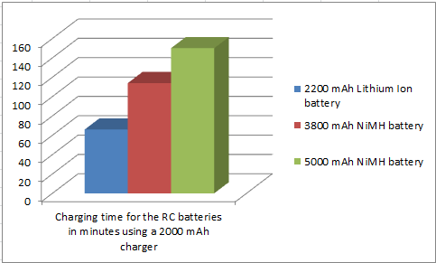
Figure 4.2.1.b Charging time for all the RC researched batteries

4.2.2 Close Range Charging
Wireless charging would have been a better choice in order to make charging easier for the user. The user can charge the Bionic Arm by just leaving the arm in the proximity of the magnetic field. The magnetic field is created by using antennas and coils which are be located in the charging station and device that needs to be charged. In order to direct the magnetic field, Ferrite shielding is used to direct the magnetic field into an antenna. This would be indeed be a good way to charge the device if the price was right.
Our group decided not do this method because of the budget that we for the Bionic Arm; however, if these method of charging was used, the user would be able continuously use the arm as long as the prosthetic arm was in range of the charging area. Figure 4.2.3.a. shows the components that would be needed in order to realize a wireless charging circuit inside the arm. There will be a transmitter inside the charging station that will transmit a signal to the receiver. The receiver would be installed inside the arm area where the battery is located.
- Pros: - Convenient charging
- No wired needed to charge
- Futuristic design
- Cons: - Very expensive
- Longer charging time for RC batteries
- Ideal for phones batteries not RC batteries
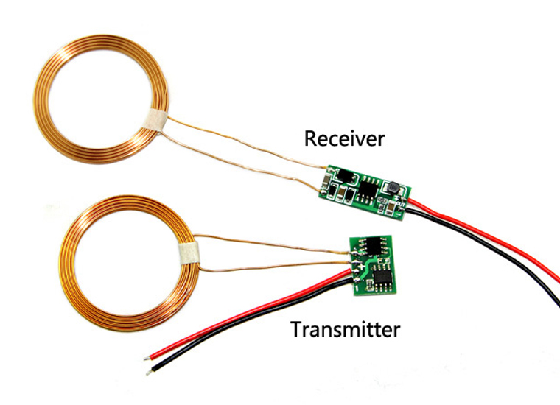
Figure 4.2.3.a A picture of the parts required for the wireless charging of the arm, reprinted with permission from ElecFreaks

4.2.3 Charging Schematic
The charging schematic in figure 4.2.2.a. shows what our plan is for the charging the prosthetic arm. A Tenergy Universal charger will be used to charge our main 7.2 Volt battery. After the battery is charged, the 7.2 Volt bus can give power to the whole arm. The controller and all the other electronic components can be powered. This 7.2 V will distributed to every single electronics component in the prosthetic arm. Voltage regulators will need to be used for certain electronic components in the prosthetic arm. Our initial plan was to add a 9 Volt battery to power the all the electronics minus the servo motors. If a 9 volt battery was added, the touchscreen and other electronic components would remain active if the main RC battery was low on power. When the 9 volt battery is charged, a regulator will change the voltage for the touchscreen and microprocessor.
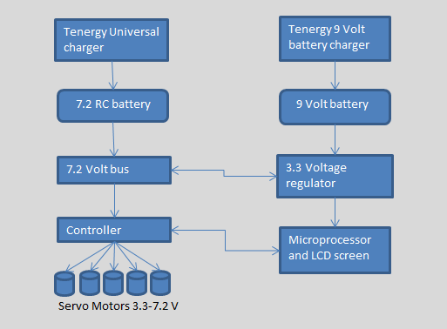
Figure 4.2.2.a. A Charging schematic for the prosthetic arm

4.3. Servos
In this section, servos are discussed in depth. More specifically, the controller, precision, our servo choice and a schematic of our servos to the microcontroller will all be addressed.
Servos are chosen due to their precise position control as well as their easy manipulation by a microprocessor. By sending signals called pulse width modulation (PWM) from the microcontroller to the servo, we can control the specific position of the servo. The position of the servo is critical in our project as the hand must be able to perform certain functions as described previously in the paper.

Simple servos use a potentiometer to determine position. For our project, we will choose a more complex method where an encoder provides specific position feedback. The speed for our servos will be single speed. Variable speed servos don’t benefit our arm and are significantly more costly.

Cost is another significant component of our servo decision. The cost between a full feature servo and a simple servo varies greatly and the choice is evaluated carefully so that the user receives a quality product that works as intended but at the best possible cost. Torque is the biggest cost factor. The more torque the servo provides, the more it usually costs. How loud the servo is can affect cost as well. Very quiet servos can be much more costly than a louder servo.

Too, we must address the torque of the servo and what is required to move our arm. There is a balance between how much power we supply the servo and what’s manageable for the arm. The more voltage that is supplied to the servo, the more torque the servo has. However, more voltage requires a larger battery and due to the minimal space in the arm, the battery must provide an appropriate torque while fitting in the arm as well.

There are two primary servos that INMOOV, our arm designer, discuss and recommend be used. The MG996 and the HK15928 are both servos that are suggested we use. The biggest difference between the two servos is that the MG996 is capable of turning 180 degrees, where the HK15298 can only rotate 90 degrees. Both servos will be used in the INMOOV project; however the above servos may not be the best solution to our project. In the coming pages, these servos will be discussed more in depth and compared to some alternate servos that may provide better functionality for our project and what our specifications require.
Deciding which form of mechanical control was a relatively easy decision to make. DC motors and AC motors, although they provide easy functionality, they’re near impossible to control precisely and effectively. This is a critical point when designing finger movement. DC motors are controlled directly by the voltage that is applied to them. AC motors are controlled by the frequency of the signal.

There aren’t too many ways to control the specific position of one of these motors. Too, AC and DC motors can prove to be costly as well. Servos are cheap, provide strong torque and allow precise control in a clean package.

4.3.1. Control
Now that the MG996 and the HK15298 have been decided upon, further investigation can be looked into how these servos are controlled by the MSP432.
There are many methods in which we can control our servos. Because we are required to use a microcontroller, we limit our control options to microcontrollers. There are many much simpler ways to control servos by using more “mini-computers”, but our group is more interested in how to use embedded systems for control.
When controlling servos with embedded systems, we use C programming to send output signals using the Timer.
Looking at the datasheet of the MG996, the servo can be controlled by any servo code, hardware or library codes which make this simple for programming. By coding the MSP432 to operate the servo, we have a simple and cohesive system.
Too, the MSP432 has an analog to digital converter on board allowing for even easier programming. The pinout of the MSP432 is shown in Eagle in a later section of the paper so the connections can be seen much more clearly and how everything will be connected. Servos are also an external device so the only figure on our circuit board is a 3pin header for the servos to plug into.
One of the pins is for a controls signal so we can precisely choose where the servos position will be and the other two are for a positive voltage (roughly 5-7V) and a ground.
The MSP432 controls pulse width modulation by use of the timer onboard. We must first program the timer in a specific mode and choose which timer to use. Timer A is the primary timer and can be used fairly simply to control the servo. Once we know which timer we can use we can output onto a specific pin.
We set the given pin to output. Finally, we can set PWM mode using the CCTL register. We can set the duty cycle fairly simply from here. This is just a basic rundown of how we can program and control the servo. Figure we see the PINOUT of the msp432 chip showcasing the PWM output pins.
One of the biggest aspects of control is how to program the servos to run certain “programs” to perform certain functions. The MSP432 has 4 different timers that can provide PWM signals. With this, we have a large breadth of resources to control each finger to receive the specific hand formation we’re looking for.
Specifics of each hand motion are described in the code section of the paper. With 5 servos, we have more than enough pins on the MSP432 to control all aspects of servo control.
There are multiple servo control points that must be addressed. First, the power supply must be filtered so that we limit the usage of noise. Second, when connecting the signal wire to the microcontroller the signal must be filtered by using a simple resistor. This allows there to be a slight buffer to protect the microcontroller. Next, servos must be powered from a separate power supply, not powered by the MSP432 or any other microcontroller.
There are multiple reasons this should be done, but the biggest is that the servos are powered off a higher voltage. We don’t want the servos to only be fed 3V. The more voltage that is supplied to the servo, the greater torque that is received (up to a certain point) and finally, the servo and the microcontroller must share a similar ground.

4.3.2. Precision
One of the key reasons as to why we must use a servo versus a typical DC or AC motor is that with a servo, we have precise control over the position of the servo. Servos are precise due to the way they function. Without going into too much detail, by understanding the precision of the servo we can apply these concepts to our project and in turn, create a more sophisticated product. When we program the microcontroller, we send a specific pulse width using the timer.

Depending on this width that is sent, we know the servos position. This why the servo we chose above is so precise. The timer of the MSP430 is incredibly precise and due to this, our servos will also be precise in their position. First, we have a minimum pulse of about 1ms which keeps the servo at 0 degrees. If we increase the pulse to around 1.5ms the servo goes to neutral position and changes to 90 degrees. Finally, if the pulse is around 2ms, the position of the servo advances to 180 degrees. These pulse widths can vary and the position will change depending on the “home” position of the servo. Obviously depending on the time that’s sent we can achieve any angle that is desired. Like discussed in the control section, all of these signals will be sent on an output pin from the MSP430 control.

We will program with these ideas in mind to get exact hand gestures each and every time a “program” is selected. The user would not want any ambiguity in which gesture they are calling for so it is critical that the servos that are selected as well as the microcontroller can provide the precision that we are looking for. The above meet these requirements. Another important point is that the servos must always know how to go back to the home position. Once the arm picks up the item and lets go of the item, the servos need to return to their home position and allow the object to be dropped off.

There are 5 servos included in the arm, so there will be 5 servos that all need precision given directions by the microcontroller. More depth will be provided as to how each servo will be programmed to achieve the desired position in the programming section.

A servo may also be added into the wrist to allow for more complex hand movement. The servo in the arm wouldn’t be controlled by any external sensors, but would simply be prevalent for increased feature set. The servo also adds considerable weight and with 5 servos already in the arm, we want to avoid adding even more weight. Finally, where the wrist servo is supposed to go is an ideal location for our microcontroller and all associated electronics. The wrist servo will only be added if considerable time is left in the project, or we deem into the future that it would provide an exponentially great benefit.

4.3.3. Servo Choice
Deciding which servo that will be used is the first and arguably the most important component of the servo section. Figures 1 and 2 above depicted what INMOOV suggests we use. In Table 4.3.1a below the data specifications are provided for each servo suggested.

 | MG996 | HK15298
Torque | 10kg-cm | 14kg-cm – 15kg-cm
Weight | 55g | 66g
Speed | 0.20sec/60degree(4.8v) | 0.13 / 60deg @ 6v, 0.11 / 60deg @ 7.4v
Voltage | 4.8V-7.2V | 4.8V-7.4V
Motor Type | Metal Gear and Doube Ball | Coreless
Cord-Type | JR Style | JR Style
Cost | $5.74 | $21.80
Table 4.3.1.a comparison of MG996 and HK15918 servos
By looking at the specs of both servos, they’re relatively similar in their specifications. Torque varies considerably, however as well as weight. Although we’d like a light arm, we will favor a more powerful arm that is able to pick-up heavier objects than lighter servos that struggle picking up light items. Like stated previously, however, the HK15298 can only rotate 90 degrees. In an application where 180 degrees is required the MG996 will be a much better fit. The biggest difference between the two servos is the cost. Because INMOOV suggests that the two servos be used, and they have slightly different applications, a cost comparison cannot be done on these two servos.

Below, several other servo choices are examined and the possibilities of using them instead of the two servos recommended by INMOOV. These servos were chosen because they are in similar price ranges as the ones above and provide alternate specs that could potentially work for our project.

 | HXT500 | TGY-375DMG
Torque | 0.6 kg-cm - 0.8 kg-cm | 1.6 kg-cm-2.3kg-cm
Weight | 6.2g | 11.4g
Speed | 0.08 sec/60 (4.8V) 0.07 sec/60 (6.0V) | Speed @ 4.8V: 0.13 sec / 60° at no load  Speed @ 6.0V: 0.11 sec
Voltage | 4.8V-6V | 4.8V-6V
Motor Type | Teflon Bushing, Coreless | Metal Gear, Ball Bearing
Cord-Type | JR Style | JR Style
Cost | $2.49 | $20.30
Table 4.3.1.b comparison of HXT and TGY-375DMG servos
The above data provided are two examples of servo research conducted. The HXT500 is similar to the MG996 where the weight varies considerably. By looking at the picture, the HXT500 servo looks like a cheaper servo more for light hobby activities. It also can only provide around 1kg-cm of torque which isn’t enough to power our arm. The TGY-375DMG also has considerably less torque and similar speeds. The cost is similar to the HK15298. Taking into account the recommendation made by the creators of the arm and the research conducted for other servos, the recommended servos are the ones that will be used in the final project.

Both servos provide enough torque at an appropriate speed with the right dimensions to work for our arm. It should also be mentioned that the JR style is a common style among servos and will work fine for our application. On our final circuit, a JR female connector can be applied onto the final circuit to provide even further cohesiveness and allow for easy connection. Too, this allows for if a servo motor were to go bad or we weren’t able to use it any longer, it could be swapped out from the main board easily.

4.3.4. Servo Schematic
To showcase the connections between our servos and the servo board, we will use the eagle software to draw a schematic. Like discussed above, we have the MSP432 chip which has a plethora of input/output pins that can be used. The servo has 3 wires associated with it; one will be used for a positive voltage, one will be used for a negative voltage and then the last one is an output signal wire that is connected to the input/output pins to the MSP430.
Like discussed above, the power supplied to the servos must not come from the microcontroller itself, but from a separate power bus. Then, the microcontroller’s ground must be the same as the ground for the microcontroller. These connections can all be seen when we build the schematic board. The servos are provided abut 5-7V which can be taken directly from the battery so no DC-DC conversion or voltage regulator will be needed for the servo application of the arm.
With the eagle software, the servos won’t actually be placed directly on the circuit board as they are outputs for the board and MSP432. Instead, 3 pin headers will be soldered directly onto the board so the servos become more of a plug-in-play application.
On the schematic will also be a 1kohm resistor between the servo signal line and the input/output pin of the board. This helps to sustain the signal and alleviate some of the noise from the line. This provides even further precision when trying to control each individual finger.

4.3.5. Stepper Motor
Our group considered using stepper motors for the fingers of the prosthetic arm. A stepper motor is a motor that rotates in steps when programmed. The stepper motor has the ability to hold the last position that it was in. Since the stepper motor rotates in steps, it is very different to conventional motors that continuously rotate. The stepper motor’s steps are increased in degrees; therefore, a whole turn for the stepper is considered 360 degrees. Each step has an increment of 0.9 to 1.8 degrees with 200 or 400 increments which represent a 360 degree circle. Our current servo motor can rotate 180 degrees. The degrees that the sevo motors rotate is good enough for the prosthetic arm A set of coils inside the stepper create a magnetic field that interact with the fields of permanent magnet. By turning the coils on and off in a certain sequence, the angle of the motor can be controlled. This motor would be a good choice since it can rotate in both directions. The stepper motor and servo motors need a controller to work. The servo motors were picked because of the overall cost. The stepper motors would have been a real good choice due to their accuracy compared to the servo motors.
Pros: - Stepper motor is easier to control than a servo motor
- Stepper is more accurate than a servo motor
-Cheaper than servos
- 0 to 360 degree rotation
Cons: - Acceleration is limited
- Maximum speed is limited

4.4. Comparing Signals
Now that we have discussed the DC power supply and the charging mechanism that will be implemented in this project along with the specific servo motors, we will now discuss the possible wireless signals that we can use. The improvement in cell phone technology has allowed the industry to use its sophisticated processor design and apply its features to various other appliances and devices. There is certainly a benefit to wireless signals as it makes any device seem more portable and customizable by the consumer. For example, having the option of changing channels on a television using a mobile phone that is connected to the TV via a Bluetooth connection is more appealing than manually walking to the TV and tapping a push button. Furthermore, the size, mobility, eloquence, and the number of available features of mobile smart phones these days makes them the most suitable electronic devices to serve as a “wireless transmission line” that transmits input from the user or consumer to the electronic that is being controlled. There are three wireless signals that will be focused on and discussed in detail; GSM, Wi-Fi, and Bluetooth. At first, we will discuss the possibility of using GSM signals as we have favored that over Code Division Multiple Access (CDMA).

4.4.1. GSM
GSM, or Global System for Mobile Communications, “began in the 1980s as an effort to obtain a single European 2G standard. The first GSM systems were employed beginning in 1991 and immediately became a huge success. After that, it was obvious that GSM would eventually become more than just a European success, and as a result, GSM was renamed to have a more worldwide appeal.” (Tanenbaum & Wetherall, 2010) “The GSM implementation uses a combination of Frequency Division Multiple Access (FDMA) and time Division Multiple Access (TDMA) media access control methods to provide a full-duplex,” (Global System for Mobile Communications (GSM)) a two-way based communication were the device is able to send and receive signals, “communication over two frequency bands within the 862-to-960 MHz portion of the electromagnetic spectrum.” (Global System for Mobile Communications (GSM)) Further explanations on TDMA, FDMA, and the frequency bands will be discussed below.
TDMA is how a single user has access to all the frequency bands available, at a given time; however, only one user can have access at a certain time. This is shown in the left side of figure 4.4.1.a. where the three different blue bars represent the three different users who are allowed to have access. It clearly displays how one user and only one can have access to all the frequency bands at a time. The next user can have access after a given period of time as shown in the figure after 4 seconds. On the other hand, FDMA allows multiple users access at all times, allocating an equal portion of bandwidth to all. This also can be seen on the right hand side in figure 4.4.1.a. where the horizontal bars represent multiple users on different bandwidths who can have access at the same time.
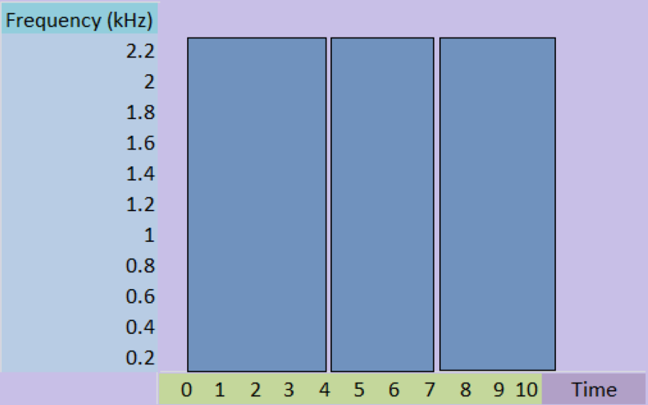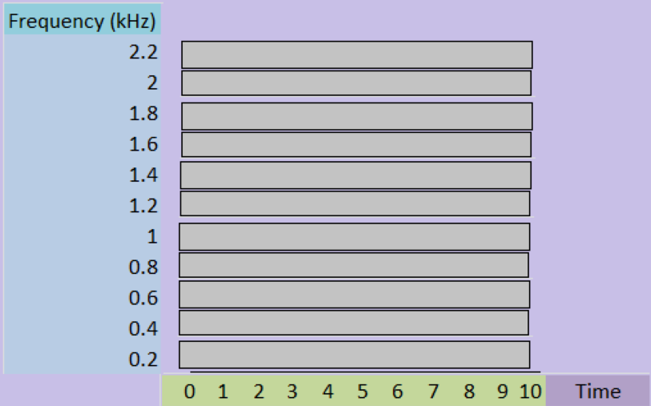
Figure 4.4.1.a. Frequency allocation vs time allocation of TDMA (left) vs FDMA (right)
Regardless if FDMA or TDMA is used, frequency bands are implemented to allocate equal bandwidth onto which a specific user can have uplink and downlink communications having exactly “890 to 915 MHz band for mobile to base (uplink) communication and 935 to 960 MHz band for base to mobile (downlink) communication. Carrier signals are evidently 200 kHz apart,” (Global System for Mobile Communications (GSM)) as shown in figure 4.4.1.a. with regards to both FDMA and TDMA. Basically, each band has multiple carrier signals to have a total of “124 pairs of super channels based on frequency division multiplexing (FDM), where each of these are then subdivided into eight traffic channels using time-division multiplexing (TDM). In conclusion, GSM provides 992 full duplex channels for voice communication.” (Global System for Mobile Communications (GSM)) Furthermore, technically GSM can be separated into 3 divisions:
- Mobile Station
- Base Station
- Network Subsystem
The mobile station relates more to the user, as “the mobile station consists of the mobile equipment, such as the handset, and the Subscriber Identity Module (SIM). The SIM allows the user to have access to subscribed services. The mobile equipment is uniquely identified by the International Mobile Equipment Identity (IMEI). The SIM card contains the International Mobile Subscriber Identity (IMSI) used to identify the subscriber to the system, a secret key for authentication along with other relevant information. The IMEI and the IMSI are self-regulating, and as such allow personal mobility.” (GSM (Global System for Mobile Communications)) A password can be set by the user on the SIM card to avoid having unauthorized access.
“The base station subsystem is composed of two parts: the base transceiver station and the base station controller.” (Global System for Mobile Communications (GSM)) It essentially maintains and controls the link with the mobile station. “The base transceiver station houses the radio transceivers that, ultimately, defines a cell and handles the radio link protocols with the mobile station. Since the base transceiver stations may potentially handle a large number of radio signals, the requirements for it are to be rugged, reliable, portable, and cost as low as possible. In addition, the base station controller manages the radio resources for a single or for multiple transceiver stations as well as act as the connection between the mobiles station and the mobile services switching center.” (GSM (Global System for Mobile Communications))
“The central component of the network subsystem is the mobile services switching center. It connects the mobile signals to fixed networks as well as provides all the functionality needed to handle a mobile subscriber, such as registration, authentication, location updating, handovers, and call routing to a roaming subscriber.” (Global System for Mobile Communications (GSM))
The reason for describing GSM and its affiliated features is that this signal can be implemented into our project’s design. With the recent rise of smart watches and portable music players, which have the capabilities to text and call other devices, such as mobile phones, along with our intention to implement an LED or LCD screen, GSM can be used as an extra feature to make our design match recent technological advancements by providing the user the possibility to be able to call and text.

4.4.2. Wi-Fi
The second signal we will be discussing is the Wi-Fi. Many people know what it is used for as it allows them access to the internet. Needless to say, we will describe the origins of Wi-Fi and how it became instrumental to most people’s daily lives and following that, we will mention how it can be implemented into our design.
“In 1985, a technology called 802.11 was made available for use due to a United States Federal communication commission ruling, in which three radio spectrums were allocated for use for nearly all wireless communication: 900 MHz, 2.4 GHz, and 5 GHz. The early version of wireless protocol’s heritage is now outdated as a result would now be considered measurably slow by the standards that exist today. In 1999, 802.11a and 802.11b were released, and for a good number of years, they were the standard for Wi-Fi networks. They both operated at a frequency of 2.4 GHz range in the radio spectrum; however, unlike 802.11 they were able to transmit data at a much faster rate. The 802.11a protocol could support data transmission up to 54 Mbps, but was designed for much shorter ranges at a much higher cost to produce and maintain. On the other hand, 802.11b had a much lower cost and longer range, but worked at a much slower speed reaching a maximum speed of 11 Mbps. Since both protocols operated in the unregulated 2.4 GHz bandwidth, they were susceptible to interference from other appliances that used the same frequency, such as microwave ovens, cordless phones, and wireless keyboards. In 2003, 802.11g was introduced as the latest standard. 802.11g protocol was designed to encompass the best features of the previous transmission standards where it operated at a maximum transfer rate of 54 Mbps while maintaining a longer range as well as lower costs. Soon thereafter, the adaptation of 802.11n, sometimes called Wireless-N, became at the forefront of wireless transmission technology. It had the ability to transfer data up to 300 Mbps and the capability to incorporate multiple wireless signals and antennas (called MIMO technology); basically, people could surf the web even faster and with more stability. The new protocol also allowed data to be transmitted on both the standard 2.4GHz frequency as well as the less populated 5GHz which led to a stronger signal and less interruption. The latest technology, 802.11ac, proved to be another huge step in wireless transmission along with the advancements in dual-band technology; data can now be transmitted across multiple signals and bandwidths allowing for maximum transmission rates of 1300 Mbps with extended ranges and nearly uninterrupted transmission.” (Staff, 2014) Since there could be interference from other devices on the permitted wireless frequencies, IEEE then formed standards in which wireless transmission had to comply with.
“Under the IEEE Wi-Fi standards, the available frequency bands are split into several separate channels. These channels overlap in frequency, and therefore Wi-Fi uses channels that are, essentially, far apart. Within each of these channels, Wi-Fi uses a “spread spectrum” technique in which a signal is broken into several packets and transmitted over a range of frequencies. Spread spectrum enables the signal to be transmitted at a lower power per frequency and also allows multiple devices to use the same Wi-Fi transmitter. Because Wi-Fi signals are often transmitted over short distances (usually less than 100 meters or 330 feet) in indoor environments, the signal can reflect off walls, furniture, and other obstacles, thus arriving at multiple time intervals and creating an issue called multipath interference. Wi-Fi reduces multipath interference by combining three different ways of transmitting the signal.” (Wi-Fi)
Now that we mentioned a brief history on the creation of today’s Wi-Fi, we will discuss how it operates. As mentioned earlier, Wi-Fi is essentially a wireless network protocol and as such, uses radio signals to communicate. The basics of Wi-Fi are that a device needs to be connected to a router, which would have a stable connection to the internet, and then the router would transmit back to the device the information gathered and requested by that device. Fundamentally, the device and the router would need to support a full-duplex communication. As mentioned earlier, Wi-Fi signals transmit at frequencies of 2.4 GHz or 5 GHz, “which are higher frequencies used than that for other devices as well as allows the signal to carry more data. These two signals use 802.11 networking standards, which are divided into several categories:
- 802.11a: Transmits at 5 GHz and can move up to 54 Mbps. It also uses orthogonal frequency division multiplexing (OFDM), which is a more efficient coding technique that splits radio signals into several sub-signals before reaching a receiver. This is a technique that is used to vastly decrease interference
- 802.11b: This standard is the slowest and most inexpensive. The reason for its popularity was its cost; however, now it is becoming less common as faster standards became less expensive. 802.11b transmits in the 2.4 GHz frequency band of the radio spectrum as well as handle up to 11 Mbps. It uses complementary code keying (CCK) modulation to improve speeds.
- 802.11g: Just like 802.11b, this standard transmits at 2.4 GHz; however, it is much faster and can handle up to 54 Mbps. 802.11g is much faster as it used the same OFDM coding as 802.11a.
- 802.11n: This is the most widely available of the standards as well as is backward compatible with 802.11a, b, and g. Compared to the other standards, it has considerably improved the speed and range. 802.11m has reportedly achieved speeds as high as 140 Mbps and can transmit up to four streams of data, each at a maximum of 150 Mbps; however, most routers only allow for two or three streams
- 802.11ac: This is the latest standard as of early 2013. It is still in draft from IEEE. There are devices that support it on the market today, yet it still has to be widely accepted. 802.11ac is backward compatible with 802.11n, which essentially makes it compatible with the other standards too, with n on the 2.4 GHz band and ac on the 5 GHz band. It is the fastest compared to all the rest as well as is less prone to signal interference. It can reach a maximum speed of 450 Mbps on a single stream.
There are other 802.11 standards that focus on specific applications of wireless networks, like Wide Area Networks (WAN) which allows the device to transfer from one wireless network to another seamlessly.” (Brain, Wilson, & Johnson)
What once was an achievement in the past is now considered to be a basic need and want in everyday life. Whether to look for restaurants to eat or to obtain directions to specific place, accessing the internet has become essential. Each person has their own habits and uses for the internet as it contains an enormous amount of features that are available. Implementing a Wi-Fi module in our project that would connect to a wireless signal would certainly be a possibility.

4.4.3. Bluetooth
The third and last wireless signals we will be discussing the Bluetooth. “Bluetooth is derived from the nickname of a Dane King who brought together warring factions in what are now Denmark, Norway, and Sweden into a single kingdom. The frequency hopping spread spectrum (FHSS) technique upon which Bluetooth wireless technology bases its communication protocol is accredited to a patent issued in August 1942 named “Secret Communication System.” The patent details an FHSS technique for a radio-controlled torpedo. Since the radio signals hopped across the radio spectrum, an enemy would not be able to jam the signal. But it is to 1994 that Bluetooth wireless technology really traces its roots. In the same year, a Swedish telecommunications company named Ericsson arrived to the idea of replacing the twisting cables of RS-232, which were commonly used by then to communicate between instruments with an RF-based ‘wireless’ alternative. In addition to Ericsson, other telecommunications companies such as Intel and Nokia had also been working on the idea of wirelessly linking cellphones and computers at around the same time.
As a result of each company’s works and findings, they all soon realized that to have any chance of universal interoperability, as in allowing products from different companies to connect since they all used a common RF protocol, the technology would need to be standardized and driven by a Special Interest Group (SIG). After that, the companies met at the Ericsson plant in Lund, Sweden in 1996 to agree and settle on the establishment of a SIG. In 1998, the Bluetooth SIG was officially established and included five companies; Ericsson, Nokia, Intel, Toshiba, and IBM. And soon thereafter, the first version of the wireless technology was introduced a year later. By 2005, the second version, which had an enhanced data rate, had been sanctioned.
After that, in 2007, the Bluetooth SIG acquired a Nokia-led initiative that had a goal of developing a wireless connectivity that was an ultralow-power, by consuming using much less power than the Bluetooth wireless technology, as well as communicate with cellphones. Shortly thereafter, a new form of Bluetooth wireless technology was developed, where it was initially named Ultra Low Power Bluetooth and later Bluetooth low energy, where it complemented the existing version but could run using coin cell batteries.
In 2010, the latest and fourth version of Bluetooth wireless technology, which included Bluetooth low energy, was sanctioned, so two types of chips described in the core specification became available, Bluetooth v4.0 and Bluetooth low energy ICs. In recent times, Bluetooth wireless technology is incorporated into billions of chips in thousands of applications, and Bluetooth low energy extends its usefulness to a huge new sector of devices powered by coin cell batteries.” (Semiconductor, 2014)
To summarize what was mentioned above Bluetooth is a wireless technology that was made with the intention of connecting cell phones to computers. It eventually became the wireless technology to transfer data from and to multiple electronics. “The first and foremost application of Bluetooth technology would be to eradicate the tangling of cables that would cause havoc in a room.” (Mary) With the rise of this wireless technology, many applications have it embedded and as a result, it has provided many contributions.
“One of its biggest contributions is to provide a cell-phone with a headset that works wirelessly. Furthermore, a PDA, a PC, or a laptop, which has Bluetooth embedded in it, is able to communicate with other devices and update its latest information. This has allowed the simplicity in synchronizing data. In addition, it is almost impossible to send emails while travelling in a flight; however, up on landing, the Bluetooth enabled laptop can send the email only after it gets connected with the user’s cell-phone. Another application is the introduction of wireless mice and keyboards. Other applications include the ability of locating a printer through a laptop’s Bluetooth.” (Mary)
Bluetooth technology has certainly changed how the industry views and manages wireless communications. The technology has made it possible to not only remove unwanted cables, but also made it possible to realize a short range encrypted communication between several connected devices. Bluetooth has many applications as mentioned earlier, and in our project, it may be implemented with the intention of having the arm connect wirelessly to a Bluetooth enable device such as a cell phone or a television. The wireless connection can be used to either control the connected device or the arm itself, as well as have a feature to update the MCU’s software.

4.5. Implementations of Wireless Communications
Now that we have discussed different types of wireless communication signals and connections, we will be discussing our most favored wireless signals and their possible implementation into our design. As mentioned earlier, wireless communications has certainly proved its benefits over the years and employing such features into our design will further the design’s complexity. Furthermore, having wireless capabilities embedded into our design will provide the user with a reliable and stable connection to their favorite technological devices in order to perform several different tasks as well as allow the designer the complete capability of uploading software and firmware updates.
In addition to that, the designer would have the ability to test the MCU and its function in the field by downloading error reports as well as other related information formulated by the MCU at the designer’s discretion. The applications of wireless capabilities seem endless, and in the following sections, we will discuss some specific types of wireless technological modules and how they will be implemented as well as discuss their specific designs.

4.5.1. Wi-Fi Module
We have mentioned Wi-Fi’s history along with IEEE’s standards. This technology has become an essential element to be integrated with other electronic devices. One of the biggest reason for this is it allows access to the internet. Generally, people do not know how it functions or how it communicates with a router or modem, as most people really care about is that this technology allows them to access their favorite online hobbies, websites, and social media.
There are plenty of resources available to completely design our own Wi-Fi schematic and eventually have a PCB layout generated and printed to be implemented into our design; however, since this would be designed by four prospective electrical and computer engineers along with the time constraint that this project needs to be researched, designed, and assembled in, we will look at several Wi-Fi modules that exist today.
The first one would be Texas Instrument’s CC3000 Module. “The CC3000 module is a self-contained wireless network processor that simplifies the implementation of Internet connectivity and using TI’s Simple Link Wi-Fi solution minimizes the software requirements of the MCU and as such, it is the ideal solution for embedded application which uses a low cost and low power MCU.” (TI SimpleLink™ CC3000 Module – Wi-Fi 802.11b/g Network Processor, 2012) The Wi-Fi Solution for TI’s Simple Link CC3000 Module can be viewed in figure 4.5.1.a. below, where TI visually describes its design:
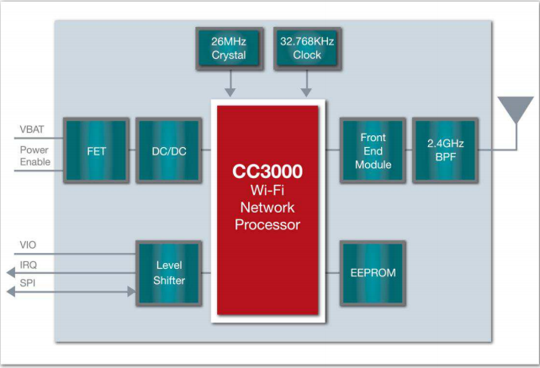
Figure 4.5.1.a. Wi-Fi Solution for TI Simple Link CC3000 Module, reprinted with permission from TI
The circuit schematic design can be viewed on the CC3000 module’s datasheet, where every pin is mapped as well as the input and output pins that connect this module to the host MCU. We are able to draw TI’s schematic and then convert it to a PCB layout in order to print it. In addition to the schematic, TI has a design recommendations section where they describe the layout for the CC3000 module, the RF trace, and the antenna that will be used. The most notable recommendation was the implementation of the antenna, as TI recommends having the antenna on either a separate board, or cut the board to allow the antenna some room to avoid interference from RF lines and signals. TI has implemented the CC3000 design into several modules that are commercially available such as the Wi-Fi SMD Module, the Wi-Fi Shield, and the Wi-Fi Breakout. All of the previously mentioned modules can be directly purchased and implemented into our design.
The second Wi-Fi module that we will be discussing is Espressif Systems’ ESP8266. According to them, the ESP8266 is “Espressif Systems’ Smart Connectivity Platform (ESCP) of high performance wireless SOCs, for mobile platform designers, provides unsurpassed ability to embed Wi-Fi capabilities within other systems, at the lowest cost with the greatest functionality. The ESP8266 offers a complete and self-contained Wi-Fi networking solution, allowing it to either host the application or to offload all Wi-Fi networking functions from another processor. When ESP8266 hosts the application, and when it is the only application processor in the device, it is able to boot up directly from an external flash. It has integrated cache to improve the performance of the system in such applications and to minimize the memory requirements.” (Espressif Smart Connectrivity Platform: ESP8266, 2013) Needless to say, the specifications on the ESP8266 are very much suitable for our design specifications and as such may be implemented into our design. Furthermore, the ESP8266 has been redesigned into a newer and updated version called ESP8266 Module (WRL - 13678).
This newer design is also a “self-contained SOC with integrated TCP/IP protocol stack that can give any microcontroller access to a Wi-Fi network. It is also capable of either hosting an application or offloading all Wi-Fi networking functions from another application processor. Each ESP8266 module comes pre-programmed with an AT command set firmware, which allows the user to directly connect it to an Arduino device, or similar MCUs, and get about as much Wi-Fi ability as a Wi-Fi Shield offers. This module has a powerful enough on-board processing and storage capability that allows it to be integrated with the sensors and other application specific devices through its GPIOs with minimal development up-front and minimal loading during runtime. Its high degree of on-chip integration allows for minimal external circuitry, including the front-end module, is designed to occupy minimal PCB area.” (Wi-Fi Module - ESP8266) This specific design would be a better option than its preceding version as it can be bought and directly attached to our MCU as well as use as little power as possible and is very cost effective.
The final Wi-Fi module we will be discussing is the XBEE Wi-Fi module with a wire antenna available from DIGI. The XBEE Wi-Fi “Embedded RF provides simple serial to IEEE 802.11 connectivity. By bridging the low-power/low-cost requirements of wireless device networking with the proven infrastructure of 802.11, the XBEE Wi-Fi creates new wireless opportunities for energy management, process and factory automation, wireless sensor networks, intelligent asset management as well as other features. This module gives developers the fastest IP-to-device and device-to-cloud capability possible. Focused on the rigorous requirements of these wireless device networks, the module gives developers IP-to-device and device-to-cloud capability” (XBee Wi-Fi) Needless to say, all three modules prove to be useful if we decide to embed any of them into our own design. To discuss this further, we have created a table and all their summarized specifications can be viewed in figure 4.5.1.b. below:
Wi-Fi Module | Transmit Current | Receive Current | Supply Voltage | Frequency Band
CC3000 | 260 mA | 92 mA | 3.6 V-DC | 2.4 GHz
ESP8266 | 215 mA | 60 mA | 3.6 V-DC | 2.4 GHz
XBee | 309 mA | 100 mA | 3.46 V-DC | 2.4 GHz
Figure 4.5.1.b. Summary of the three Wi-Fi Modules’ Specifications
From the specifications summary table in figure 4.5.1.b. we can see that for our project’s design the best module would be the ESP82166 as it used the least amount of current to send and receive packets in the form of Analog and Digital signals. In addition to that, all the different Wi-Fi modules use the same 2.4 GHz frequency band and since the ESP8266 draws the least amount of current, it will consume less power and essentially allow our power supply to last longer. It is worth noting the Texas Instrument’s CC3000 module is also a good fit regardless of its power consumption, and would be ideally a more suitable option if we decide to go with a Texas Instruments microprocessor.

4.5.2. Bluetooth
Now that we have discussed the possible modules for integrating a Wi-Fi module into our design, we will now discuss the possible Bluetooth modules available today. The first module to debate is Roving Networks RN-42 Bluetooth module which is also known as the Bluetooth Mate Silver. “The RN42 is a small form factor, low power and very economic Bluetooth radio for OEM’s adding wireless capability to their products. The RN-42 supports multiple interface protocols as well as is simple to design and is fully certified, allowing it to be a complete embedded Bluetooth solution that can be integrated into a design that requires wireless communication. With its high performance on chip antenna and support for Bluetooth Enhanced Data Rate (EDR), the RN-42 delivers up to 3 Mbps data rate for distances to 20m. The RN-42 is also available without an antenna in a module called RN-42-N. Useful when the application requires an external antenna, the RN-42-N is shorter in length and has RF pads to route the antenna signal. One of the notable features of the RN-42 is that it is functionally compatible with RN-41 which will be discussed later on in this section.” (RN-42, 2011)
“The RN-42 is ideal for short range and ideal for applications that use a battery for input voltage. The RN-42 uses only 26uA in sleep mode while still being discoverable and connectable. Multiple user configurable power modes allow the user to dial in the lowest power profile for a given application. There is an upgraded module called Bluetooth Mate Gold if a longer range is required. The Bluetooth Mate has on-board voltage regulators, so it can be powered from any 3.3 to 6VDC power supply. The RN-42’s physical dimensions are just 1.75 by 0.65 inches, and it only consumes 25mA on average.” (Bluetooth Mate Silver)
Since we have talked about the RN-42, it is only logical to move on and discuss the benefits of using the RN-41. “The RN-41 module is a small form factor, consumes low power, class 1 Bluetooth radio that is ideal for designers who want to implement wireless capability into their design without spending significant time and money developing Bluetooth-specific hardware and software. The RN-41 supports multiple interface protocols, is simple to design in, and is fully certified, making it a complete embedded Bluetooth solution. With its high-performance, on-chip antenna and support for Bluetooth EDR, the RN-41 delivers up to a 3-Mbps data rate for distances up to 100 meters. Just like the previously mentioned module, the RN-41 is also available without an antenna in a module called RN-41-N. Its physical size is only 13.4 by 25.8 mm and requires a minimum of 3.3V to a maximum of 3.6V.” (RN-41 Class 1 Bluetooth Module)
“In addition to that, the RN-42 module from Roving Networks is a powerful, small, and very easy to use Bluetooth module. The RN-42 is designed to replace serial cables. The Bluetooth stack is completely encapsulated. The designer basically visually sees serial characters being transmitted back and forth. For example, pressing a character from a terminal program on a personal computer and that same character will be pushed out the TX (transmit) pin of the RN-41 Bluetooth module.” (Bluetooth SMD Module - RN-41)
Now that we have discussed Roving Networks both RN-41 and RN-42, we will talk about using TI’s SABLE-x 2.4 GHz Bluetooth Low Energy (BLE) Module. “SABLE-x is a certified Bluetooth Smart module built to deliver unmatched and unrivaled RF as well as power performance. This module can deliver over twice the signal range of previous generation Bluetooth low energy technology, and can operate at nearly 1/3 the average power for a 1 second connection interval when compared to previous Bluetooth low energy modules. Based on the new TI Simple Link Bluetooth Smart CC2640 wireless microcontroller (MCU), this self-contained module provides unmatched integration, including an ARM Cortex-M3 application processor, ARM Cortex-M0 processor for the RF core, Sensor Processor Engine, FLASH memory, and high- and low-speed clocks. Serial-to-BLE for the SABLE-x was created by developers, for developers. This free PC-based application features tools and resources to accelerate your development efforts with the SABLE-x module, highlighted by a simple, comprehensive API command set to enable serial-to-BLE communications from a host MCU through the SABLE-x module. Its benefits and features include:
- Latest silicon technology delivers 7 dB link margin improvement vs. current Bluetooth low energy modules
- Features ARM Cortex-M3 processor for host applications and an ARM Cortex-M0 dedicated for the RF core
- Dedicated Sensor Processor for even lower power operation
- Integrated FLASH memory, Bluetooth low energy stack, and high- and low-speed clocks
- FCC (USA), IC (Canada), ETSI (Europe), GITEKI (Japan), RCM (AU/NZ) Module Certification
- Multiple certified antenna options Trace, Dipole, FLEXPIFA, and FLEXNOTCH LSR offers in-house certification of additional antennas at little or no cost
Furthermore, its applications could include sensors, lighting, security, home automations, sports, and fitness. In addition to that, its actual size is about 11 mm by 18 mm.” (SaBLE-x) Needless to say, this Bluetooth module has everything a developer would need to implement wireless communication into their own design. To summarize this section, we have devised the main components we will be looking at with regards to power, range, and current as can be viewed in figure 4.5.2.a. below:
Bluetooth Module | Current | Voltage | Range
RN-42 | 25mA | 3.3 - 6 V | 55m
RN-41 | 25mA | 3.3 - 3.6 V | 100m
SABLE - x | <10uA | 1.8 - 3.8 V | 10m
Figure 4.5.2.a. Summary of Power Consumptions and Range of Bluetooth Modules

The reason we are only looking at basic power consumption, current distribution, and range is because we do not need to use most of the features on some of these modules, such as the ARM Cortex-M3 application processor in the SABLE-x.

4.5.3. Chosen Wireless Communication Module and Schematic
Now that we have discussed all the different wireless communication modules of both Wi-Fi and Bluetooth that we may use, we will now talk about the design schematic of two particular modules; a Wi-Fi one and a Bluetooth one.
The first module we will implement into our project would be the Bluetooth module. As discussed in the previous section, the module we prefer to use would be the SABLE-x Bluetooth module as it integrates smoothly with our chosen MCU as well as have all the features we are looking for. Some of the features include power consumption, current usage, range, physical size, and if it complies with the standards set as of today. The SABLE-x Bluetooth module has a very complex design schematic. In fact, the whole design can be viewed in its datasheet, and one would need to use their zoom in feature and zoom in over 300% in order to be able to narrowly read the input and output pins as well as the electronics used to design the LSR’s SABLE-x Bluetooth Module. Since the figure will be miniscule and will be hard to read and understand, we will not be using it, and as such we will use its substitute figure schematic which maps out the basic output and input pins as well as the number of buses they are comprised of and can be viewed in figure 4.5.3.a. below:
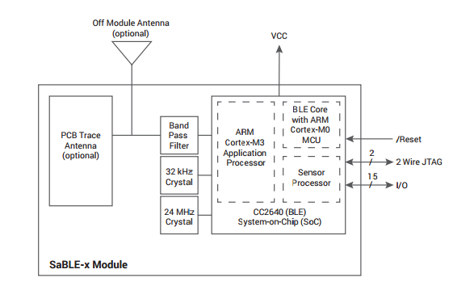
Figure 4.5.3.a. Substitute SABLE-x Basic Schematic of Input and Output pin, reprinted with permission from TI
The next module to discuss is Texas Instrument’s CC3000 Wi-Fi module through LSR whose schematic can be viewed in figure 4.5.3.b. below:
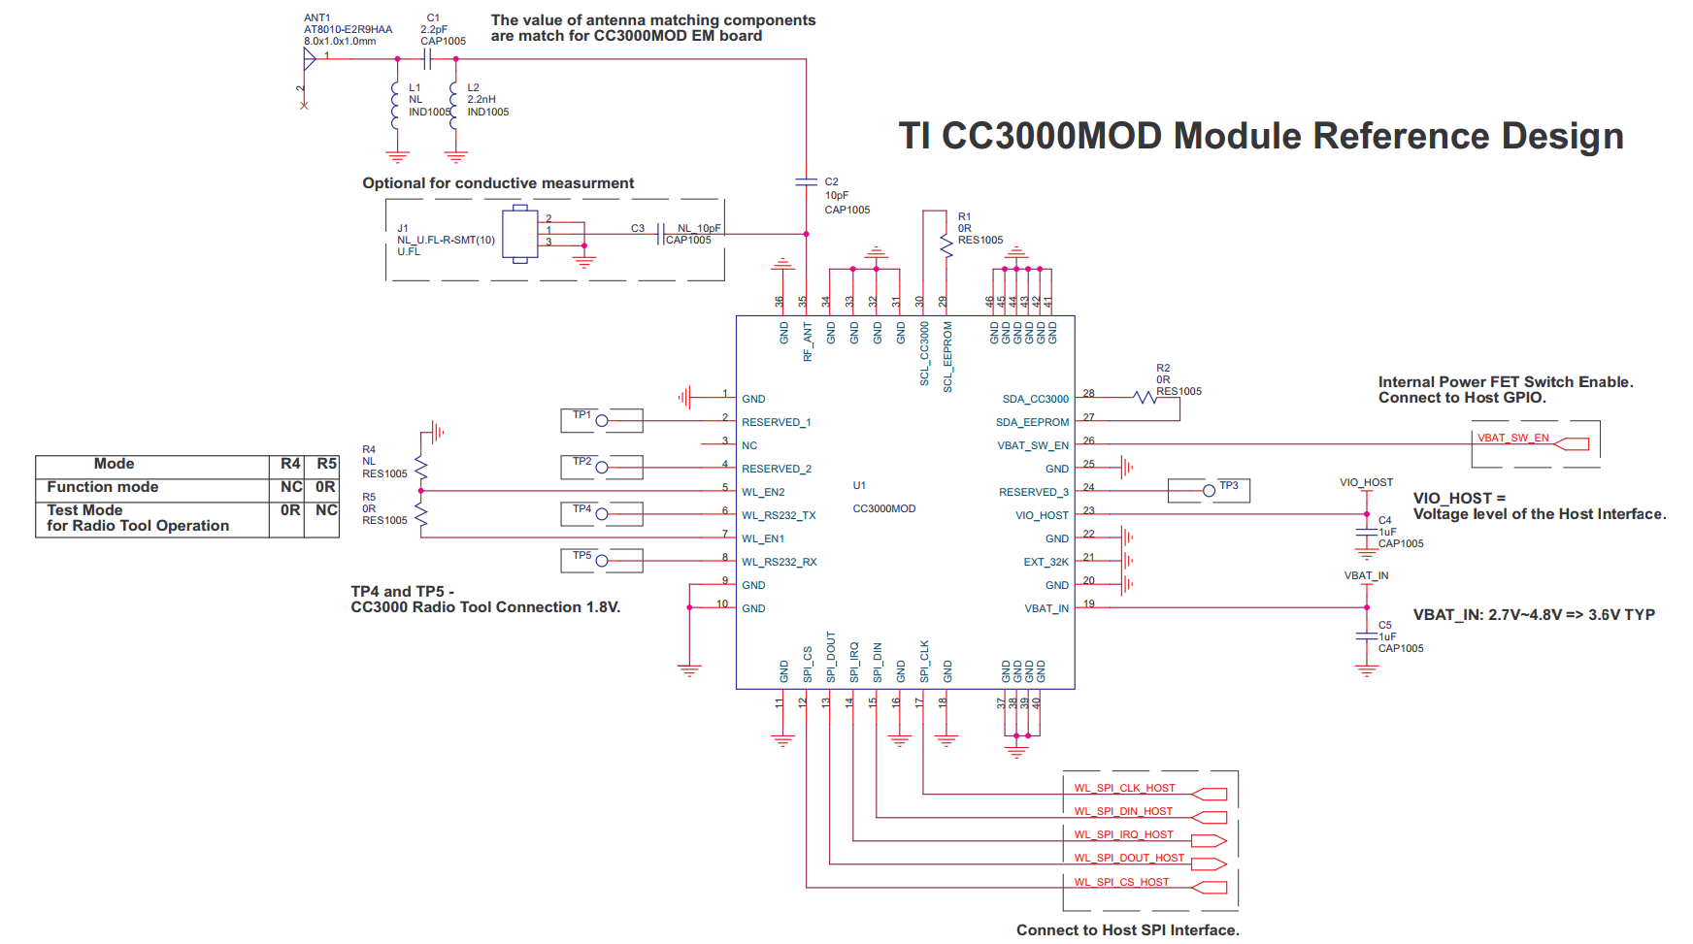
Figure 4.5.3.b. TI’s CC3000 Wi-Fi Module Schematic, reprinted with permission by TI
The same reasons can be applied to choosing the Wi-Fi module. In fact, another reason for choosing Texas Instruments CC3000 wireless communications design is because we would be using Texas Instruments’ microcontroller, Bluetooth Module, and now Wi-Fi module. The only reason for completely implementing Texas Instruments design only is the seamless compatibility between all the electronics combined. As mentioned in the previous section, this design is unified, and having multiple electronic layers that are compatible would decrease the number of errors and the possibility of complications.

4.6. Microcontroller
In order to run the touchscreen and the servomotors for the arm we need a microcontroller with enough pins, memory and that is accurate enough to allow for the most accurate of servo motor control we can allow. All of this needs to be done while maintaining a low overall power usage as to enable as long of a battery as possible for the arm. In addition the microcontroller should preferably be able to handle a high enough of a voltage to run the touchscreen and servomotors with minimal external components on the board. In addition to those requirements the microcontroller needs to be easily programmable while on board.
Another main requirement for the microcontroller is a low cost. One of the main concerns for the arm as a whole is the cost to produce which needs to be as low as possible while maintaining a high overall production quality. Preferably the microcontroller we pick should provide a balance of all of our needs without having too many unnecessary components.

4.6.1. Requirements
In order for the Microcontroller to meet the requirements of our design it should meet the following specifications. These are not mandatory and microcontrollers that meet most of these are ok as well:
- Under 4 Volts required to operate
- At least 50 I/O pins
- Support for SPI format I/O
- Multiple low power modes
  - Need to be able to turn off all I/O except single interrupt enabled pin
- Able to handle 3V through a pin
- Support for USB input
- Needs to have an accurate internal clock
- Support for an external crystal
- Ability to enable and disable interrupts
- Support for 32bit instructions
- Inexpensive; under $15 preferably.
Our requirements for our microcontroller were chosen based on a number of factors. These factors are, the arm’s requirements, and the requirements for our other chosen components. The requirements for the arm played a major role in choosing the requirements for our microcontroller. Our arm needs to have a long battery life and needs to be light weight which requires that the power usage by our microcontroller needs to be as low as possible. This enables us not only to increase the arm’s battery life but also allows us to use a smaller battery which also decreases the weight of the arm. In addition to the low power usage the arm also needs to be inexpensive so our microcontroller needs to be inexpensive which is why we set a price cap of $15 for the chip. This price cap allows us to have a wide selection of chips while still being at a low enough cost to keep the arm inexpensive. In addition to low cost and low power usage the arm will also require that our microcontroller is able to go into a low power or “sleep” mode to save even more power and provide even more user options.
In addition to the requirements of the arm itself the microcontroller’s requirements were greatly impacted by the external components we are going to be running with it. These components include a touch screen display, servo motors, and an array of sensors that will all be hooked up to the board. So just to be able to even hook up all of these items the microcontroller will need to have plenty of I/O pins for us to use. So we set the requirement at 50 pins, so that we not only have enough pins for everything currently designed into the board but that we can also add additional I/O options at a later time without changing our microcontroller. In addition to the 50 pin requirements our external components also require us to be able to use multiple I/O formats. Two of these formats are JTAG and SPI. JTAG is a requirement to be able to program many microcontrollers and allows us to be able to debug the controller easier. SPI format is used by the touchscreen controller and thus must be available for our microcontroller. In addition to required I/O formats our controller must also be able to power some of the external components, these are the sensors and the touchscreen. The servo motors will be powered individually but controlled by the controller. In order to do this the individual pins of the microcontroller are going to be required by us to have be able to handle 3v through the pin, the current will be controlled on the board and is not as big of a concern.
Also in order to run all of our external components accurately and correctly at all times we need to have accurate clocks available for the microcontroller. In order to get the accuracy we will need from the clocks, we have two requirements for the controller. Firstly the internal clocks and DCO need to be accurate throughout their entire operating range, this will allow us to have a good reference for the rest of our components and for our next requirement. Our microcontroller must have support for external crystals, preferably both high and low frequency ones. The use of external crystal clocks will enable us to ensure accurate clock rates throughout all of our components ensuring that they can be kept in sync with each other which is of upmost importance for the successful operation of the arm.
The rest of the requirements that we set for the microcontroller are based on our programming needs. These requirements include the ability to use 30bit instructions and the capability to control all aspects of interrupts such as enabling and disabling them for specific items. We need 30bit instructions as this allows us to make extensive use of immediate type instructions which will help us save memory with the program. In addition 30 bit instructions also allow us to use some instruction types without having to break it into 2 instructions saving even more memory. In addition to being able to use 30bit instructions, our microcontroller must allow us to use all of the interrupt capabilities we will need. These include the ability to turn them on and off and control the priority they have in the program. This requirement is very important for the programming we are going to be doing for the microcontroller. This is because we will need interrupt controls in order to ensure that all commands are done on time and in the correct order even if multiple are given at the same time. Without this ability there are many problems that can arise from operation of the arm, such as forgetting where the arm is or possibly not noticing that a component is not responding or throwing an error code.
In addition to all of these requirements there are also several other factors that we are considering for our microcontroller. These include, ease of use, previous experience, and outside knowledge and tools available for them. The first of these that we are looking at is ease of use. This is important to us because we need to be able to understand what we are working with and how we are going to work with it. This also applies to things such as what programming language it can be programmed with. For instance we would much prefer if we could program the microcontroller in C over assembly. Or we would like to be able to program through a serial connection instead of a more complex format that requires additional outside components which would increase the overall cost of the arm. Another important factor we are looking at for the microcontroller is our previous experiences with it. Playing a role very similar to the ease of use of the microcontroller our experiences with it from past projects will help a ton in our understanding of how it works and how to program it. Both of these factors would result in a both a better more efficient program for the arm and a reduction in time spent building the arm; both of which are very important to the overall goal of this project.

4.6.2. MSP430
One of the first microcontrollers we looked at for the project was the MSP430. The MSP430, made by Texas Instruments, was looked at due to our previous experiences with the controller. The MSP430 being one of TI’s low power microcontroller line is both small, inexpensive, and easy to work with. The following are a list of pros and cons in relation to the requirements we set for our microcontroller.
Pros:
- Inexpensive at under $5 for a majority of packages.
- Multiple Low Power Modes, Can lower power till the chip can only be woken up from an external source.
- Simple to program, through TI’s Code Composer Studio
- Support for SPI format I/O
- Vcc between 1.8 and 3.6 volts.
- Also Supports UART and DMA
- Already have experience with it
- Extensive Sources for programming and data online
Cons:
- Inaccurate clocks
- MSP432 is newer and very similar
- Low power modes are hard to use
- 16 bit chip
The MSP430 series of microcontrollers provide both a reasonable platform to build our arm on while also being relatively easy to use. For our requirements it meets almost all of them. Being a microcontroller series designed for low power applications it naturally has low power requirements and can be run at extremely low voltages and currents. This allows us to get the most battery life possible out of the arm no matter what we are running on the microcontroller. Not only does the MSP430 use low power but it still provides all of the power that we need in order run our external peripherals those being, our sensors, our touchscreen, and our servo motors all of which are low power models as well. When it comes to I/O options the MSP430 does not disappoint either. With options for SPI, DMA, UART, and serial connections in addition to regular I/O pins we can easy hook up all of our needed devices to the chip without any issues. In addition to not only having a large variety of I/O options the microcontroller series has more than enough pins for our needs.
In addition to the technical requirements the MSP430 series of chips also meets several of our non-critical requirements. Coming in at around $5 for a chip it is well within our cost range and is low enough of cost that buying multiple chips will not be an issue. Not only is it low cost but the MSP430 is a chip we have experience with and it has a plethora of resources for both coding and hardware. Us having experience with the microcontroller allows us to bypass most of the issues we would have when learning how to program and use a brand new microcontroller. This could also help us reduce costs and time spent by reducing the time spent prototyping and writing the program that will run the arm. In addition to the experience we have with the MSP430 we also have a large quantity of outside experience available to us from libraries, and other documents available for the MSP430. These documents will help tremendously with the design and building of our program and arm as they provide a place for us to find specific answers and solutions that we might have had to spend many hours attempting to find or solve on our own.
Unfortunately the MSP430 is not without problems. Firstly there are important parts of the microcontroller that are not easy to use, and those are the low power modes. With a wide variety of them it at first seems that the low power modes available make things better, but in the end all they do is add complexity to the overall program and process that is unnecessary and be bypassed with other options. In addition to the low power options the MSP430 also has issues with the clock signals being inaccurate. Though this is not a critical issues the inaccuracies can potentially cause major issues when running the arm in the long run. This would possibly create major issues and bugs that we are trying to avoid as completely as possible. One of the other issues, though not one with the MSP430 itself, is what else is available. The MSP432 is a new low power microcontroller also by Texas Instruments and it is essentially a better MSP430.
Overall the MSP430 series of microcontrollers are solid choice but they are not without their flaws. Meeting all of our critical requirements and most of our non-critical ones it is more than capable of being used for the arm. But its issues can become an issues in the long if we choose to go with it. With somewhat inaccurate clocks, hard to use low power modes, and a very similar microcontroller the MSP432 out on the market. Overall the MSP430 series is a good inexpensive choice that we are considering for the arm.

4.6.3. MSP432
Another of the first microcontrollers we looked at was the MSP432. We looked at this one due to its similarities to the MSP430.
Pros:
- Inexpensive at around $7 a chip
- Multiple low power modes
- Low power modes are easy to use
- Supports UART, DMA, and SPI
- Vcc between 1.65 and 3.7 volts
- Have experience with a similar microcontroller.
- Large amount of pins available
- Highly accurate clocks
- 32 bit chip
Cons:
- More expensive than the MSP430, which is not to different
- Newer model, not as much information available on it
- Not the easiest chip to use
- Only one package currently available
- Software is still in development and subject to change
The MSP432 series of microcontrollers are exceed our requirements in every way will still being inexpensive and easy to use. The MSP432 microcontroller is another of Texas Instruments’ low power microcontrollers that as with the MSP430 provides a large range of usage options and provides all of the tools needed for the arm. For power options the microcontroller has a wide voltage range, from 1.65-3.7 volts, and can run on input currents as low as 20nA, with a very wide standard operating range for the current. This not only allows us to reduce power usage for the arm, but it also allows us a large amount of control of how much we use.
Another power feature that allows us more control of power usage and reduces our power usage are the multiple low power modes available for the chip. With power modes going as low as using 20nA, we are able to greatly reduce the power usage when the arm is in sleep mode without having to rely on an external power source to wake the chip up which will prove beneficial during the design of our board and arm overall.
In addition to the power option available for the MSP432 there are also many I/O options available for us to use. With the current package available, the MSP432P401R, having 100 pins of which over 90 are I/O pins there are more than enough for what we are going to need and for all future developments that can go into the arm. Of the I/O pins 20 support high power, providing a convenient place to run our servo motors off of. In addition to the high power pins there are also other pins for all the input formats that we could need, including SPI, DMA, UART, JTAG, and serial connections. Combined together the MSP432 has all of the I/O options we will ever need for the arm.
In addition to the I/O features the MSP432 also has several other features which will be useful to the overall project as a whole. With multiple accurate built in clock options the microcontroller provides us with all the clocks we will need. In addition to the normal built in clocks there is also options to both a low and high frequency crystals providing potential for even more accuracy if needed. In addition to the crystals the MSP432 also has a built in real time clock that can be extremely useful for future development. But the real time clock is not the easiest to use, and requires the microcontroller to always be powered.
Even with all of these positives of the MSP432 the microcontroller does have some negative aspects. The first of these and most obvious is the cost. At around $8 a chip, which still is not expensive at all, it comes out more expensive than many other microprocessors out there. The cost, even though it is more than other microprocessors, is still not prohibitive but will come in to effect if we ever need to mass produce the arm. Outside of the cost of the microcontroller the rest of the issues with the MSP432 have to deal with our previous experience with it or lack thereof. As of this time none of us have worked with the MSP432, but we have worked with a very similar microcontroller in the MSP430. Due to our lack of experience with it there are potential issues that we may encounter while building and programing the arm. The main issue that happen is taking an increased amount of time with the programming and building of the board for the arm. This extra time spent programming and building the board will take away from time debugging and improving the arm overall. In addition due to our lack of experience there is potential to make critical mistakes that can be damaging to the microcontroller, so we will have to take extra precautions to avoid such mistakes. One of the other issues with the MSP432 is the lack of resources available to us due to it being relatively new. Though this is not a major issue and can easily be looked past it can still cause some issues when programing and using the microcontroller. Unlike the other controllers available to us there is hardly any information about programming it and there are very few libraries written for it that are readily available. The main issue here is that it will take us longer than we would like it to program the board and debugging can take a while as we have fewer other people’s experience to draw upon.
Overall the MSP432 is another very solid choice for our microcontroller. Providing a low power option that exceeds all of our requirements. With 100 pins available we will not run into any issues hooking up external devices to it and we will have more room to add stuff with minimal changes in the future. In addition the clocks and I/O formats available offer us many options with which to work. The MSP432 provides a great, expandable, and inexpensive platform from which to build the arm and will be considered highly.

4.6.4. ATMega 328p
Another one of the microcontrollers we looked at for our design was the ATMega328p. The ATMega328p, made by Atmel, was looked at due to our previous experiences with the controller. The ATMega328p being one of Atmel’s low power microcontroller line is both small, inexpensive, and easy to work with. The following are a list of pros and cons in relation to the requirements we set for our microcontroller.
Pros:
- Inexpensive at under $20 for a majority of packages.
- Simple to program, through Arduino’s IDE
- Support for SPI format I/O
- Vcc between 1.8 and 3.6 volts.
- Also Supports UART and DMA
- Already have experience with it
- Extensive Sources for programming and data online
Cons:
- Inaccurate clocks
- Low power modes are hard to use
- 8 bit chip
The ATMega328p series of microcontrollers provide both a reasonable platform to build our arm on while also being relatively easy to use. For our requirements it meets almost all of them. Being a microcontroller series designed for low power applications it naturally has low power requirements and can be run at extremely low voltages and currents. This allows us to get the most battery life possible out of the arm no matter what we are running on the microcontroller. Not only does the ATMega328p use low power but it still provides all of the power that we need in order run our external peripherals those being, our sensors, our touchscreen, and our servo motors all of which are low power models as well. When it comes to I/O options the ATMega328p does not disappoint either. With options for SPI, DMA, UART, and serial connections in addition to regular I/O pins we can easy hook up all of our needed devices to the chip without any issues. In addition to not only having a large variety of I/O options the microcontroller series has more than enough pins for our needs.
In addition to the technical requirements the ATMega328p series of chips also meets several of our non-critical requirements. Coming in at around $12 for a chip it is well within our cost range and is low enough of cost that buying multiple chips will not be an issue. Not only is it low cost but the ATMega328p is a chip we have experience with and it has a plethora of resources for both coding and hardware. Us having experience with the microcontroller allows us to bypass most of the issues we would have when learning how to program and use a brand new microcontroller. This could also help us reduce costs and time spent by reducing the time spent prototyping and writing the program that will run the arm. In addition to the experience we have with the ATMega328p we also have a large quantity of outside experience available to us from libraries, and other documents available for the ATMega328p. These documents will help tremendously with the design and building of our program and arm as they provide a place for us to find specific answers and solutions that we might have had to spend many hours attempting to find or solve on our own.
Unfortunately the ATMega328p is not without problems. Firstly there are important parts of the microcontroller that are not easy to use, and those are the low power modes. With a wide variety of them it at first seems that the low power modes available make things better, but in the end all they do is add complexity to the overall program and process that is unnecessary and be bypassed with other options. In addition to the low power options the ATMega328p also has issues with the clock signals being inaccurate. Though this is not a critical issues the inaccuracies can potentially cause major issues when running the arm in the long run. This would possibly create major issues and bugs that we are trying to avoid as completely as possible. One of the other issues, though not one with the ATMega328p itself, is what else is available. The ATMega328p is a new low power microcontroller also by Texas Instruments and it is essentially a better ATMega328p.
Overall the ATMega328p series of microcontrollers are solid choice but they are not without their flaws. Meeting all of our critical requirements and most of our non-critical ones it is more than capable of being used for the arm. But its issues can become an issues in the long if we choose to go with it. With somewhat inaccurate clocks, hard to use low power modes, and a very similar microcontroller the ATMega328p out on the market. Overall the ATMega328p series is a good inexpensive choice that we are considering for the arm.

4.6.5. Chosen Microcontroller
After considering multiple microcontrollers we have made the decision that we are going to use the MSP432 to build our arm around. More exactly we are going to use the MSP432P401R due to it being the only one currently available for purchase at the time this project is being done. The only other microcontroller that was considered with much interest for the arm was the MSP430 series also from Texas Instruments. The MSP430 while offering everything we are looking for in a microcontroller came out slightly behind due to a number of issues that the MSP432 just did not have. Firstly the MSP430 while it has many of the same clock choices as the MSP432, and they both have more than enough for the arm, they are just not as accurate as those on the MSP432. This is an issue that can cause series problems further down the road in development and one that we can do very little about other than to limit the needed clock accuracy of what we develop. This is not something we wish to do. In addition to the inaccurate clocks it is much more difficult and confusing to use the low power modes with the MSP430 than it is with the MSP432. Even though the MSP430 has more low power modes available than the MSP432 they are not all needed for the arm so the extra difficulties caused by using them are simply a hindrance to development that we would like to avoid. Another issue that we found with the MSP430 that was not in the MSP432 was the difficulty in using 32bit instructions in our programming. Not all MSP430 packages support 32bit instructions and those that do only have limited use of them. As we intend to use everything possible to save memory and also to use plenty of immediate type instructions the lack of 32bit instructions being readily available for use is a detrimental to our overall design goals and thus is something we wish to avoid if possible. The MSP432 on the other hand is a fully 32bit microcontroller so this is not a problem. There are still some areas that the MSP430 series beats the MSP432. These areas are in cost, experience, and developmental resources available to us. Cost wise the MSP430 is about $2-$3 cheaper than the MSP432 which is slight issue if the arm were ever to be mass produced. But in the end the difference in cost between the two microcontrollers is such a small difference that it is truly of no concern to the development of the arm. The big draw back to us using the MSP432 over the MSP430, does not come in the cost but in our experience with it. Simply put we all have experience with the MSP430 series of microcontrollers and will therefore be more able to develop the board and the software around it. This will increase the development time of the arm and can possibly result in more bugs being in the final arm. But we have chosen as a group to overlook this draw back as we believe we are capable of working through any issues encountered due to lack of experience. One of the things we considered on making this decision is that while the MSP430 and the MSP432 are different microcontrollers they are similar enough where we believe that we will be able to apply much of our knowledge of the MSP430 to the MSP432 during development.
The only other draw back out our decision to use the MSP432 over the MSP430 is the lack of as many developmental resources, such as libraries and other documents, available for the MSP432. This can become an issue when attempting to debug problems and when designing the program and board for the arm. With the MSP430 there is enough online documents and libraries that if a strange problem occurs we can simply look up a solution if we cannot figure one out ourselves in a reasonable amount of time. With the MSP32 this is simply not the case. Due to the relative newness of the microcontroller it is difficult to find too many helpful documents and code libraries online with which to use. We have decided to look past this due to the amount of future development space that the MSP432 provides us and because we are not convinced this will prove to be a major issue in the long run. Over all the MSP432 will provide us with a very good microcontroller with which to build our arm around. It has all of the features we need and more, providing plenty of future developmental space for us. We are sure that the choice to use the MSP432 will prove to be a good one in the long run and that the arm as a whole will turn out better for it.

4.7. Sensors
The sensors in our robotic arm provide all outside interaction with the arm. Without the sensors we would not be able to control the robotic arm the way we would like. We’ll discuss two major sensor for the arm; EMG sensor and proximity sensor. The primary sensor that will accept all outside inputs is the EMG sensor. More information will be provided later in the document, but a brief introduction will be included in this section. An EMG (electromyography) sensor provides an analog signal which must be converted to a DC signal so our microprocessor can process the signal and translate it to our servo movement. Figures 4.7a and 4.7b display how our EMG sensors will be attached to the arm and the circuit board that the sensors will connect to.

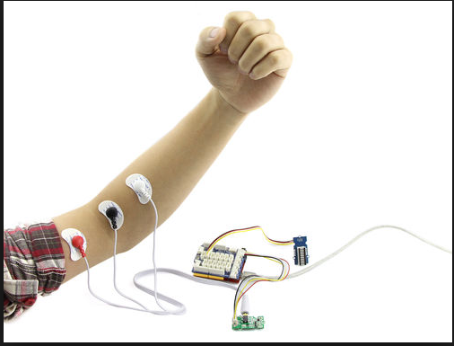
Figure 4.7.a. shows how the EMG sensors are connected to the arm

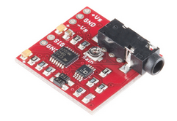
Figure 4.7.b. shows the EMG sensor board
Once the board is powered by 3-5V, the board outputs a voltage on a specific pin that we can transmit to the MSP432 to control our servos and how they respond. The board outputs a raw EMG signal, but more importantly the board will output a rectified and amplified signal for better analog-digital conversion once transmitted to the MSP432. Potentially (time permitting) a proximity sensor can be implemented. The sensor would be placed in the middle of the hand and when an object becomes close to the hand, the hands close, grabbing the item. Due to the EMG sensor as well as the touchscreen to control functionality the sensor may not be necessary but an added feature.
This board has an IR emitting LED and an IR sensitive phototransistor. Depending on the amount of light that reflects back to the phototransistor the output value will change accordingly. This could be incorporated simply into the MSP432. For example, say we want our arm to close at an approximate reading of around 2V. Until the MSP432 receives the reading of 2V the arm will remain stationary awaiting all other inputs from other devices. As soon as it receives the 2V however, it will close the hand until the value does not read 2V any longer, where it will resume its normal operation.

4.7.1. Analog Signals
Like stated above, the EMG circuit outputs an analog signal. Once we set the I/O pins to input, we can take our signal from the EMG circuit and input it into the MSP432 microprocessor for processing and then to further control our robotic arm. In Figure 4.7.1a below, we see how the EMG sensor and board will convert the signal. We first receive the raw EMG signal. The board then uses a diode or other rectifying device to rectify the signal and receive a clearer signal. Finally, the signal is integrated to receive a clean output from the sensor. The rectified and integrated EMG signal will be flowed to the MSP432 for further processing.

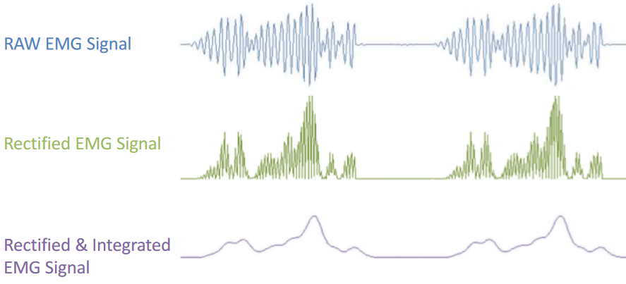
Figure 4.7.1.a. Output of EMG circuit
An important question here is why stick with an analog device and not a digital one. The simplest answer is functionality and cost. When a user moves their muscle, by nature, it’s an analog signal meaning that it varies with time. Any circuit that outputs a digital circuit is simply doing the analog to digital conversion onboard the circuit. It’s also expensive to find one that does the conversion onboard and beacause the MSP432 does this already we’ll simply purchase a cheaper EMG sensor and do the conversion on the MSP432. The input for the proximity sensor is similar in that it’s just an analog signal that’s received. One of the biggest differences here is that the proximity sensor board does not rectify or integrate the signal making it a potentially messy signal. We can rectify the signal ourselves, however it would need to be seen if this is necessary. Not only would it incur additional cost but add additional complexity. Figure 4.7.1.b shows the output of the sensor on an oscilloscope. As soon as the object became closer to the sensor, the output peaked. Once this is converted digitally to a specific value the input/output relationship becomes basic programming.
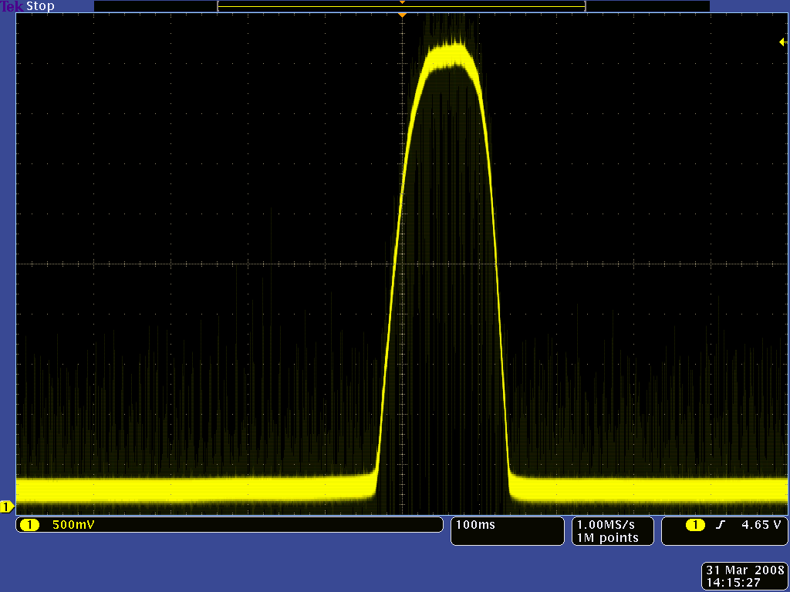
Figure 4.7.1.b. Oscilloscope Output of Sensor

4.7.1.1. Input/ output
Although there’s been discussion of the signal that’s received from the EMG circuit and proximity sensor, the processing of the signal is critical in the overall design. Here, the MSP432 input/output will be discussed and how the overall MSP432 and EMG sensor will relate.

The MSP432 family of devices has at most 11 digital I/O pins that can be used. Once we have our signal from the EMG signal the first order of business is analog to digital conversion. This is done on board with the MSP432. To perform the A/D conversion there are a couple steps we must compute in the MSP430. The steps are outlined below.

- The analog input pins are defined first.
- We must select a clock source for the conversion operation.
- We define a conversion mode.
- We define a reference voltage so that the microcontroller has a baseline to do the conversion. The MSP430 defines this as V_{REF}.
- The sample and hold time are defined so we know how long the microcontroller will sample the signal for. In our situation, it will sample for however long the pin receives the signal. When the muscle moves, the controller will begin to sample the signal and begin to convert to a digital signal.
- We switch on the ADC functionality and take the exact reading.

Through this process we’re able to take our analog signal from the EMG circuit and convert it so that we have a precise digitals signal to then control our servo motors discussed earlier.

The output value is stored in a register value that can be pulled using C code. With the MSP432, the output is stored in the ADC10MEM register. The most recent digital value is stored here. When the digital value reaches a certain value, we can move a given servo. For example, say the threshold for muscle movement is set to 5V. If the MSP432 receives a value of 5V in the ADC10MEM, we will move the servos to a specific position. Anything less that the 5V value, the servos will remain in their default position.

The proximity sensor details are nearly identical to the EMG sensor. We’ll receive an analog signal and program it accordingly. The proximity sensor again, is an added benefit that may be incorporated into the project if there is time permitting. It adds additional cost as well as added weight which can deter the project even further and potentially cause issues.

4.7.1.2. Circuits Needed
The EMG circuit will be purchased already together and as a kit. The package comes with one EMG sensor as well as the circuit that will do the processing of the received signal. Figure 4.7.1.2a shows the pad that connects to the electrode that will adhere to the skin of the user.
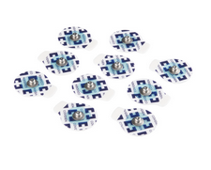
Figure 4.7.1.2.a. Sensor pads for EMG sensor
When the Eagle software is used, a simple 3-pin header will be used here similar to the way the servos are attached to the main circuit board. Because the EMG sensor goes directly on the location of the muscle, there is no need to place the circuit board on our main control board. Rather, the board goes on the arm itself. Figure 4.7.1.2b shows how the circuit board can attach directly onto the arm.
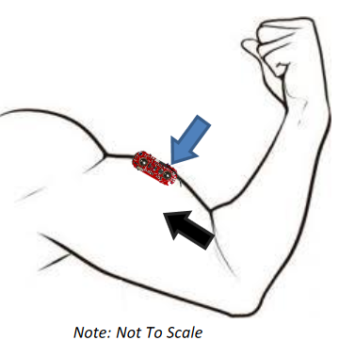
Figure 4.7.1.2.b. Location of the circuit board on the muscle
The EMG board, like the servos, has 3 pins. One is for the output signal provided by the sensors attached to the arm and the other two are for a positive and grounded voltage. The circuit is powered off of 2.9-5.7V so a voltage regular will need to be used here from our main power supply battery.

4.8. Code and Software
In order to program the microcontroller that will program the arm we will be using a combination of multiple device libraries and the C language. In addition we will be using Code Composer Studio from Texas Instruments to write the code in. In addition to those options we are going to use JTAG to flash the program onto the microcontroller. The basics of how the program works and its design are described in section 3.2 current code. The following sections are a more in depth description of the actual program itself and its actual function.
We are going to be using the C language to write the program in and will be allowing the complier to change it into assembly to use on the MSP432P401R. There are several reasons for this decision to use C over MSP432 Assembly. The first and primary reason is the relative ease of use for C over assembly.
If we were writing the program in Assembly we would have to worry about individual registers and other issues. When dealing with individual registers there are many issues that can arise due to accidently reusing a register and thus erasing vital data for the current, or other ongoing, operation. In addition to having to use individual registers writing in assembly also causes the creation of things such as loops and individual functions to become a more difficult task.
This would increase the development time for the program by a noticeable amount of time. That extra time spent in developing the program could be used in other aspects of development of the arm. In addition to all of those issues assembly limits what all can be done in one line of code substantially. In C we can multiply 2 values and save them to a variable all in a single line of code. Where as in assembly (not all assembly, some does include pseudo-instructions for multiplication) that same multiplication function would take a loop of add instructions to make. This would increase the overall amount of code that we would need to write creating more room for errors and taking even more time away from other aspects of development.
Another reason we are going to use C is due to our extensive experience in using the language for programming. All of us at some point have written programs entirely in C. This experience will greatly aid us in the development of the program and in its debugging. For assembly our experience is much more limited. We have all worked some with assembly but we are still pretty inexperienced with it and are uncomfortable writing in it. This inexperience with assembly will further increase development time by preventing us from quickly writing and debugging the program.
In addition to there being several issues with using assembly for the program, there are also very little benefits for us to use assembly. With current compilers the final result of a program written in C or in assembly are practically the same which means that there is little benefit from writing the program in assembly over C.

4.8.1. Flowchart
The following flowcharts show the actual design of the program and how it functions with the actual arm.
General Program Flow: The flow chat in figure 4.8.1a shows a more in-depth look at the flow of the program that is shown in figure 3.2.1.a. After program startup the program enters into an infinite loop of checking and updating all of the I/O functions. The first one that is checked is the input from the touchscreen controller. While at this stage the program will wait until such time as an update from the controller is received.
When an update is received the program will then update the touchscreen and then update all other things that need updated. This could include things such as the servo motors, preset arm positions, the sensors, and other information such as date and time. After the update is performed the arm will go back to waiting for a new update from the touchscreen controller. While waiting for updates from the touchscreen controller the arm will also be checking for input from the sensors.
If input is received from the sensors the arm will then update the arm’s position to what is requested by the user via the touchscreen controller. After the arm’s position is updated it will then go back to waiting for further input. Both the touchscreens input and the sensors input are treated with the same priority but only one thing is updated at a time. If an update from the touchscreen controller is received to power down the arm or to put it into sleep mode then the program will break out of the loop and immediately perform the power down or put to sleep operation.
Figure 4.8.1.a. General program flow
Power Up sequence: figure 4.8.1.b. shows the power up sequence in more detail than what is shown in figure 3.2.1b. The first thing that happens during the power up sequence for the arm is an external power supply is applied to the microcontroller, the servo motors, the sensors, and the touchscreen. After the power is applied the program will start up and begin by initializing the touchscreen, the servo motors, and the sensors. Firstly the touchscreen is initialized via a set of commands as defined by the touchscreens drivers. After it is initialized the main menu for the touchscreen controller is created via a set of commands to the touchscreens driver. After the touchscreen is set up the servo motors are initialized through their drivers, and finally the sensors are initialized through their drivers. After everything is turned on and initialized the arm will move to its base position and then will be ready to use or to go into a sleep mode.

Figure 4.8.1.b. Power Up sequence For Arm
Instruction Handling: Figure 4.8.1c shows how commands being received from the touchscreen controller or sensors are handled by the program. When a command is received from either source it is handled as soon as it is received unless a previous command is still being executed. If a previous command is being done the new one is put into a queue and is then executed as soon as the previous one is done. Both sources of command are treated with the same priority by the microcontroller. When a command is received from either source it is first check to make sure it can be done, if it cannot be done it is dropped and the user is informed. After the command is checked as such the program will update the arm based on what type of command was used. After the update is made the command is performed. Once the command is complete the user is notified and then the program returns to the main loop.

Figure 4.8.1.c. Command Handling Process

Touchscreen Updating: Figure 4.8.1d shows how the program handles updating the touchscreen when it is needed. The first thing that is done is the need for an update is checked. Not all commands require updating the touchscreen. After checking, the program then goes and begins updating the touchscreen via a series of commands to its driver. Commands are separated by conformation from the touchscreen that they are valid and have been received. Once all of the commands are sent and confirmation is received for them the program will return to the main loop.

Figure 4.8.1.d. Touchscreen Updating Process

Servo Motor Updating: Figure 4.8.1e shows how the program updates the servo motors when a command is received. First the program checks to see if the position the command wants is what the arm is currently in. If it is the same position then nothing is done. Otherwise the program will continue with moving the servo motors. The first thing done is the distance needed to be moved by the servos is found. After that distance is known the program then tells the servo motors to move that distance and waits until they have. After they are moved the program updates the current position that they are in. Once the update is complete the program returns to the main loop.
Figure 4.8.1.e. Servo Motor Updating Procedure
Sensor Reading: Figure 4.8.1.f. shows how the program receives and confirms a signal from the sensors. Firstly when a signal is received that the sensor has been triggered the program creates a delay to check if the signal is valid or an extraneous signal. If it is extraneous signal the program returns to the main loop. If the signal is confirmed to be valid the program then checks if there is a sensor initiated update to be made. If there is the program will update the servo motors, if not it will notify the user and return to the main loop.
Power down/go to sleep Sequence: Figure 4.8.1g shows the power down sequence for the program and the arm as a whole. The first thing that happens is a command to power down or go to sleep is received. Once it is received the program begins the power down sequence. After the command is received the program disables further commands from coming in. After that it moves the arm into its base position. Once the arm is in its base position the servo motors are turned off.
Once the servo motors are turned off the sensors are turned off. After the sensors are off the touchscreen is shut down. If the command was to go to sleep the touchscreen is left powered with a single button to wake the arm back up. If the command was to power off completely then the power to the arm is turned off completely and the program ends.
Figure 4.8.1.f. Sensor reading procedure
Figure 4.8.1.g. Power Down/Go to Sleep Sequence
Waking up from sleep: Figure 4.8.1h shows the sequence for waking up the arm from sleep mode. The first thing that is happens when the command to wake up from the sleep mode is the servo motors are woken up. After they are woken up the arm is moved to its base position, which it should already be in. After the position is reset the sensors are woken back up. After the sensors are awake and responding, the touchscreen is returned to its starting menu and commands are enabled. Then the program returns to the main loop.
Figure 4.8.1.h. Procedure for Waking up from sleep

4.8.2. Functions Used
The following details the functions used in the program. While remaining the same functions as talked about in section 3.2.2 this section goes into more depth on how they work and less and to what they are designed to do. In addition there are several things assumed for all functions. Firstly the current state of the arm, the current time, and the touchscreen will be accessible from any point in the program and will be changeable from any spot. This is to reduce the amount of variable passing needed to be done with the program. In addition all commands are enabled and disabled from a single variable that can only be modified from a few functions but is readable from every function. Lastly there will be other function written in the program to handle small tasks, as these function are not critical to the overall design of the program they are not mentioned here.
PowerUp: The power up function has no input and cannot be called by the main loop. As the initial function that run when power is first applied to the arm it will first start by enabling power to the servo motors, the sensors, and the touchscreens, through a switch connected to the microcontroller. Once power is enabled, the function makes a series of function calls to initialize the other components of the arm, starting with the touchscreen. Once these calls are made this function will then make a call to reset the arms position and will then call the main loop. This function does not return any values.
InitializeTouchScreen: The initialize touchscreen function is called by the PowerUp function and performs the initial startup for the touchscreen. This function has no input parameters. When called the function will first establish a connection to the touchscreen. After the connection is established the function will send a series of signals to the touchscreen to begin initializing it. After conformation is received from the touchscreen that it has been initialized the function will then make a series of command to the touchscreen to set up the initial menu for the arm. After it is done it will return to the PowerUp function. This function will return a value to indicate if it was successful or not.
InitializeSensors: The initialize sensors function is called by the PowerUp function and performs the initial startup for the sensors. This function has no input parameters. When called will establish a connection to the sensors. After this connection is established the function will transmit a series of commands to initialize the sensors. After the sensors are initialized the function will transmit another series of commands to check if they are functioning. After this is done the function will return to the PowerUp function. This function returns a value to indicate if it was successful or not.
ResetArm: This function is called by both the PowerUp function and the PowerDown function. This function has no input parameters. When called this function will return the arm to its base position and return the touchscreen to its main menu. This is done through a series of function calls to the MoveArm function. This function will then return to the function that called it. This function has no return value.
MainLoop: The MainLoop function serves as the main driving function in the arm. This function is called from the PowerUp function and runs the rest of the time the arm is on. This function has no input parameters. When called the function will begin the loop of checking for user input. When input is received the function identifies where it was from and then calls the functions to handle the input. This function has no return value.
PutToSleep: The put to sleep function is called from the main loop and has no input parameters. When called the arm will turn off the ability for new commands to be accepted. After that ability is turned off, the function will disable the servo motors, and the sensors (both power and command capabilities). Once those are disabled the function will change the touchscreen to allow for only an option to wake the arm up. This function will then return to the main loop. This function does not return any value.
LockArm: This function is called from the main loop. It has no input parameters. When called this function will disable the sensors and the servo motors and prevent them from doing anything. This is done through a series of commands to them. After they are disabled the function will return to the main loop. This function has no return value. While the arm is locked the touchscreen will still have full function it just will not do anything if something is pushed.
PowerDown: The power down function is called by the main loop. This function has no input parameters. When called this function will begin powering down the arm. The first thig that is done is the ability to accept new commands is disabled. After that is disabled the arm will power down the servo motors and the sensors. After they are powered down the touchscreen is shut down through a series of commands and then has the power cut off. After all externals are cut off the main power to the arm is disabled turning off the microcontroller and the program. This function does not return to another and therefor has no return value.
MoveArm: The Move arm function is called from the main loop, and the reset arm functions. Its input parameter is the new position the arm is getting moved to. When called the first thing the function will do is check to see if the arm needs to be moved at all. After that is checked the function will then calculate how much each servo needs to be moved in order to reach the new position. Once this is calculated the function moves each servo into the new position and updates the arm current position. The function then returns to the calling function. It returns a value if that says if that the move was completed, the move was not needed, or the move failed.
CheckIO: The check I/O function is called from either the main loop, or the power up function, when another function returns a failure state. This function has no input parameters. When called the function will ping each of the I/O devices according to their drivers to check if they are still responding correctly. After they are all checked the function will return to the calling function. This function returns a value indicating if all the I/O devices are responding.
NewPreset: The new preset function is called from the main loop. It has no input parameters. When called the function will first change the touchscreen menu to a new menu for creating the preset. Then as the user inputs the new preset details the function will store them in memory to be accessed at a later time. Once the user is done inputting the new preset the function will return to the main loop. This function has no return value.
DeletePreset: The delete preset function is called from the main loop. It had no input parameters. When called it will update the touchscreen with the delete preset menu. Once the touchscreen is updated the function will wait for the user to input what preset is being deleted. Once the chosen preset is known the function will delete that preset from memory and free up the memory slot it used. Then the function will return to the main loop. It will return a value that indicates if the preset was deleted successfully or not.
ModifyPreset: The modify preset function is called from the main loop. It had no input parameters. When called it will modify the touchscreen to the ‘modify preset’ menu. The function will then wait for the user to identify which preset they wish to modify. After the preset to be modified is chosen the function will bring up the new preset menu, from the new preset function, but starting at the values currently used with the preset being modified. After the user has input the modifications desired the function then updates the preset in memory. The function will return to the main loop. The function will return a value to indicate If it was successful or not.
SetTime: The set time function is called from the main loop. It has no input parameters. When called the function will bring up a menu on the touchscreen that enables the user to input the correct time for them. Once the time had been inputted by the user the function will update the time stored in the arm. The function will then return to the main loop. The function will return a value to indicate if it was successful or not.

4.8.3. Libraries Used
In order to write the program to run the arm we are going to be using a series of prewritten libraries. These libraries all serve the function of helping to expedite and improve the overall programing process during development. In order to fulfill their purpose we are going to use libraries for the following tasks.
- Math: In order to drive the servo motors we are going to need to be able to effectively perform math operations with the microcontroller. This will also come in handy with controlling the touchscreen. To make the math programing easier we are going to need a library that contains a number of mathematical functions for us to use. A library that contains these function will save time by both having us not write basic mathematical functions that we need, and by preventing basic mistakes when writing these functions to help reduce debugging time.
- Touchscreen Controller: One of the major parts of the project is the touchscreen controller for the arm. Normally a touchscreen can be extremely hard to program for. This is because not only do you need to read the input from the touchscreen, and write to the touchscreen but you also need to be able to interpret the input and output from the touchscreen. Normally this is incredibly hard to do but there are ways around it. One of those ways is a touchscreen control library. This library would enable us to write and read from the touchscreen controller with a simple call of a prewritten function. This is a major improvement over having to write and debug functions that do this from scratch. This type of library will greatly reduce development time of the program.
- Servo Motor Controller: Another major part of the project that needs done is the control of the servo motors. In order to do this we need to be able to send commands to the servo motors with values found elsewhere in the program. In order for the servo motor to understand these commands we need to be able to send them correctly and this requires functions that can handle this. Instead of writing these functions by hand, which can be very difficult, a library that contains them will be of incredible use to us. This library would save time programing and would allow us to control the servo motors more effectively than if we had written the functions ourselves.
- Sensor Controller: Another major part of the project that needs run by the program is the sensors. In order to run them with the program we need to be able to correctly and accurately read the input. In order to do this we need to be able to distinguish between spurious and real input from the sensors, and determine if that input is the correct input for the arm to respond. In order to do this the functions used will be complicated and time consuming to debug. So instead of writing them ourselves we would use a library that contains them already. Of all the libraries this one is the most important for the project as it is the hardest to write on our own.
- General Use Libraries: Outside of specific libraries, used to aid in programing for specific parts of the arm, we are also going to want to use more general use libraries. These libraries are basic libraries that contain basic but commonly used functions for programming. These functions include things such as data structures and other basic instructions that we would be using multiple times throughout the program. These libraries, though not important to the completion of the project, would save time from general programing that can be used for developing and debugging other elements of the arm.
After identifying what libraries we need or want to aid us in the programming of the arm we then went and found as many as we can. The libraries we found and choose to use are those that are both easy to use, useful, and use lower memory than others. The following libraries are the ones we choose to use. Also explained is why we choose to use those libraries. Also included are choices other than libraries that we made, for instance buying a driver for something instead of programming the controls for it by hand.
- Math.h: For our math library we choose to just use the general one available for the C language Math.h. As we are writing the program to control the arm in C we are able to use the libraries available to C. We choose to use this library for multiple reasons. The main reason is the ease of use and readily availability of this library as it is included in most compilers. In addition to being easy to use this library also contains all of the math functions we will need for the mathematical calculations to run the arm. There are more expansive options out there but they are unneeded as our mathematical requirements are not extensive enough to warrant larger libraries being used.
- SmartGPU2 C Library: For our touchscreen library we are going to be using the SmartGPU2 C library. This library contains all of the functions that we will need to control and read from the touchscreen controller on the arm. In addition to containing all of the functions we will need for the touchscreen this library is also very easy to use. We choose this library over other libraries for touchscreens because this library is built for the touchscreen we are going to be using for the project. While other libraries will work and are able to perform all of the functions we need to do, this library is built for our specific touchscreen. By being written for our touchscreen this library will work better for it than any other library and will be easier to use.
- Servos.C: To control the servo motors we have chosen to use the Servos.C library. This library is a bare bones servo motor library designed to run servo motors. While it does not contain all of the functions we need to run the servo motors it contains enough for us to use. The functions the library is missing are mostly the calculations needed to move them but these are not too hard to write and can be found from other libraries if needed. Any other functions the library is missing are those that are not important for operation of the servos in relation to our arm. Over all this library while not being everything we wanted from it will still shorten our time spent programing and debugging the arm.
- Sensor Driver: Instead of using a library to control our sensors for the arm we have decided to use a driver to run them instead. The driver, on a separate board, will take care of all of the difficult functions of running the sensors for us. The driver will allow us to avoid writing control functions entirely for the sensors. By allowing us to do that we will save time on the programming that we will be able to spend of both developing and debugging other parts of the program.
- General Use Libraries: The general use libraries we are going to use are just the general libraries for C. We have chosen not to use any others as after consideration we have found that this type of library is not necessary for the completion of the project. This is because many of the functions that would be gained from this type of libraries are not going to be used for the programming at all. While it would save time that could be used elsewhere in the project we have decided that these libraries are not necessary.

4.8.4. Hardware
In order to write the program to run the arm we are going to be using a series of prewritten libraries. These libraries all serve the function of helping to expedite and improve the overall programing process during development. In order to fulfill their purpose we are going to use libraries for the following tasks.
- Math: In order to drive the servo motors we are going to need to be able to effectively perform math operations with the microcontroller. This will also come in handy with controlling the touchscreen. To make the math programing easier we are going to need a library that contains a number of mathematical functions for us to use. A library that contains these function will save time by both having us not write basic mathematical functions that we need, and by preventing basic mistakes when writing these functions to help reduce debugging time.
- Touchscreen Controller: One of the major parts of the project is the touchscreen controller for the arm. Normally a touchscreen can be extremely hard to program for. This is because not only do you need to read the input from the touchscreen, and write to the touchscreen but you also need to be able to interpret the input and output from the touchscreen. Normally this is incredibly hard to do but there are ways around it. One of those ways is a touchscreen control library. This library would enable us to write and read from the touchscreen controller with a simple call of a prewritten function. This is a major improvement over having to write and debug functions that do this from scratch. This type of library will greatly reduce development time of the program.
- Servo Motor Controller: Another major part of the project that needs done is the control of the servo motors. In order to do this we need to be able to send commands to the servo motors with values found elsewhere in the program. In order for the servo motor to understand these commands we need to be able to send them correctly and this requires functions that can handle this. Instead of writing these functions by hand, which can be very difficult, a library that contains them will be of incredible use to us. This library would save time programing and would allow us to control the servo motors more effectively than if we had written the functions ourselves.
- Sensor Controller: Another major part of the project that needs run by the program is the sensors. In order to run them with the program we need to be able to correctly and accurately read the input. In order to do this we need to be able to distinguish between spurious and real input from the sensors, and determine if that input is the correct input for the arm to respond. In order to do this the functions used will be complicated and time consuming to debug. So instead of writing them ourselves we would use a library that contains them already. Of all the libraries this one is the most important for the project as it is the hardest to write on our own.
- General Use Libraries: Outside of specific libraries, used to aid in programing for specific parts of the arm, we are also going to want to use more general use libraries. These libraries are basic libraries that contain basic but commonly used functions for programming. These functions include things such as data structures and other basic instructions that we would be using multiple times throughout the program. These libraries, though not important to the completion of the project, would save time from general programing that can be used for developing and debugging other elements of the arm.
After identifying what libraries we need or want to aid us in the programming of the arm we then went and found as many as we can. The libraries we found and choose to use are those that are both easy to use, useful, and use lower memory than others. The following libraries are the ones we choose to use. Also explained is why we choose to use those libraries. Also included are choices other than libraries that we made, for instance buying a driver for something instead of programming the controls for it by hand.
- Math.h: For our math library we choose to just use the general one available for the C language Math.h. As we are writing the program to control the arm in C we are able to use the libraries available to C. We choose to use this library for multiple reasons. The main reason is the ease of use and readily availability of this library as it is included in most compilers. In addition to being easy to use this library also contains all of the math functions we will need for the mathematical calculations to run the arm. There are more expansive options out there but they are unneeded as our mathematical requirements are not extensive enough to warrant larger libraries being used.
- SmartGPU2 C Library: For our touchscreen library we are going to be using the SmartGPU2 C library. This library contains all of the functions that we will need to control and read from the touchscreen controller on the arm. In addition to containing all of the functions we will need for the touchscreen this library is also very easy to use. We choose this library over other libraries for touchscreens because this library is built for the touchscreen we are going to be using for the project. While other libraries will work and are able to perform all of the functions we need to do, this library is built for our specific touchscreen. By being written for our touchscreen this library will work better for it than any other library and will be easier to use.
- Servos.C: To control the servo motors we have chosen to use the Servos.C library. This library is a bare bones servo motor library designed to run servo motors. While it does not contain all of the functions we need to run the servo motors it contains enough for us to use. The functions the library is missing are mostly the calculations needed to move them but these are not too hard to write and can be found from other libraries if needed. Any other functions the library is missing are those that are not important for operation of the servos in relation to our arm. Over all this library while not being everything we wanted from it will still shorten our time spent programing and debugging the arm.
- Sensor Driver: Instead of using a library to control our sensors for the arm we have decided to use a driver to run them instead. The driver, on a separate board, will take care of all of the difficult functions of running the sensors for us. The driver will allow us to avoid writing control functions entirely for the sensors. By allowing us to do that we will save time on the programming that we will be able to spend of both developing and debugging other parts of the program.
- General Use Libraries: The general use libraries we are going to use are just the general libraries for C. We have chosen not to use any others as after consideration we have found that this type of library is not necessary for the completion of the project. This is because many of the functions that would be gained from this type of libraries are not going to be used for the programming at all. While it would save time that could be used elsewhere in the project we have decided that these libraries are not necessary.

4.8.5. Components Sourcing
In order for us to gather all of our components to make the arm we had to go to multiple places both online and physical locations. Where we got our components and why we got them from there is listed below:
- Arm: In order to get the arm we needed to get it 3D printed so we decided to go with the UCF ASME chapter who provide 3D printing services. We choose to use this service to get the arm printed due to two main reasons. The first reason was due to their location. Sense they are on the UCF campus we do not have to travel to pick up the arm or pay shipping for it. In addition the close proximity means we can check on the progress of the printing over time. We also picked to get the arm 3D printed by them because of the price. For the whole arm it only costed us $130.
- Servos: To get the servo motors we decided to purchase them online. This was because they are not readily available locally. We also managed to get them with free shipping over Amazon.
- Tenergy Battery: In order to get the Tenergy Battery we had to order it online. We also got free shipping from Amazon on this item.
- Charger: To get the charger for the Tenergy Battery we also had to order online. As with the battery we managed to get free shipping from Amazon
- MSP432: To get the MSP432P401R microcontroller we ordered it from Texas Instruments. We choose them as they were the only source with them constantly in stock and at a decent price. We also got free shipping on the microcontroller.
- Strings: The strings we are using we got online as well. We were not able to get free shipping on this purchase but it was still relatively inexpensive overall and we could not find a better source for it.
- MyoWare Sensors: The sensors were purchased online from MyoWare. We were unable to find them elsewhere. We were unable to get them for no shipping but they were overall inexpensive as well.
- Electrodes: The electrodes to use with the sensors we also had to get shipped in. The shipping costs were inexpensive for the components.
- LCD Touchscreen: In order to get the LCD we also had to get it shipped in from online. Even though the shipping was expensive at $24.99 over all the price was still reasonable and within budget.
After getting all of our components for the arm soured we were happy with the results as we got them both quickly and relatively inexpensively. Overall after shipping and tax the total cost for all of the arm came out to $306.42.

4.9. INMOOV Open Source Project
INMOOV was created by Gael Langevin in January 2012 as his own personal project. The project has since grown into a massive success leading to other projects such as Bionico and E-Nable. The project is completely open-source allowing any hobbyist or design team to print the parts completely free of charge. Although the project was designed to construct an entire robot, we’ll simply be printing the hand and arm. Because the project was designed to be printed on a 12x12x12cm 3-D printer, UCF’s ACME will be printing all of the necessary parts and pieces to construct the arm. There are roughly 20 pieces that must be printed and put together to construct the entire hand and forearm. In the next section, there’s a brief outlining of the construction of the arm. ACME could also print the arm relatively cheap compared to other outlets. We avoid shipping costs as well as any other middle man costs that may be incurred. Finally, ACME is really good with customer service and correcting any parts that may be a problem. They will reprint them free of charge.
One other point which must be discussed is why INMOOV was selected than many other projects out on the market. The most critical point is INMOOV provides completely open source files so it’s easy for a senior design team to print the parts and focus more on engineering than acquiring rights to design files. INMOOV also proves to be one of the leading printed 3D arms in the market today. With INMOOV providing the base-point for many other popular projects, it became clear why we should choose INMOOV for our project.
Also, the team could have simply purchased an arm already put together, but 3D printing has become so prominent that we were all interested in the prospect of printing our own hand and arm as well as putting it together so we could better build the arm to suit our needs of the project.

4.9.1. A Look Inside
With the use of PLA decided, we use an excellent resource INMOOV to print each piece and construct the arm. INMOOV provides all of the files needed to print a right hand and forearm. Below is the list of parts used. There will be further demonstration of these pieces later in the document.

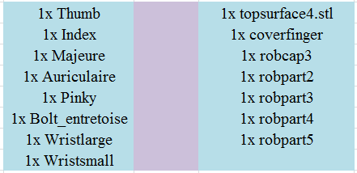
Table 4.9.1.a. STL File names of all parts needed to be printed

Construction of the arm mechanisms once the 3-D pieces of the project are printed is a lengthy process. In this section, the construction of the arm will briefly be mentioned as well as servo implementation. The servos are installed in the lower portion of the arm as seen in Figure 4.9.1.a. below:
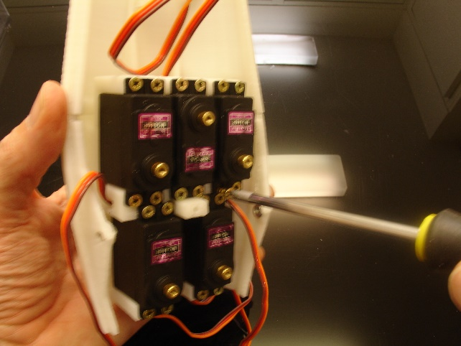
Figure 4.9.1.a. Servo protection
It can be seen here that the servos are protected from the outer case of the arm. The outer portion also serves as a place for the servos to be held securely and safely. Wires extend from the servos up to the hand and connect to the fingers. Each finger is controlled by a servo; hence the 5 servos. In Figure 4.9.1.b. we see how these wires move each individual finger.
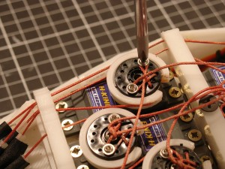
Figure 4.9.1.b. Wiring the servo motors
The wrist also has a servo so that the wrist can move as well. This servo is ultimately optional in our project. Benefits of adding the wrist movement would be so that the user can have more manipulation of the arm as well as added movement for any functionality needed within the wrist. With this additional servo, however, incurs additional cost as well as further complications with the microcontroller. More mechanical complexities can yield further issues with a final design. This feature will be added if it’s deemed necessary at the conclusion of the project.
Another important feature of the arm is the gripping on the actual hand itself. The author of INMOOV suggests either silicone from an oven mitt or ping pong grip. This will assist the arm in picking up different items. Once the servos are completed wired up and everything is complete, we see the completed arm shown in Figure 4.9.1c with this added grip.
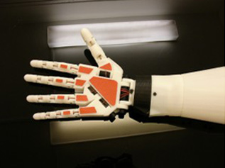
Figure 4.9.1c Completed Arm and Hand with added grip material

4.9.1.1. Physical Strength of the arm/Endurance
Like discussed in previous sections, the arm will be printed using PLA which, although brittle, provides precise printing capabilities when used with a 3D printer. The arm we’re constructing is a prototype so although endurance is an important component of the arm, it is not our main priority. If the arm were to be constructed commercially, 3D printing wouldn’t be the ideal choice due to the length period of time it can take for each piece to be printed. For a prototype however, it works just fine and provides sufficient physical strength for the arm.
What’s more important is the strength of the servos used to move the fingers of the hand. The servos must be powerful enough to hold an object effectively. The servos used have a torque of 15kg-cm at 6V which should be more than enough to prevent the servos from lagging. Even at 4.8V the servo provides a torque of 13kg cm. We also must evaluate what the arm can be capable of holding. Are we looking for the arm to pick up incredibly heavy objects, or more everyday items? For the price point of the product, we’re designing for more of an everyday item. Items such as a small ball, an apple, or a pencil are the basic types of items we’ll be testing.
Testing will be conducted to check the endurance and strength of our arm. A pressure sensor will be used to determine the pressure of each finger as well as multiple fingers in tandem. More explanation on Testing is found in Section 7 of the paper.
The battery endurance of the arm will also be tested to determine how long the microcontroller, the servos, the sensor and the screen can last on one charge. This will be determined when everything is together and tested.

4.9.1.2. Hardware Protection/3-D printed Prosthetic
Due to the nature of the project, the arm will be exposed to a plethora of different conditions such as environmental changes. With this in mind, the arm must be designed to accommodate these conditions. The arm will be made of PLA or Polylactic acid. All hardware will be enclosed within the arm, so the PLA will be the primary boundary between the critical hardware and any outside conditions that could affect the arm. The servos have plastic protection as well to protect the mechanical systems inside. Too, the circuit board will have protection by the PLA cased arm. The user should treat the arm as if it was their own. It shouldn’t be exposed to any detrimental conditions that could harm the arm in any way. One decision that must be made when the arm was printed was if the arm should be printed with PLA or ABS. There are as vast amount of differences between 3-D printings with ABS vs. PLA, but some of the main differences include.
- PLA is prone to curling corners and tends to me more precise than ABS.
- PLA is more brittle than ABS.
- PLA can be printed with finer detail on a well calibrated machine versus ABS plastic.
The last point is why we ultimately decided to go with PLA. Due to the fingers of the arm, it’s better if they’re printed with a very fine accuracy. Although PLA is more brittle than ABS, the strength of PLA will be enough for our prototype 3-D printed arm. Too, this is a very beginning prototype so if the product were to go into production, molds would be created for the arm and a more efficient way of building the arm would be determined. The hardware protection conditions will be tested as well. This is discussed in much further depth in the testing portion of the paper.

4.9.2. Protection of circuits
In this section, our group will this discuss how the circuits are going to be protected. The circuits in the arm need to be protected against again sort of minor shock or shaking. The ABS case around the circuit will protect the important components inside. The ABS case should be able to protect the circuits from water damage in case something spills on it or if it rains. The inside components will be protected by some extra padding to reduce the shock if the hand is dropped or receives some sort of shock. The point of having the extra padding around the servo motors in the case is to keep the servos in place if the arm falls. If the servo motors are set in place correctly, the function of the fishing lines might get compromised when the user tries to operate the arm. The ABS is resistant to electricity since it’s made out of plastic. If the arm was exposed to heat, it would be able to resist at least 105 C. The bionic should be treated like a real arm; therefore, a user should not expose it to too much heat or inflict heavy blows to it. The microprocessor will also receive some padding and extra protection from water. In order not to overload the circuits, the user should not overload the servo motors by carrying something too heavy. The prosthetic arm will also be locked so that children do not tamper with the circuits inside.
Only an adult will be able to safely open the lock on the Bionic Arm in order to make changes. Since the screen is very sensitive, the user should handle the arm with care. A protective screen will be added on the touchscreen so that it’s protected. The touch screen will need extra protected padding on the sides to protect it if the arm is dropped to the floor. The arm will provide plenty of physical protection to the circuits that will assist in operation of the arm. In Figure 4.9.2.a, we see the location of where the circuits will be housed in the arm. The circuits will lie underneath the rope that will control the fingers. Although these will be moving, they will have no impact on the circuit or its performance. This will be proved in the testing section to ensure there is plenty of clearance.

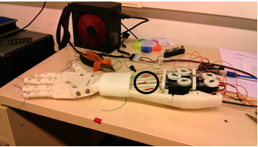
Figure 4.9.2.a. Location of electronics in arm base
The MSP432 is also filled with internal circuit protection features. These include internal protection diodes to prevent too much current from frying the chip as well as a security fuse to protect it as well.
The circuits in the arm need to be protected against again sort of minor shock or shaking. The ABS case around the circuit will protect the important components inside. The ABS case should be able to protect the circuits from water damage in case something spills on it or if it rains. The inside components will be protected by some extra padding to reduce the shock if the hand is dropped or receives some sort of shock. The point of having the extra padding around the servo motors in the case is to keep the servos in place if the arm falls.
The ABS is resistant to electricity since it’s made out of plastic. If the arm was exposed to heat, it would be able to resist to at least 105 C. The bionic should be treated like a real arm; therefore, a user should not expose it to too much heat or inflict heavy blows to it. The microprocessor will also receive some padding and extra protection from water. In order not to overload the circuits, the user should not overload the servo motors by carrying something too heavy. The ABS case will also be locked so that children do not tamper with the circuits inside. Only an adult will be able to open safety lock on the Bionic Arm in order to make changes.

4.9.3. Coating the material
One of the biggest problems with 3-D printing is the layered look of the printing. Although acceptable, there are products that assist with this so a more desired look can be achieved. Table 4.9.3.a shows several products that assist and help to ensure a smooth gloss finish.

 | Works on PLA? | Chemical Used | Cost
Filabot Smoothing Pen | Yes | Acetone | $7.30
Filabot High Performance Print Coating | Yes | Not Specified | $38
Foreasy Smoothing Pen | Yes | Acetone | $6.99
3D Print Removal Tool | Yes | N/A | $5.77
Table 4.9.3.a. Summary of Smoothing Agents

The soothing pens both use acetones which isn’t ideal for PLA. Acetone works better for ABS plastics which won’t be used in our project. Thus, the two pens aren’t the best fit for our project. The 3D print removal tool is simply a tool that is used to smooth out the material. Its function is similar to that of sand paper.

The biggest difference between using Acetone and other products is that Acetone just helps smooth out the ridges and doesn’t help to provide any additional protection. The XTC product, once hardened, provides an additional layer of protection to the arm and the mechanics on the inside. Before we make the additional expense, testing will need to be conducted on the arm to determine if the coating is worth it. If we need additional protection then the XTC product is ideal for our situation. If we need just a little cleanup of the arm, the acetone stick or nail polish remover will be a better solution.
After some research, nail polish is the cheapest option and works for a hobbyist. Time permitting, we’ll have to decide which route we’d like to take to really make the arm professional and clean looking.
In the next section, we look at what these products are capable of doing to PLA material.

4.9.3.1. Heat
Because the arm will be interacting and touching a user’s skin, heat is an important factor when designing the circuitry and battery so that the arm maintains a stable temperature. A temperature sensor can be added to the battery to monitor the heat. See Figure 4.9.3.1.a. for a summary of the temperature sensors considered for the arm. All 3 sensors are a simple 3-pin chip that requires a positive voltage, a ground, and an output. The output is read as a voltage and when a scaling factor is applied, a specific temperature is reached.

 | Voltage Input | Accuracy | Cost
TMP36 | 2.7V-5.5V | ±2° C | $1.50
MCP8908 | 2.7V-5.5V | ±0.25° C | $4.35
LM35DZ | 4V-30V | ±0.75° C | $1.47
Figure 4.9.3.1.a. Summary of temperature sensors
We see that all 3 sensors are relatively similar. Each has a similar voltage input which would work with our selected battery. Too, the accuracy is more than sufficient for the application and reasons for adding into our circuit. The MCP8908 is a tad more costly, but once shipping is factored into each chip, they’re all about the same.

4.9.3.2. Appearance
We see a before and after picture in Figure 4.9.3.2.a. where the difference can clearly be seen when a finished product is added. On the left is the finished product and on the right we see the straight out of the printer product. It makes a huge difference for such low cost. The lines from the printer are no longer visible and the covering helps make the product glossy and professional. By adding these products to our final design, not only do we make our finished product more professional, but we smooth out all of the layers that are normally, clearly visible on the product.
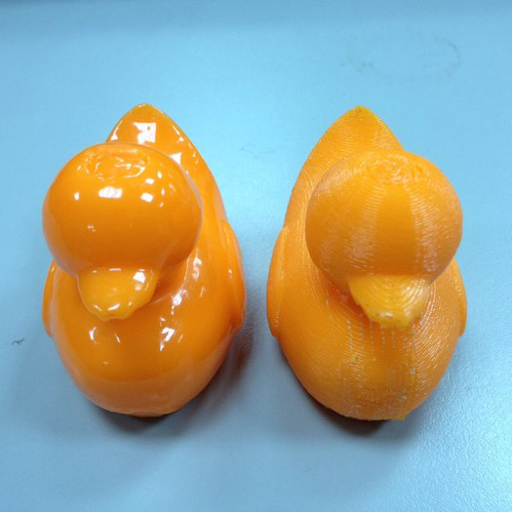
Figure 4.9.3.2.a. Comparison of printed object with and without smoothing agent
The appearance of the arm isn’t simply based on the coating either. We chose a plain and basic white PLA to print the arm. Numerous other colors were offered, but white was chosen because of the ability to alter the color more easily if we decided to change it. PLA is easily printed using cellulose spray paint. If at the end of the project, we decided to make the arm a more realistic arm color, we can easily spray paint it.

4.9.3.3. Silicone Appearance
After the prosthetic arm is assembled, it will be very noticeable when used in public. Users might not like the prosthetic arm’s normal appearance. This might be because users might not want to make other people uncomfortable in public when the arm is used. People look for conformity when in public; therefore, many companies have been creating realistic looking for the prosthetic arms. Since people feel this way, many companies have developed realistic looking skins for the prosthetic limps. A lot of these skins are made out of silicone and look very real. Many companies use a scanner to scan a person’s arm in order to make the skin for the opposite arm. After the arm is scanned, an accurate opposite arm skin color can be created.
The silicone skin has to be heated in a 60 degree oven in order to make sit ready for donning procedure. In the donning process, the silicone is heated to 60 C in preheated oven for a certain amount of time. After heating the silicone, a donning spray is added to the prosthetic arm so for optimal application of the skin. The silicone skin is easy to clean since it does not get dirty real fast. A user would just have to use soap and water to clean the silicone skin. Our group has looked into using silicone skin; however, our total budget could not accommodate this feature. Our current 3D design made it hard to fit a silicone skin over it since it was a prototype. The silicone skin would need to be modified if installed over a prosthetic arm since the arm has touchscreen and is sensors in the hand.
The overall appearance would be greatly enhanced if a silicone skin was set; however, the 3d printed version of our arm was not smooth all over. Because the arm was not smooth all over, the silicone skin would be hard to set over the arm and the appearance might not be that good. In order to fix this problem, many companies have designed the fingers to be smoother and more realistic. These newer prosthetic arm designs make the donning process much easier when adding a silicone skin for the prosthetic arm. Instead of adding a silicone skin, our group will coat the ABS plastic with a gloss spray in order to make the prosthetic arm shiny for demonstration purposes.
- Pros: - Realistic look for the prosthetic arm
- Can be easily cleaned
- Color can customized to your own skin color
- Cons: - Slightly expensive
- Has to be replaced if damaged

4.10. LCD Touchscreens
An important part of our design is an LCD screen. The prosthetic arm is supposed to show the status of the arm; for instance, the touch screen will be able show battery temperature, battery life, and the state of the prosthetic arm. The LCD screen has to be a touch screen. Research will be done on 3 different touchscreens so that a good screen can be found for the prosthetic arm. A touchscreen on a prosthetic arm will need a lot of protective padding since it’s so sensitive. The screen will be very sensitive to scratch and shock; therefore, our group will install a protective padding to make sure that the screen can withstand a certain degree of shock during the testing.
The first LCD screen that was looked at was a Pixnor UNO R3 2.8 TFT Touch Screen. This LCD screen was a touch screen and had a SD card input. The touchscreen had a 2.8 inch screen and would be an ideal size for the prosthetic arm. The cost was $12.59; however, this touchscreen requires a lot of programming. The time frame for programming this screen could take months and make it much harder for our group to finish the project. Our main focus is to find a touchscreen that is easy to program. Overall this touchscreen looked good and had a lot of positive specifications; however, the programming and additional parts that needed to be bought would rule this screen out as a choice. This screen was not compatible with the microprocessor that our group wanted to purchase for the prosthetic arm. This touch screen needed addition components.
- Pros: - 2.8 inch LCD touch screen
- SD card input
- Durable PCB board and metal
- Cons: - Ideal for Arduino board only
- Hard to program
- Additional boards needed
The second touchscreen that we looked at was the uLCD-70DT LCD Display Touch Screen. This screen was really large compared to the first screen. Since this screen is 7 inches, it would be hard to fit this screen on the arm. This touchscreen comes with a Full sided SD memory card connector. This screen has an on board amplifier to power an 8 ohm speaker for the touch screen.

Since the touchscreen supports audio, our group can add even more features if required during the assembly stage. This screen is compatible with Bluetooth and Wifi which will not be used for the prosthetic arm. If our group bought this LCD screen, our group would have had to buy a DIABLO16 Processor. This ruled this screen out as possible choice since our group chose the MSP432. Compatibility issues were a big problem when looking for a good touchscreen.

- Pros: - Full sided SD memory card connector
- Audio
- Good price
- Cons: - 7 inch screen
- Needs a specific processor

The third screen that was looked at was the SmartGPU 2 from Vizic Technology. This screen had an SD card input up to 32 GB. This screen really stood because the screen did not have to be directly programmed. This touch screen is a slave device that only receives orders; therefore, the time required to program the screen is drastically reduce the time needed to program the prosthetic arm. The smart GPU 2 has an audio jack which gives the user the option of play sound. Another great feature of this touchscreen is that it has 5 simple pin interfaces that have to be connected to a microprocessor.
- Pros: - 2.4 inch touch screen
- Easy to program
- SD card input
- Slave compent requiring no programming
- Compatible with most microprocessors
- Cons: - Very expenisive
- Very Fragile

4.11. Heat Sensor
A heat sensor is very important for the prosthetic arm and for the electronics. The electronics cannot get too hot; therefore, it is very important to have heat sensors in the arm. One heat sensor will be placed on the battery. In order to protect the battery, the heat sensor will make sure that the battery operates at a safe level. The battery sensor will be added close to the battery. The current battery temperature will be shown on the LCD touchscreen and will give a warning if the temperature goes above a certain level. Programming will be required to make sure that warning light will go off when the battery overheats. Another heat sensor needs to be placed in the hand so that the user of the prosthetic arm knows how hot an item is when touching it. A third sensor is being considered on the electronics components of the prosthetic arm. This will the user know if the electronics are being damaged. A couple of heat sensors will be researched in order to find the best one for the prosthetic arm. The performance of the arm depends a lot on the temperature.
The first heat sensor that was researched was the LM89 on ti.com. This sensor can accurately measure the temperature of the external component. Also, the LM89 can measure its own temperature. The programmer has the option to calibrate for different non-ideality factors since it has an offset register. The offset register can sense different thermal diodes. When calibrating this sensor, the programmer does not require software management. The sensor has a standard error of +/- 3 C. This heat sensor can shut the whole system down if a monitored component overheats.
Another heat sensor that was researched was the LM90 on ti.com. This sensor can also measure the temperature of an external component. Also, the LM90 can measure its own temperature. The programmer has the option to calibrate for different non-ideality factors since it has an offset register. The offset register can sense different thermal diodes. When calibrating this sensor, the programmer does not require software management. The sensor has a standard error of +/- 3 C.

A third sensor was looked at for the battery the RC battery. This sensor is made specifically for RC batteries. Our group will consider buying this sensor since it is can give us an accurately give us the temperature of the battery. This sensor is used as a safeguard for over charging; however, it can also be used display the current temperature of the battery. Figure 6.1.b. shows a picture of the sensor installed around a RC battery. The heat sensor will shut the arm off if it reaches a certain temperature. This feature will protect the prosthetic arm if there is a malfunction. Our current RC battery comes with Traxxas connector which makes this sensor a good choice for the battery.
- Pros: - Battery temperature can monitored
- Battery protected from overheating
- Easy to install and connect to PCB design
- Cons: - Only for RC batteries
- Cannot measure PCB board temperature

4.12. Pressure Sensor
A pressure sensor can be also be used in the prosthetic arm. This sensor will make the arm very efficient when grabbing objects. For instance, when the arm grabs a water bottle, the pressure sensor will help tell the system that enough pressure has been applied to the object. Another example is when the user wants to shake a person’s hand with the prosthetic arm. The pressure sensor will let the system know when enough force is being applied for a handshake. The area where the sensor has to be located has to be in the hand region of the prosthetic arm. The pressure sensor will require a voltage regulator so that it can operate in the operation range. Research will be done a few sensors in order to see which one best fits the prosthetic arm. If a pressure sensor is installed, wires would have to be run from the tip of the fingers to the PCB board. The sensor is really important since it gives the microprocessor important information on holding items.

5. Compatibility
This section is all about how everything will work together without causing problems with anything else. It will also help to bring each section of the product together to really provide a cohesive final project.

There are several critical components of the project. These are outlined below:

- MSP432 Controller
- LCD Screen
- Sensors
- Servos

Here, we see a broad overview of all the components. The MSP432 is clearly in the center and controls each of the remaining peripherals.

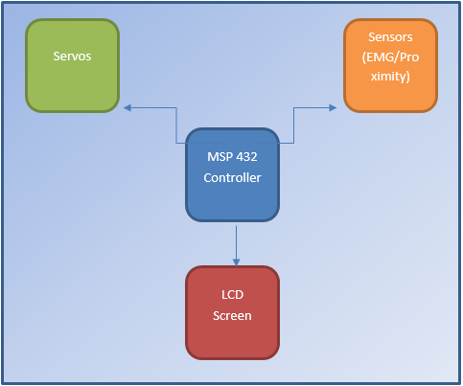
Figure 5.a. Flow Diagram of Entire Project

The next sections are divided into software and hardware. The software portion will discuss the software relationship between each device. For example, the LCD screen compatibility with the MSP432 is a critical design parameter. The hardware portion will discuss power compatibilities. Ideally, the entire arm is run off of one power supply, so we need to consider the compatibleness of power supplies. How the different sensors, screen and servos will fit into the arm also falls into the hardware section of compatibility.

5.1. Software
Because the MSP432 will be used, C programming will program the microcontroller to obtain the desired functions for the arm. The most important and complex compatibility test is the association of the MSP432 and the LCD touchscreen. How they interact and the code to program them is critical to the overall design functionality.

The LCD touchscreen provides bidirectional serial interface to a host controller through its USART. The LCD screen provides a plug in play interface with any board that has UART capabilities. Because the MSP432 provides UART capabilities we can definitely use the MSP432 to run our LCD touchscreen.
The data format for UART in association with the touchscreen is 8 bits, no parity and 1 stop bit with a baud rate of 9600. The device communicates by commands as a single byte or byte package and will always receive back a single ACK (acknowledgement). Some example commands are below:

- Initialize SMART GPU: 55hex “U”
- Draw Circle: 43hex “C”
- Draw Image/Icon: 49hex “I”
- Get touchscreen icons: 49hex “L”
- Get Time and Date: 50hex “P”

These will be transmitted from the MSP432 through UART. The touchscreen’s processor will then take these commands to achieve the desired functionality.
Images are stored on the SD card internally. Specific parameters are set for the LCD touchscreen. These are shown below in Figure 5.1.a. below:

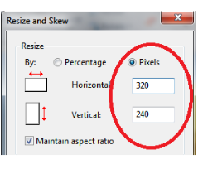
Figure 5.1.a. LCD image specifications
The parameters must be set this way so that the pictures fit accordingly onto the screen. Multiple pictures must also be taken into account. Because we will have multiple arm movements there will be multiple icons for each hand movement.
Libraries are provided for the touchscreen to communicate in C. There’s a header file that includes main functions and leaves critical microcontroller specific information to be altered.
/****************************************************************/
//Communication Functions(PLATFORM DEPENDENT) - MODIFY TO FIT YOUR PLATFORM
/****************************************************************/
/***Serial port prototypes configuration/definitions***/
//Sends a single character through the serial port(USART) connected to SmartGPU2
#define PUT_CHAR_SG2(data) Serial.write(data) //pchar(data) or put_char(data) etc.
//Returns a single character obtained from the serial port(USART) connected to SmartGPU2
#define GET_CHAR_SG2() Serial.read() //gchar() or get_char() etc.
//Changes/Sets a new Baudrate in the Host Processor serial port(USART)
#define SET_BAUDRATE(newBaud) Serial.begin(newBaud) //setUsartBaud(newBaud) or setBaud(newBaud) etc.
//Performs a Hardware Reset on smartGPU2, Reset pin connected to host
#define RESET_SG2_GPIO_LOW digitalWrite(p13, LOW) //GPIO_Set(13,LOW) or PORTB=0x00 etc.
#define RESET_SG2_GPIO_HIGH digitalWrite(p13, HIGH) //GPIO_Set(13,HIGH) or PORTB=0x01 etc.
//Delay definition for some SmartGPU2 commands
#define DELAY_SG2(del) delay(del) //delay(del) or delay_ms(del) etc.

Figure 5.1.b Header File Code to be altered to match our processor
These values must be changed. When we used UART in the embedded systems course we were given the source code to communicate via UART. We will use that code to communicate and leave the rest of the “behind the scenes” code up to the libraries that are included with the touchscreen. Without the header file shown in Figure 5.1.b, most of the touchscreen initializations would have to be written within our team and would make using the touchscreen cumbersome and extend the build time extensively. We update simple commands such as how to return a single character, setting the baud rate, performing baud resets and creating delays (only necessary for a couple touchscreen commands). After the header file, the main file is run through. This file includes all critical commands to boot up the touchscreen as well as includes all initializations needed to communicate with the screen. Too, it also includes all necessary touch commands as well. This is important so that we can communicate from the MSP432 to the touchscreen easily and seamlessly so that less time is focused on programming and more time is spent on practical application of the screen. The main file also lays the ground work for SD card management, audio interfacing and other image functions.
Next, the software compatibility between the EMG sensor and the MSP432 will be discussed. The coding of the EMG sensor was discussed in an alternate section which explains in detail how the sensor will communicate with the EMG sensor. The two are compatible primarily because the EMG sensor simply outputs a single analog value. All we have to do is direct this output to an input on our microcontroller and use some basic code to control when we want the servos to move.

5.2. Hardware
There are many circuit boards that all must fit inside the arm without interfering with the mechanical aspect of the arm. Because there are 5 servos, one controlling each of the fingers, the bulk of the arm is for motor capabilities. Then, from these servos, we will have wire spanning the entire arm which greatly limits the room to place the electronic control for the arm. The touchscreen will also be mounted on the arm and the electronics associated with the screen must fit within the arm.

One of the difficulties of the INMOOV arm is that it’s designed more for a hobbyist than for a consumer. This causes slight difficulty with regards to fitting all of our additions into the arm. We’re also not mechanical engineers, so the design of the arm isn’t our most important focus either. INMOOV was designed for all of the electronics to leave the arm and the control to be done mainly off-board. Because of this, the arm wasn’t designed to house batteries, LCD touchscreens, microcontrollers or any other addition that could be potentially built into the final arm design. Below, the position of these items are identified.

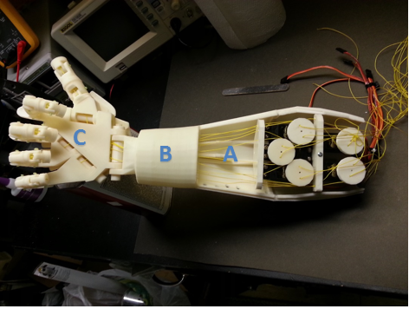
Figure 5.2.a. Circuitry locations
The microcontroller and associated servo wires will fit in the space marked ‘A’. The touchscreen should fit where ‘B’ is shown. Where ‘B’ is marked, a square cut will be made for the size of the screen and all associated wiring will be routed back to the position marked ‘A’. The proximity sensor will fit in the section marked ‘C’. The wiring will be routed through the finger and back into position ‘A’.

Note that most of the wires are leaving outside the end of the arm rather than positioned closer towards our expected position. Our servos will need to be positioned differently, facing the other way, so the wires can reach the microcontroller more appropriately. Too, the wires will be much shorter as to not clutter the moving mechanisms in the area.

Another important hardware component is how power will be distributed throughout the many mechanisms. The battery that will be used is the Tenergy 5000mAh battery which provides an output voltage of 7.2V. The servos have more torque at 7.2V so this battery works perfectly for the motor control side of the project. The microcontroller can be powered at 1.6-3.7V so a voltage regulator will be needed when adding voltage into the microcontroller. The touchscreen operates at a voltage of around 5V so the voltage will need to be stepped down here as well. See below for a table of operating voltages for each critical component of the project.

 | Operating Voltage
Servos | 7.2V
LCD Touchscreen | 5V
EMG Sensor | 3.5V
Microcontroller | 1.6-3.7V
Table 5.2.a. Operating voltage compatibilities
Both the microcontroller and EMG sensor can be powered off of the same power supply. The servos will be powered directly from the battery and the Touchscreen will need a simple 5V voltage regulator to step down the 7V provided by the battery.
A 5V voltage regulator costs about $1.50 and will be a simple addition into the circuit. The chip has 3 pins; ground, a voltage in and a voltage out. The maximum voltage that the chip can accept is 35V which works fine for our chosen battery. Similarly, a 3.5V regulator can be purchased for around $2 and added to the circuit.

The voltage coming out of this regulator can be directed to both the EMG sensor as well as the microcontroller. These voltage regulators will be loaded onto the final PCB so that all voltage regulation is done onboard. The 3V regulator can also be used for the microcontroller’s power as well. There will need to be further testing to ensure that all of the power can be split as described above without any further problems affecting the operation of the design. Splitting power may cause inconsistencies with the servos or the way the EMG sensor is outputting it’s response from the user.

6. Prototype
This is the section were theoretical discussions of all electrical and electronic components would be embedded and integrated into obtaining a physical design. This section will solely focus on all the physical parts, where we divided all the sub-sections into six sections where we discuss a range of topics related to the implementation of the final design.
The prototype of this design includes all electronics as well as the complete three-dimensional printed prosthetic appendage. We will discuss the power, as in the input of our power supply, and then discuss the charging of the battery used. Following that, we will discuss the MCU and the relating functions. Section 6.4 will overlay the wireless communication module that we have chosen in section 4.5. We will also discuss the physical endurance of the printed arm to see the physical strength and durability of it. Lastly, we will discuss the EMG prototype circuit as well as the module chosen in real world details.
Building the prototype is the second step after buying and designing all the parts for the prosthetic arm. The microprocessor will be designed on a PCB board. The voltage regulators will also be assembled on this board. The LCD screen will not take much to assemble. The LCD screen only requires minor programming to get it started. The microprocessor will use libraries that were given by the LCD Company. After 6 weeks of printing, the 3d printed parts can finally be assembled. The 3d printed parts will not have the exact same specifications when printed due to the standard error; therefore, all the parts will have to be slightly sanded so that every part can be assembled. The assembly of the 3d printed parts will be shown in this section of the report. An additional 3d printed part for a case will need to be printed for the LCD touchscreen. Since the prosthetic arm was printed without having a specific place for a touchscreen, an extra part will be needed for the arm. After the prosthetic arm is assembled, the electronic components need to be put in. Small bolts will be used to put the small pieces of the 3d printed arm together. Since research was done on every single electronic component, the electronic components can easily fit inside our prototype. In order to control the bending of the fingers, fishing lines will be put in every single finger. The servo motors will rotate and control the fingers depending on what action the user performs. A lot of testing will be done in order to make sure the fingers work like they are supposed to. The five servo motors will need to be carefully put in. Around these servo motors, protective paddings will be installed for stability. The microprocessor will also use paddings once it is mounted in its designated spot. Since the device has to be regularly charged, an easy access hatch will be created to charge the two batteries or the single battery.

6.1. Power
The bionic arm cannot be powered directly since it is a portable unit. Since the bionic arm needs to be used in areas where there might not be power, the unit has to be wireless and be able to last a decent amount of time. Batteries will be utilized in order to power the bionic arm. The power usage of the arm is expected to be really high since the unit has 5 servos and a LCD screen. We expect to power the LCD and 5 servos with their own separate battery. The batteries used for the bionic arm have to be rechargeable batteries in order to save money when using the arm. The batteries considered for the servos and LCD are 9 volt batteries or RC batteries. The kind of battery that will power the bionic arm is NiMH. Voltage regulators will be used to regulate the voltage to the desired voltage for the microcontroller, LCD, and the servo motors. The LCD battery life should last longer since it uses less power than the 5 servos when active. In order to save power when the LCD screen is not in use, our group will program it to go in sleep mode when it is not active. The microcontroller in the bionic arm will also be programmed to know when the sensors are not needed in order to save power. The main goal is to save power so that the use of the arm is optimal; therefore, most components will be in sleep mode. The LCD will display the battery life for the servo motors and the screen itself. Furthermore, the user should take care when using the bionic arm to carry heavy stuff that might overload the servo motors. If the bionic arm is overloaded, the servos will not run smooth and use a lot of power so that it can complete a normal programmed action. The user should use the bionic arm for its designed purpose and pay attention to its weight limits. We expect the armor to operate optimal consume power normally if it lifts objects between 1 to 1.5 pounds. If the bionic arm is used to lift normal light items and use programmed hand gestures, the battery life is expected to last 2 to 4 hours with the high capacity battery that will be purchased. The Bluetooth function will drain the battery really fast if left on; therefore, the user should turn the Bluetooth off on the LCD screen. The programming of the microcontroller is the most important part in order to save power. The main goal of saving power is to maximize the use of bionic arm after every single charge. Power will also be saved when the bionic arm is programmed to know when to lock and hold an item for an extended period of time. For instance, the user could be holding a can, fork, and a pencil. The user will be able to let the microprocessor know via the LCD touch screen that he or she wishes to keep a state that the arm is in after an action is performed. This will indeed make the bionic arm smarter when saving power.
The EMG Myoware sensor will need Voltage regulators so that it’s powered with a 9 volt battery. In order to lower the voltage, 5 volt regulators will be used to reduce the voltage. For the EMG circuit, 5 volts and negative 5 volts is required to make the servo work. Our group will not need to purchase regulators for the servo motors. The RC battery is 7.2 volts which is in the range of 3 V to 7.2 V. The LCD screen will also need to be powered. The LCD screen that will be used is the GPU 2. In order to power the GPU 2 LCD screen, a 3.3 voltage regulator will be needed to lower the voltage. Figure 6.1.a shows the regulator that will be used our circuit. The regulators will be placed in between the battery and the components. The responsibility of the regulator is to regulate the voltage for every single component in the device. A voltage regulator will also be need for the Bluetooth system installed in the Bionic Arm. The LCD touch screen will need a regular for 3.3 volts. Since the touch screen is so sensitive, it is very important that the correct voltage be applied to it in order to avoid damaging such an expensive part of the Bionic Arm. The Bluetooth will also require a 3.3 voltage regulator. Furthermore, the servos do not require a regulator since the servos can operate at between 3.3 and 7.2 Volts. The battery for the servos is 7.2 volts in this case. Figure 6.1.a shows the battery that will be purchased for the prototype
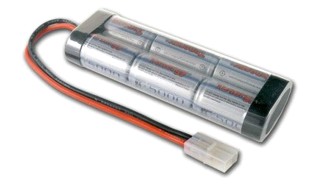
Figure 6.1.a A picture of 7.2V Tenergy 5000mAh Flat NiMH High Power Battery Packs
In order to protect the battery, prosthetic arm, and the user, a Traxxas battery heat sensor will be installed around the battery in the prototype. This sensor will protect the battery from overheating and overcharging. Figure 6.1.b shows the how the sensor will be installed in the arm. The Traxxas sensor is made specifically for RC car batteries and it will protect all the components inside the arm.

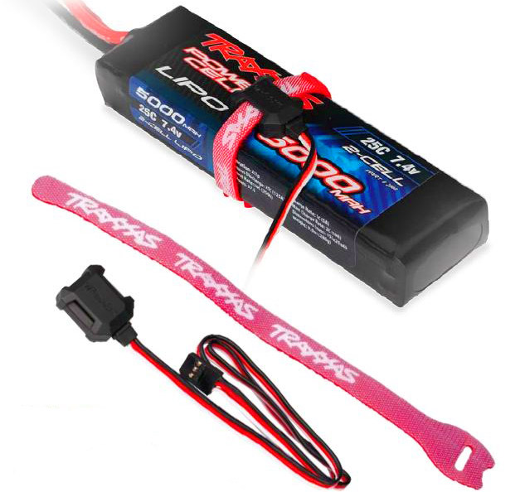
Figure 6.1.b. A picture of a heat sensor around an RC battery

6.2. Charging
For the prototype, easy access to the battery has to be available. Charging will be an important feature for the prosthetic arm since it uses so much electronics. Our plan is to add a small opening in the prototype. The prototype can be charged via this opening, and the battery can be changed. A universal charger will easily charge the battery for the arm. Our group might either use two batteries or 1 RC battery for the circuit. If one battery is used, the charging time will only depend on one battery. The charger that was purchased for the prosthetic arm will be able to charge the arm in 2.5 hours. The charging time depends on the charger. In our case, a 2000 mAh charger was purchased. Wireless charging was not chosen since it would involve multiple components with a high cost. In order to protect the battery, a smart charger was bought via Tenergy. This charger has a safety sensor that prevents overcharging of the battery. A Traxxas sensor for the RC battery will be installed around the battery. This sensor will give a warning if the battery overcharges or if the temperature of the battery gets to high. In order for the battery to last longer, the battery should be charged only when the battery level is extremly low. Repeatably charging the battery could really reduce the lifespan of the battery.

6.3. Microcontroller Prototyping
For prototyping the microcontroller on the arm there is really only one option and that is to hook it up to the board and use it. The reason we are doing this is because of the complexity of replicating a microcontroller using other methods and due to the ease of reprogramming the microcontroller even when it is on the board.
One of the major issues with replicating a microcontroller in any other way is due to the extreme complexity of doing so. Due to the immense amount of electrical components within the microcontroller to do so any other way, outside of using an emulator which is run on a computer, would require an extreme amount of components and time which is something we cannot afford during development. In addition to the amount of time doing such a thing would take it would also produce inaccurate results. Using a device that gave inaccurate results would cause the overall prototype to be of no use to us as we would be unable to learn anything of value from it. In addition it is very possible that if something works correctly on the prototype built this way then it would not work on the actual finished project. In other words doing such a thing is impractical and will only hinder the development of the arm.
The other main reason we are using the actual microcontroller instead of a prototype version is because of the ease of programing the microcontroller once it is on board. Assuming we have hooked the microcontroller up correctly we will have a JTAG connection to the microcontroller. Using this connection we can reprogram the microcontroller simply by hooking it up to the computer and uploading the program to the microcontroller. This makes life incredibly easy and allows us to fix any programming errors that we make very quickly with little to no down time.
In order to connect the microcontroller to the board there are two very simple steps that we need to take. The first step is to layout the microcontroller correctly on to the board. This is done simply by following the schematic as detailed later in this paper. And after it is placed on the board we then have to check to make sure all of the pins are in the correct place and that they all are all touching their pads correctly. After that is done we simply need to solder the microcontroller on to the board and we are done. It really is that simple.

6.4. Wireless Technology
A wireless communication module will be implemented into this project design in order to realize two things:
- Be able to communicate wirelessly with a mobile device
- Be able to communicate wirelessly with a personal computer

The reason to implement both the aforementioned devices is that Bluetooth and Wi-Fi are both compatible with the MCU that we have already chose on using to control all the electrical and electronic elements and devices that will be implemented and integrated into this design.

The ability to have the wireless communication implemented into our design will allow the user to have complete control from a distance as that provides a sense of accomplishment and satisfaction as well as comfort in case the person is lethargic. As mentioned in previous section, section 4.5 and specifically section 4.5.3, we have decided to use two Bluetooth and Wi-Fi modules. These modules will be discussed in the following sections.

The first module to discuss is the Bluetooth module. We have decided to use Texas Instrument’s Sable-x wireless Bluetooth module for reasons mentioned in section 4.5.3. Texas Instrument’s Sable-x wireless Bluetooth module would be purchased from Texas Instruments and directly implemented into our MCU in order to have wireless Bluetooth communication integrated into our arm. We will use Bluetooth communication in order to allow the user to use his or her mobile phone to control the mechanical aspect of the arm as mobile phones allow for a personal and comforting experience for any user.

The second wireless communication to discuss would be Texas Instrument’s CC3000 wireless Wi-Fi module. Texas Instrument’s CC3000 wireless Wi-Fi module was also discussed in the same sections mentioned above in the Bluetooth paragraph where we also determined why and how Texas Instrument’s CC3000 wireless Wi-Fi module was going to be implemented into our design. Again, Texas Instrument’s CC3000 wireless Wi-Fi module would be bought from Texas Instruments themselves and integrated into our design and controlled by our own MCU. The reason for attaining a wireless communication in the form of a Wi-Fi module, is to allow the user access to the Internet in order to provide the user with another platform onto which he or she can literally do whatever he or she wants as we would have a Bluetooth module connected, and MCU to control, and an LCD screen with a personalized user interface system.

6.5. EKG/EMG
The bionic arm needs to communicate with a person’s arm. In order to make the link,
electromyography (EMG) sensors were installed where a person’s arm meets the bionic arm. EMG can also be considered muscle recording sensor. These sensors are usually used to for medical research and the diagnoses of muscular disorders. The sensor is able to detect signals when a person’s muscle is moved. By detecting this signal the bionic arm can communicate with the arm. The signal will be received by the microprocessor and will perform a programmed action depending on the motion. These actions include moving a person’s arm up and down and applying force to your bicep. Figure 6.5.a shows the EMG that will be used in the prototype.
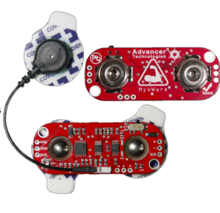
Figure 6.5.a A picture of the an EMG Senor (With permission from Advancer Technologies)
By programming the servo motors, the arm can be programmed to recognize specific and unique moves that an individual might want to perform with the arm. The EMG sensors can sense signal frequencies between 0 and 500 Hz. The interesting thing about this signal is that it comes directly from a person’s brain. In order for the body to perform an action, a signal has to be sent to the area of the body where the action is desired. These signals are sent through the nervous system in the body. The nervous system can be seen as signal going through a wire in a circuit. The EMG receives this signal and the microprocessor will determine which action needs to be taken. Figure 6.5.1.b shows an EMG plan for our design.
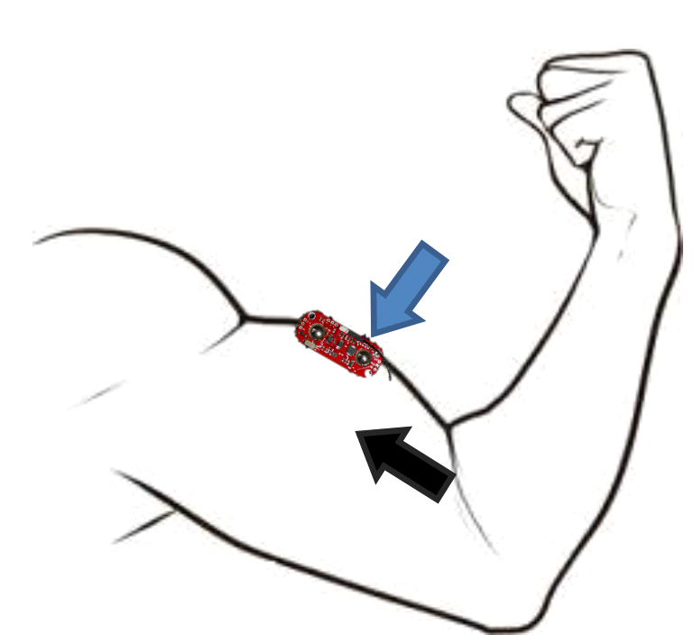
Figure 6.5.1.b. A picture showing how electrodes are placed on an amputee (With permission from Advancer Technologies)
Furthermore, in order to install the EMG senor, 3 electrodes need to be installed. These electrodes consist of positive, negative, and a ground. Batteries have to be used for these sensors since they are directly connected to a person’s arm. In order to get a good reading, the electrodes need to be placed correctly. First, the ground has to be connected to the bony part of the arm where there is minimal muscle activity. Second, the positive and negatives electrodes are placed on the area where the muscle signals need to be read. The positive and negative electrodes should be 1 mm apart from each other. Figure 6.5.2 (pending approval) shows the kind of electrodes that our group is going to use for the Bionic Arm. The positive electrode is given by a red wire and the negative wire is given by a black wire.
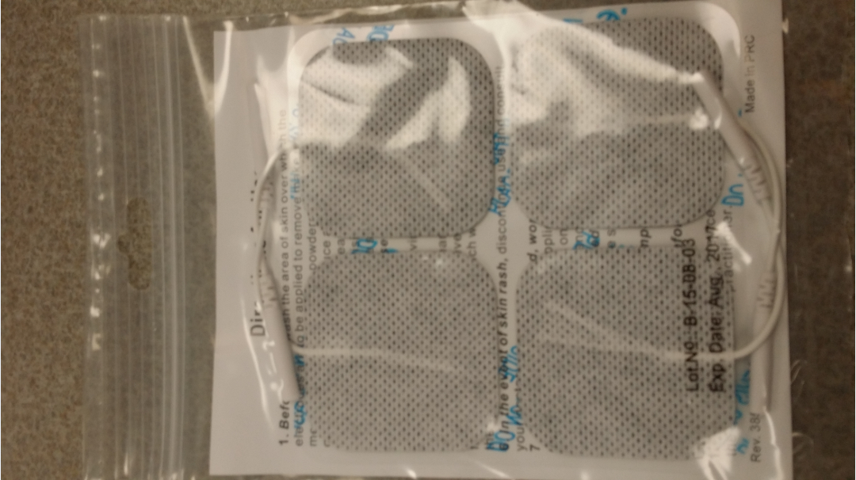
Figure 6.5.2 A picture of the electrodes that will be used
After the electrodes are connected, the desired signal might not be obtained right away; therefore, the programmer would have to do a few trial and error runs in order to get the correct signal. Correct placement is very important for the electrodes. The strength of the signal depends on the correct placement of these sensors. After the electrodes are correctly placed, the programmer can start connecting certain signals to various actions. In order to realize this circuit, two 9 volt batteries have to be used. The purpose of having two batteries is to supply a negative and positive desired voltage. An EMG that our group was looking at was sold at Sparkfun. The Myoware board that is sold at Sparkfun measures the rectified and electrical energy of a muscle. The sensors should be with the orientation of the muscle fibers. The Myoware will output 0 volts depending on the muscle activity at the moment. The required voltage for this sensor is from 2.9 volts to 5.7 volts. Figure 6.5.a (Permissions Granted) shows the senor layout for the EMG sensor.
Table 6.5.a shows the specifications of the Myoware sensor. A voltage regulator is needed to lower the 9 volt or 7.2 volts to the correct range.
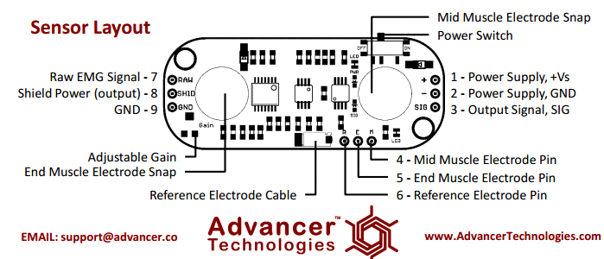
Figure 6.5.a A picture of the Sensor Layout for the Myware sensor (With permission from Advancer Technologies)
Parameter | Min | TYP | Max
Voltage supply | +2.9V | +3.3V or +5V | +5.7V
Adjustable gain Potentiometer | 0.01 Ω | 50 kΩ | 100 kΩ
Output Signal Voltage  EMG Envelope Raw EMG (centered about +Vs/2) | 0V  0V | --  -- | +Vs  +Vs
Input Impedance | -- | 110 GΩ | --
Supply Current | -- | 9 mA | 14 mA
Common Mode Rejection Ratio (CMRR) | -- | 110 | --
Input Bias | -- | 1 pA | --
Table 6.5.a A table for the Specification of the Myoware Sensor (With permission from Advancer Technologies)

6.6. Physical Endurance
The physical endurance of the prototype will be very important. In this section, the endurance of the all the parts inside the prosthetic arm will be discussed. The first part that will be discussed is the 3d printed prosthetic arm. The prosthetic arm is printed using ABS plastic. This plastic is very resistant to minor hits and electrical shocks. The plastic will reduce the chance of a user getting shocked.
The 3d printed parts will be held together by bolts; therefore, it will be harder for the smaller parts to get lose if the arm falls down. A bead string wire will run through the fingers and to the servo motors. The bead string is very strong and should be able to resist overstretching to an extent; however, the fingers should not be overstretched during the demonstration.
Furthermore, the LCD touchscreen is very sensitive to shock; therefore, a special 3d printed case will be printed in order to house the screen. The housing for the touchscreen will be mounted over the wrist of the prosthetic arm. Once the Touchscreen is inside the case, extra padding will be added in order to make sure that the LCD touchscreen remains stationary during movement.
The Case for the touchscreen will use bolts on the sides in order to mount it on the 3d printed prosthetic arm. Acetone will be used to glue the case to the prosthetic arm. Figure 6.6.a. shows the custom made case for the touchscreen that will be mounted on top of the wrist. In addition, the microprocessor is also very sensitive.
When the microprocessor is installed the housing part of the arm, extra padding will be added in order to protect it from shocks or and sudden movements. The microprocessor will be protected since it is inside the prosthetic arm. Moreover, the servo motors inside the prosthetic arm will be screwed in. Since the servo motors are screwed in, the will be very stable in the prosthetic arm; however, padding will still be added to protect the motors from shock.
The battery's physical endurance is pretty good since it is in the case. If the battery was damaged, the user should not worry too much since the battery has a low toxicity level. Additionally, the EMG sensor is very sensitive to shock; therefore, care has to be taken in order to protect the sensor. The material that the prosthetic arm is made out of protects the components inside.

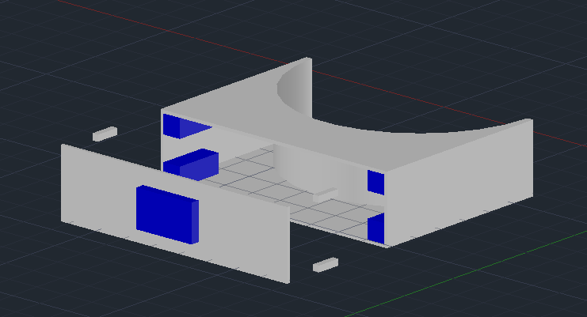
Figure 6.6.a A picture of a designed case for the touchscreen
The case will have a middle opening in order to put the Smart GPU 2 inside. The blue section in figure 6.6.a shows the area where the screen will be installed. The wires that are run from the top of the case to the prosthetic arm should be long enough and well placed in order to open the touchscreen case. The wires will be connected in the case in a way that the lid that holds the touchscreen can be opened for modification. Extra padding will be added in the case in order to protect the screen. On the exterior sides around the touchscreen, a special shock absorbent material will be set so that the screen is more protected. Figure 6.6.b shows an x-ray image of the designed case for the touchscreen. AutoCad was used to design the case for the prosthetic arm. The case will be 3d printed with ABS material in order to stay consistent. Small bolts will be used in the inside of the case in order to secure it to the prosthetic arm.

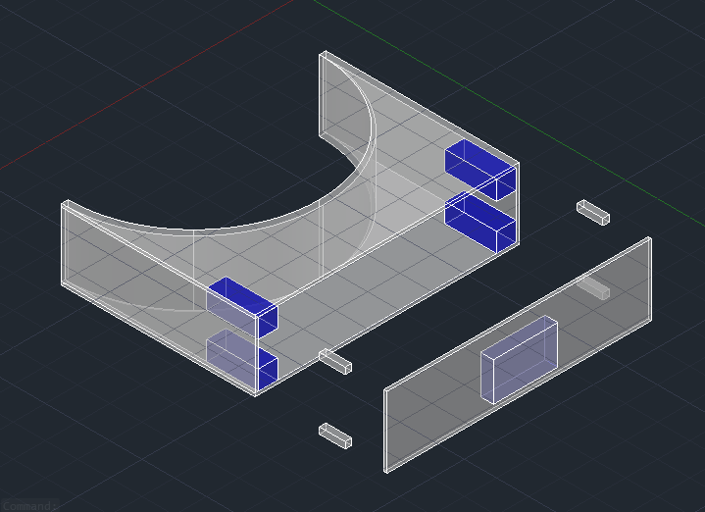
Figure 6.6.b. A picture showing the 3d x-ray image of the designed case

6.7. LCD Touchscreen
Our group plans on installing a LCD touch screen on the Bionic Arm. The LCD touch screen will have several functions that will be very important when using the bionic arm. One of these functions includes showing battery life for every single component in the bionic arm. This feature will inform the user when the batteries needs to be charged. Secondly, the touchscreen will give the user the ability to use certain programmed commands. For instance, when a user wishes to hold a cup, the user can tell the arm to lock and hold the last state by using the touch screen. Our group researched touchscreens and decided to use the GPU 2. The GPU 2 processor does not need any configuration or programming on itself. The device is a slave device that only receives orders from the designed microcontroller. On important feature of this LCD screen is that it does not require a complex code to work. The GPU 2 can communicate via serial interface UART; therefore, it can communicate with any microprocessor with a serial port. For instance, the GPU 2 can communicate with Arduino, Raspberry PI, mbed, PSOC4, PIC, Atmel, Freescale, STM, FPGA, PCs(RS232), PLCs(RS485), 8051, and low end 8 bit microcontrollers. Figure 6.6.a shows the GPU 2 Touch screen.
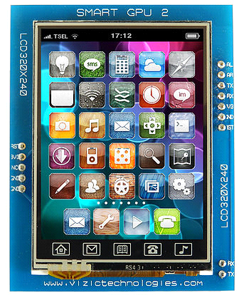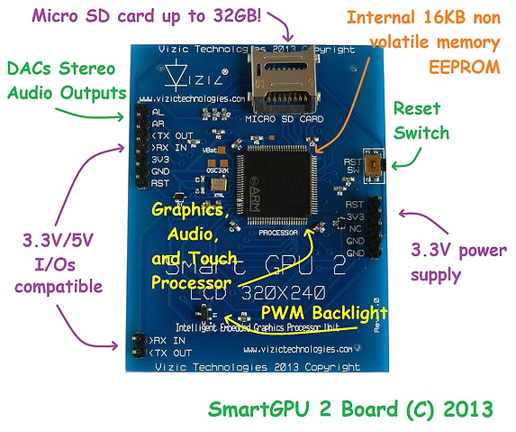
Figure 6.6.a A picture of Vizic Technologies Smart GPU 2 - LCD320X240 - 2.4"(With permission from Vizic Technologies)
The touch screen is compatible with 5 volts or 3.3 volts, and the screen comes with its own 3.3 power supply. When the host wants to communicate with the touchscreen, the host has to set the baud rate to 9600. After the programmer sets the baud rate, the programmer has to input an ASCII character ‘U’ in order to initialize the device. After the initialization is complete, the programmer can program a total of 8 speeds up to 2 Mbps speeds. Another good feature for this touchscreen is that it supports an audio input. One possibility with this feature is to play music via the Bionic Arm. In addition, this touchscreen can display a clock for the user since the Smart GPU 2 processor has an embedded RTC Real Time. If files need to be managed, the touch screen can use a max of 32 gigabytes SD card. This gives the user the ability to store images, videos, and music. It is highly recommended that the user add a screen cover to protect the touch screen. The touchscreen will be mounted in a special case. A special 3d printed case has to be made since the prosthetic arm’s original design did not have location for a touchscreen. A hole needs to be drilled on the top of the prosthetic in order to run the wires from the case to the microprocessor. When the Smart GPU 2 is ready to launched, master commands will be available to work the screen. Figure 6.6.b. shows a table of the master commands that are available for the programmer when launching touchscreen. These codes are really important since they are main codes that control the touchscreen.
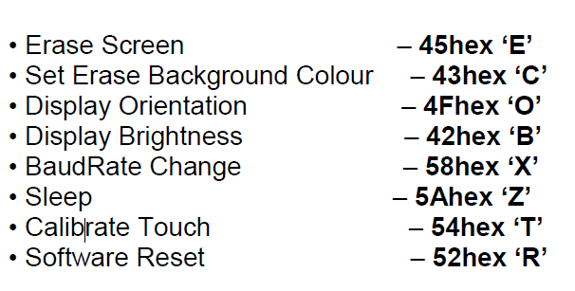
Figure 6.6.b. A picture of Vizic Technologies Master code table
The Erase Screen command will erase everything on the LCD touch screen. The display will be shown with the background color if it was set before. If this was not the case, the screen will be shown in the default color black.
The set erase background color will set the default background color for the screen. If the programmer wanted to make the background work in black, the background can be set to black. Our group will set the screen to color for the best appearance. Whenever the screen is reset, the default color that will be shown is black. The screen’s background color can be set to multiple colors. For instance, the screen can be set to red, white, blue, and a few other colors.
The display orientation command will set the orientation, landscape, and portrait. If the screen was reset, the screen will be set on the default orientation. For instance, after a reset, the screen will be set to HorizontalR 00(hex).

The display brightness command will give the programmer the ability to set the brightness of the screen. In order to set the brightness, the programmer has to set the level of brightness in a hexcode. The screen can be set from 0(0hex) to 100(64hex). This setting will allow the user save battery by having the brightness set on medium or less

The Baudrate Change command is used to change the Baudrate for the touchscreen. In order to change the Baudrate, the selected Baudrate must be in use by the programmer. If the Baudrate is not in use, the new selected Baudrate will not be modified, and the programmer will receive a NAK notification. If the Baudrate is in use, an ACK notification will be given that the code has been accepted. The touchscreen’s default reset Baud rate is 9600.

The Sleep command is used to set the screen in sleep mode. The Smart GPU 2 touchscreen takes at least 150 ms to go in and out sleep mode. The screen will turn completely white after the screen goes into sleep mode. Even if the screen goes into sleep mode, the data will be preserved. This feature will help the user save a lot of power when the arm is not operational. The sleep and brightness commands can help the user save a lot of money.

6.8. 3-D Arm Assembly
The assembly of the arm will be very important. Since the arm cost money, our group will have to carefully assemble the arm. Certain components will have to be shaved down in order to be correctly fitted. Small bolts will be used to put the parts together when the arm is being assembled. Figure 6.8.a shows how the assembly of the finger of the prosthetic. The finger will be assembled using bolts. After the holes are redrilled, the bolts can be installed in the finger. The wire for the proximity sensor, heat sensor, and pressure sensor will be run through each finger.
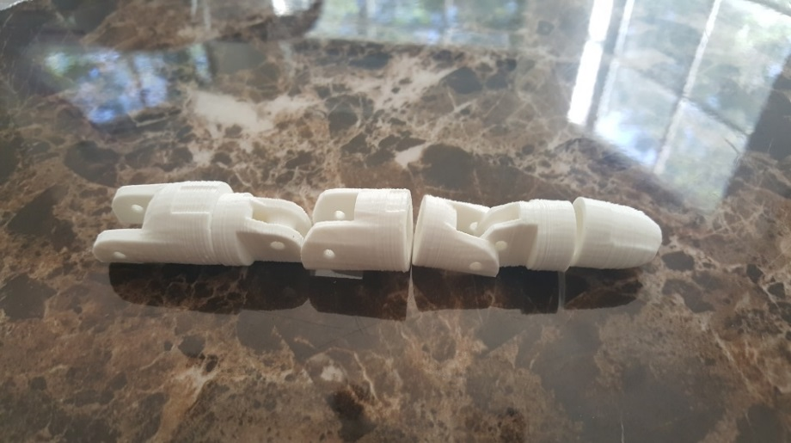
Figure 6.8.a. A picture showing the assembly of a finger
The next part that will be discussed is the wrist. The wrist will consist of 3 parts that can bend inwards. The pinky finger will have bendable joint that can move inwards when the servo motors rotate. Also, the ring finger will be able to bend inwards when the servo motors rotate. When the prosthetic arm has to grab an object, the thumb will be the most important part that can bend inwards when a command is given. This part of the arm will need to be sanded for imperfections before all the fingers are added to the wrist. After sanding all the fingers, the holes in the wrist will be redrilled using a 3.5 mm drill. Bolts will be used to hold the wrist together when the parts are ready. Each finger will require a bolt when installed on the wrist. Figure 6.8.b. shows a picture of the wrist without the fingers installed.
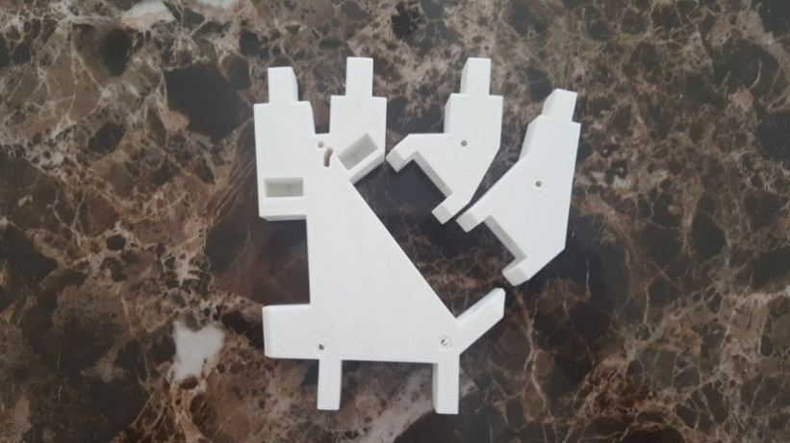
Figure 6.8.b. A picture of the wrist section for the prosthetic arm
After all the fingers are assembled, the wrist and fingers can be combined in order to assemble this section. If our group notices any imperfection in any part, ABS cement will be used to repair it. Bolts will securely hold all the fingers with the wrist. A larger bolt will be needed in order to assemble the bendable fingers. The wrist section will connect to a housing part where all the bead wires will run through when installed. Figure 6.8.c shows a picture of the plan for assembling the wrist. The Wrist will have the option of bending if an extra servo motor is added to the design.
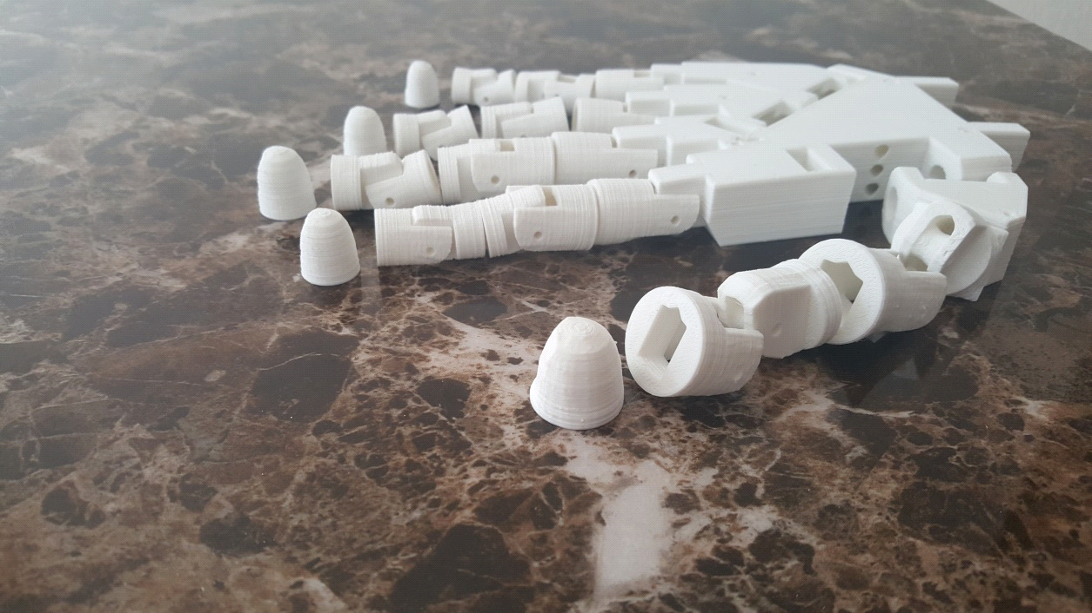
Figure 6.8.c A picture of the 3d printed wrist with fingers the fingers installed
The 3d printed hand was provided from an open source project since our group did not design the prosthetic arm. The mechanical aspect of this project will depend on the source project that was chosen. The 3d printed fingers have holes that need to be redrilled so that the bolts can fit. A 3.2 or 3.5mm drill will be used to drill holes for the hinges. Since most of the parts look the same, separate labeled containers will hold the parts. For the outside hinge, a 3 mm drill will be used to redrill the holes. The inside hinges will require a 3.2 to 3.5 mm drill for the holes. After the parts are drilled, acetone will be used to glue the parts together. 3 to 3.5 mm bolts will be used to put the fingers together. In order to further protect the arm a cover will be used to cover the fingers and the wrist. Figure 6.8.d shows the special cover with a logo on the case that will be used.
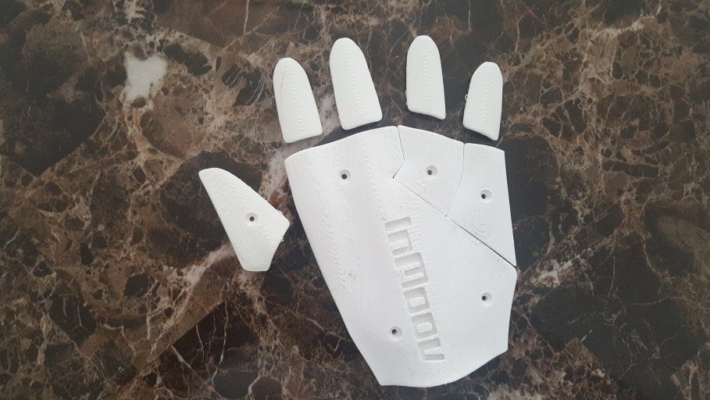
Figure 6.8.d A picture of the cover that will be used for the arm
The extra cover for the wrist will give more protection if the prosthetic arm was dropped on the floor. The company that provided the open source file has a logo on top of this cover. The cover will give the wrist and the fingers a nicer appearance. The wrist portion of the cover will require 5 holes to be drilled for the 3 mm bolts. One finger cover will be required to be drilled in order to attach the piece to the wrist. In order to attach the fingers, acetone will be used to so that the finger covers are attached. The cover will receive a gloss spray in order to make it look nice for demonstration purposes. The next 3d printed part is the casing connected to the wrist. Figure 6.8.e shows the case that will be connected to the wrist.
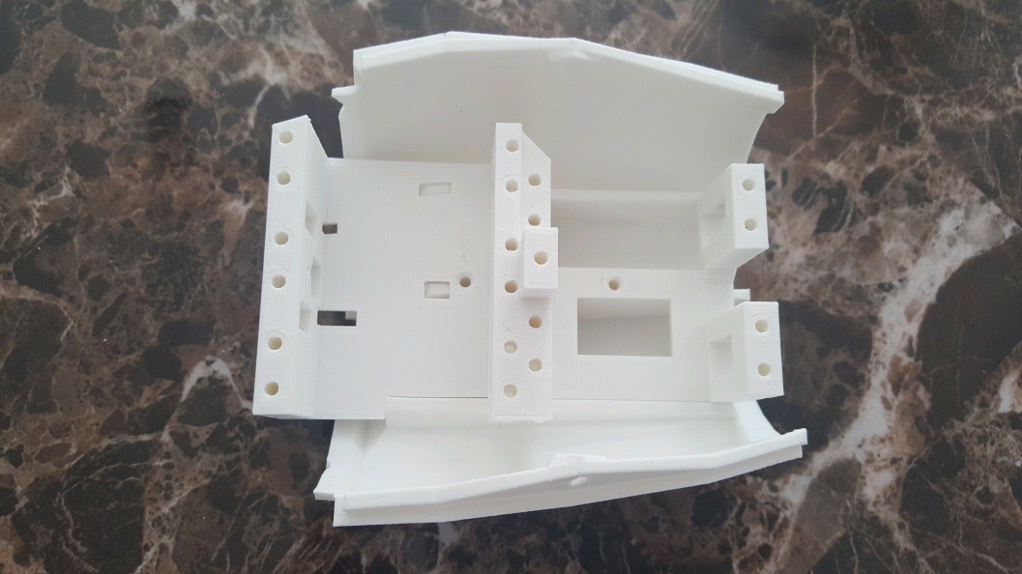
Figure 6.8.e. A picture of the PCB and servo motor housing
The part that houses the PCB and the servo motors will need to be drilled in order to use the bolts. This part will need to be sanded in order for every part to fit in it. All the servo motors will be housed in the biggest area in this piece. The other side of this piece will house the PCB design. All the wires from the servos will go underneath the middle part of this piece to the PCB. The wires will go through the upper part of this housing. The wires will go towards the fingers and need to be adjusted when assembled.
The servomotors will be screwed in when installed in the prosthetic arm. Once the servo motors are mounted, the custom printed pulleys for the servomotors can be installed. Figure 6.8.f shows the custom pulleys that were printed for the servo motors.
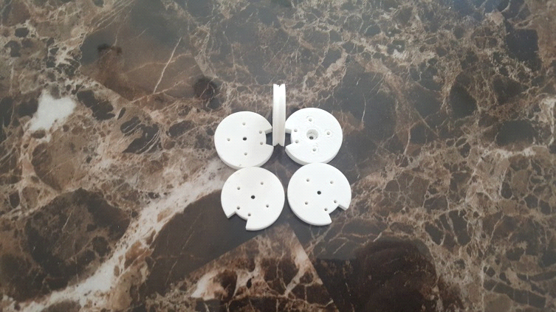
Figure 6.8.f. A picture showing the custom printed pulleys for the servo
The housing for the servomotors will have a piece separating the servomotors and the PCB. The holes in the separator will need to be redrilled. The wires that are mounted on the pulleys will go through the top holes. The wires will flow all the way to the finger tips. A smooth plastic ring will be added in every hole in order to reduce the friction when the servo motors are active. If the separator did not use the plastic rings, the wires would eventually break or starting damaging the separator. Figure 6.8.e shows the separator with holes.
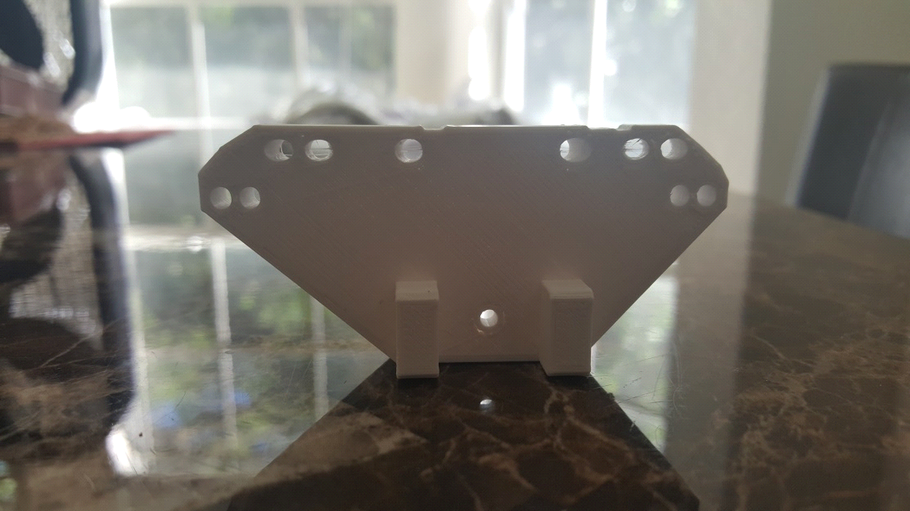
Figure 6.8.e A picture showing the separator for the PCB and servo motors
After all the parts are drilled and sanded, the electronic components can finally be installed. The servo motors will be screwed in when the housing is complete. Paddings will be installed next to the servo motors in order to protect it from shock. The pulleys will be then be installed on the servos. The pulleys will be rotate when a command is given and will be able to function individually. The microprocessor will be connected to all the sensors and servomotors; therefore, a lot of wires will be set in the housing. The servo motors in the housing part will be able to rotate from 0 to 180 degrees. Test will determine if there are any issues when servo rotates between 0 and 180 degrees.

7. Testing
After the Bionic Arm is done, tests have to be done in order to see if the Bionic Arm can perform under normal circumstances. Tests can also expose flaws and dangers in the design. These test will include the testing the endurance of the Bionic arm. For the endurance test, our group will test the durability of the Bionic Arm by performing a few minor tests in order see if the electronic components remain in place. These tests will also reveal if the electronics are affect when the arm receives minor hits. Furthermore, tests will be done to see if the charging part of the Bionic arm has any issues. Our group will test to see how long the battery lasts. Our group will also test the discharge time when the bionic arm is in use. The discharge time will depend on the kind of battery that is used. This will be done by seeing how long the servos can continuously function. The servos will the use the most power in the bionic arm. We will also test to see how LCD screen can function by itself. We will also test the wireless systems in our design. For the Bluetooth testing, we will test the range of the Bluetooth signal. We will also look into activating external components with the Bionic Arm. Our group will also test how the 3d touchscreen attaches to the prosthetic arm. Test will for the case will include shacking the arm a little bit. Test will also be run the fingers of the arm in order to see if they bend correctly.

7.1. Testing Every Prototype
In this section we will discuss how we will test each prototype of every device and element that will be integrated and implemented into our design. Each prototype requires its own set of rules and regulations in order to test the individual part effectively and as such, we have separated every aspect of this project into nine sub-sections, since, for example, the power would require the use of a digital multi-meter and an oscilloscope, while the arm itself would require a physical test performed manually by a tester. Regardless, all the testing plans for each and every prototype can be viewed and read in the following sections below.

7.1.1. Power
Tests will be conducted to see what the max power use is for every device. In order to test the overall power usage, extensive tests need to be conducted to see how long the Bionic Arm can remain operational. First, a test will be conducted to see how long the servos can work under continuous use. This test will reveal any flaws in the arm when it is under continuous use. If the arm can last at least 45 minutes under continuous use, our goal will be achieved since we assume that the average person will not be doing this. Under normal circumstances, the Bionic Arm is supposed to last over 2 hours of normal use. Second, Test will be performed to see how low the Touchscreen can remain operational. The forward voltage of the touchscreen is 60 mA. The touchscreen and the microcontroller will work together; therefore, we need to see how long both can remain operational when in constant use. We are considering installing just 1 battery for the whole Bionic Arm in order to reduce the overall cost; however, all the other functions will turn off as soon as the 1 battery goes.

7.1.2. Charging
In order to test the charging of our batteries, a charger was purchased for both types of battery. For the 5000 mAh, our group plans on by the Tenergy Universal Smart Charger for RC/ Airsoft Battery/ NiMH/NiCd Battery Packs (6V - 12V) valued at $15.99 at Amazon. This charger is a smart charger and will not overcharge the batteries; therefore, overnight charging will not damage the battery. Because of the large capacity of the RC batteries, it takes longer hours to charge. This charger has two settings. The one amp setting allows the user to charge batteries between 1000 mAh and 1800 mAh. The estimated time to charge an 1800 mA battery is 1 hour on the 1 amp setting.
For higher capacity batteries, the charger can be set to 2 amps. This setting allows the user to charge batteries above 2000 mAh. The estimated time to fully charge a 3000 mAh battery is 1.5 hours. If our group bought this charger, it would charge our 5000 mAh battery in 2 hours and 30 minutes. This charger can only charge batteries with a voltage between 6V - 12V and a capacity larger than 1000mAh or lower than 5000mAh.
After all these parts are purchased in Senior Design 2, our group will test out if the charging time is indeed 2 hours and 30 minutes. The 9 Volt battery that our group picked comes with its own charger. Our group will use a charger that charges 400 mAh; therefore, the time needed to charge 1 battery would be 1 hour and 30 minutes. We will conduct tests to see how long this battery lasts and how long the charging process takes.

7.1.3. Microcontroller
In order to test the microcontroller we need a testing procedure that provides all of the data needed to confirm that the microcontroller and program are working as intended while still being easy to perform and repeatable. In order to confirm that it is working as intended we need to check the following items. First we need to check that we are getting a signal from each of the individual pins that we are going to be using. After that is checked we need to check that we are getting the correct signal. Once that is done we need to check that given a specific input signal through a pin that we are getting the correct response from the associated output pin.
The first test that is going to be done is to check that while powered up the microcontroller is outputting to the output pins. These pins include the I/O to the touchscreen, the I/O to the servos, and the I/O to the sensors. As the first thing that is done when the controller is powered on is the initiation and powering of those components we should be getting a signal over the pins even with nothing but the power hooked up. In order to test for this signal we are going to hook a oscilloscope up between the output pins and the ground and also hook a test power supply to the Vcc on the microcontroller. After they are hooked up we will provide power to the microcontroller which should start the program and begin initializing the I/O components. In order to make sure this is happening we are going to use the oscilloscope to check for output across the pins. If there is an output then we know that the program has started correctly. If there is no output then there is a problem either with the microcontroller or the program.
After we have tested to make sure the program starts correctly we then need to test the individual outputs to make sure they are correct. In order to do this we are going to hook up each I/O device to its corresponding pin and provide power to the system again. Once the power is supplied and the program starts the I/O device should respond as it receives all of its initializing commands if nothing happens then we know there is an issue with the connection from the microcontroller to the I/O device or that the signal being sent is incorrect and the program is wrong.
Once the individual I/O components are tested we are going to test them all at the same time by hooking them all up to the microcontroller. Then we are going to apply power and make sure they are all still functioning. After this test is complete we will be ready to move on to testing the I/O components themselves to make sure the interfacing between them and the microcontroller is correct.

7.1.4. Wireless Programming
An important testing feature that we are going to be implementing into to the arm is wireless programming. This will be done by including a wireless module that will then convert the incoming data into JTAG format to allow us to program the microcontroller remotely. This will require a wireless receiver, a transmitter, and an emulator that takes the received data and converts it into JTAG. This will also allow us to program the microcontroller with the arm’s power supply instead of an external one from the computer we are programming the microcontroller from.
The main benefit this will grant us while testing the arm is it will enable us to quickly change and update the program we are currently running in order to reduce down time if we find an error or bug with the program. So instead of having to find the error, fix it in the code, then have to disconnect the board from the arm to program it. We would simply be able to divert the power to the board from the main input to the wireless JTAG connection and reprogram the microcontroller from there. This would not only decrease the amount of down time in between tests but it would also allow us to constantly be running tests even while programming as we would no longer need to pull the board out of the arm to program it.
In addition to reducing down time while testing other features of the arm wireless programming will also enable us to run more thorough and meaningful tests. This is because with the wireless JTAG we would be able to run a debugger remotely while running the arm this will give us more data on what is going on in the microcontroller and the other external I/O components during operation. This data will prove extremely useful to us as it will enable us to more quickly find the source of errors with the arm. In addition the remote debugging will also enable us to test what certain types of input would do to the arm during operation without having to use the touchscreen controller. This input would be things such as a sensor or servo motor sending an unintended response or possibly even the touchscreen giving a bad response like a button being pushed that was not pushed.
The only issue with the implementation of wireless programming onto the board would be testing the wireless programming. If the wireless programming is not properly tested using it to test the arm will only result in confusion and more problems. Without testing multiple things could happen. One of these things is we could upload a program to the microcontroller and instead of uploading correctly it gets corrupted being transferred and doesn’t work as we think is does. Or we could get wrong values while remotely debugging the program; this could easily cause us to misdiagnose a problem with the program or possibly even fail to notice a major problem that doesn’t have acute symptoms at the time. The worst of the issues that can arise though is too much current being fed to the microcontroller from the wireless JTAG module. In the MSP432 the JTAG pins have a fuse in-between them and the rest of the microcontroller. If too much current is fed into it the fuse will break. If the fuse breaks the chip becomes useless as we would no longer be able to program it. This would require that we buy a new microcontroller, further delaying development and increasing development costs of the arm.
In order to prevent these problems in the testing phase of design and to properly test the wireless programming component of the board we will have to do several different tests. The first and most important of these tests is to check the output current of the wireless module when hooked into the arms power supply. In order to test this we would first take the wires module and hook it into a test power supply. After hooking it up we would set the power supply to replicate what our power supply will be putting out. Once the power supply is set correctly we will take a multimeter and check both the output current and output voltage of the wireless module. If it exceeds the microcontrollers limit then we will need to add power regulation components to either side of the module to get the output level into safe ranges. After the output is in the correct range we then will move onto the next phase of testing.
The next stage is to ensure that the output signal from the wireless module is at the correct frequency for the JTAG to work correctly. In order to do this we would first hook up our power supply set to replicate our arm’s power supply. After that is done we will hook up an oscilloscope to the output of the module. After the oscilloscope is hooked up we are going to turn the test power supply on and check the output frequency of the module. If the output frequency is incorrect we are then going to adjust the module such that the frequency is correct by adding, removing, or adjusting components.
After the output is fully tested for frequency and current we are going to test to make sure that the device translates the input correctly. To do this we are going to physically hook up the device to the computer and attempt to upload a simple signal whose output is already known. We are then going to compare the generated output to what it is supposed to be. If the two outputs match then we are set to move on to the next step. If they do not match then we need to adjust the wireless module’s programing or possibly the components until they do.
After the output is correct based on the input we then need to test if it still works over wireless transmission. In order to do this we going to disconnect the wireless module from the computer and then hook up the transmitter to the computer.
We are then going to resend the same code used in the previous test wirelessly. As we send it we are then going to check that output and compare it to the known output. If it matches we are good to move on to the final stage of testing. If it does not we then need to test both the receiver and the transmitter to make sure they are transmitting and receiving the program correctly. Once we know where the error occurs we can then fix the error to ensure that it is transmitting correcting.
Once the wireless transmission and receiving is correct we then can hook the module up to the board. Once it is hooked up to the board we will then run one last test. And that is to upload a very simple test program through the wireless module. After the program is uploaded we will then run it to make sure that it is run correctly on the microcontroller. Once it has been run correctly we can then use the wireless module to aid us in testing other components of the arm faster than we otherwise could.

7.1.5. EKG/EMG Sensor
For this part of testing, our group will test the EMG sensors. Ideally, our group would want to work with an actual amputee; however, if this is not possible, one person in our group will volunteer and use the EMG on his bicep. We will analyze the signals when the muscle in the bicep is contracted. Furthermore, the up and down movement will be analyzed to determine what different signals are observed. After isolating the signals, our group will program the hand to move based on those movements. The signals will be analyzed by using an oscilloscope to compare the different signals produced by the brain. The measured signals will then be compared to the signals that have been researched. In order to know what each signal is, it is important to know what command the brain is sending out. The EMG works via by muscle activation via electric potential.
- All the sensors will be tested to see if the EMG is working with the pressure and distance sensor.
- The EMG sensor needs to be tested to see if the microcontroller sees it and is able to interpret the data.
- After an EMG signal is received, a text should appear on the touchscreen that indicates what action will be taken or which position is being held
- After the EMG sends the signal to the microcontroller, a hold action will be displayed as HOLD on the touch screen
- After the EMG receives the signal to release the an item, a text indicating should be displayed on the touchscreen
- The LCD should display the status of the EMG when no action is being performed

7.1.6. Physical Endurance
The physical endurance for the bionic arm is crucial because of the everyday use. The arm needs to be able to resist small blows or heavy blows. For instance, if a person fell down, the arm should be able resist that fall and still be operational. The shell of the arm should protect all the internal and sensitive components.
Since the arm was printed at UCF, our group had to use the required printing material for the 3D printing of the arm. The type of material used will be the ABS plastic. Table 7.1.6.a shows the different types of materials that were considered for printed the arm. The ABS plastic is very impact resistant and very though. This made this material an ideal choice for testing the resistance of the arm. The firsts test was shaking the arm with the components inside of it.
The point of this test was to see if the components in the arm would stay in place during normal day to day activities. The second test was to see how the components were affected if the arm was dropped from a short distance. After doing the initial tests, the arm was tested to see if the person would be shocked due to the minor blows. Since the arm is made out of plastic, the chance of shock is greatly reduced.
As a precaution, insulation was added where the arm touches a person’s skin. After doing these minor tests on the arm, we did not observe any noticeable effects with the electronic components. Another test was to see how resistant the arm was to heat. The ABS material has a melting point of 105 C.

We tested the material out by applying heat to it. Our observation was that the material used to print the arm was indeed very resistant to heat; however, with the components inside the arm, our group prefers that the arm not be exposed to too much heat. An idea that the group is looking into is to add a silicone realistic skin to make the arm look better and make it more resistant to everyday use. The silicone would reduce the shock to the components if the arm were to fall down. This silicone skin can also make the feel more comfortable when using the arm. We added some padding to protect the servo motors in case the arm was dropped.
Furthermore, tests will be conducted to test the fishing lines that control the fingers when in constant use. In order to perform these tests, our group will test how strong the fishing line is when in use. The fishing line will first be tested on the on servomotor. A weight will be added to one end of the fishing line to see what weight would negatively affect the servo motor. If the fishing line cannot perform well, piano wire will be used instead of the fishing line. Once the correct line is chosen, the fingers will be set to a state that a normal hand functions. For example, these fingers will not be able to bend all the way back. In addition, the physical endurance of the servos will be tested.

7.1.7. Proximity Sensor Testing
The proximity is very important since it will let the user know when it is getting close to an object and needs to perform an action. This sensor will be located in the hand region. Our group has decided to place this sensor in the fingers of the hand for the best results when approaching an object. The sensor is tested by seeing what signal is given when the sensor is active and approaching an object. The test will see if the servo motor can work when a command is given by the user. After a command is given, the servo motors should be able to activate and close the hand when the proximity sensor is active within a range.

- Check if the proximity sensor is active when the arm is turned on
- Check if the proximity sensor is giving out a signal if an object is pushed close
- Test the distance before the sensor detects an object
- Test the max range of the sensor
- Test if all the other sensors can communicate with the proximity sensor
- Test the reaction of the proximity sensor and the pressure sensor when an object is picked up

7.1.8. Heat Sensor Testing
Tests will have to be performed to see if the sensor can sense the temperature. The sensor will have to display the temperature of the battery when it is normal. In order to see if a warning is displayed on the touchscreen, heat will have to be applied to the sensor in order to test the programming of the microprocessor.
- Check if the heat sensor is active when the arm is turned on
- Check if the heat sensor is giving out a signal if heat is applied to the sensor
- Test if the heat sensor alerts the user when the circuit is overheating
- Test the RC heat sensor by applying heat to the sensor at different temperatures
- Test if the heat sensor will shut the arm down due to overheating
- Test if the temperature of the battery and circuit is displayed on the LCD touchscreen
- Test if a warning signal is given across the touchscreen when overheating occurs

7.1.9. Servo Motors Testing
The servo motors need to be tested in order to see if they can perform the desired tasks. In order to make sure that fingers don’t bend in an unknown position, programming will be done to prevent this from happening.
The servos need to be programmed to operate correctly between 0 and 180 degrees. After a command is given, the servos should be able to maintain the last command in order to hold an object. The tests that will be performed are listed below.
- Check if all 5 servos can rotate from 0 to 180 degrees
- Check if each servo motor can rotate by itself
- The speed at which each motor rotates needs to be controlled and not too fast.
- All the servos should be able to hold a position when given a command
- The servos should be hold and keep holding items without cause strain on the servos
- The stress on lines when the servos rotate need to be tested.
- The servos should not let the fingers bend in the opposite direction

7.2. Materials Needed
Constructing the arm will require a lot of materials. A list will be created to have an idea what will be purchased and installed in the arm. The list might slightly change when the arm is constructed. The total cost will be discussed in another section of this report. Table 7.2.a will shows the parts need to finish the prosthetic arm without the electronics components.

Prosthetic Arm case materials | Number of items
3D printed arm | 1
Bolts, Sanding paper | 50 bolts,4 Sanding papers
Piano wires for fingers | 1 roll
White Gloss Spray | 2 cans
Table 7.2.a A table showing the parts needed to assemble the arm
The required electronics components for the arm will also be listed. The numbers of components are subject to change if more components are added. Table 7.2.a shows the electronic components needed for the assembly of the arm.

Electronic components | Number of items
Servo Motors | 5
Controller for Servo Motors | 1
Tenergy 5000 mAh RC car battery | 1
Traxxas battery heat sensor | 1
Tenergy Charger for RC car battery | 1
PCB design(multiple parts) | 1
Smart GPU 2 Touchscreen | 1
Voltage regulators 3.3 V | 3
Wires | 1 roll
Proximity sensor | 5
Pressure sensor | 5
Table 7.2.a. displaying a table of the parts needed to assemble all the electric and electronic components

7.3. Test Results Conclusion
After we have completed testing all elements of the arm we hope to be able to draw the following conclusions from our testing process.
- It works: The first and most important conclusion we need to be able to draw from our tests is that it work. Most of our tests revolve around finding this out through multiple means. In order for us to define the arm as working we need to be able to see at least the following results from our previous tests.
  - Responds to commands: The arm needs to be able to respond to commands from both the touchscreen controller and the sensors. If it does not respond to the commands from either of them then it will not be working as intended. For us to consider this requirement to have been met we need to be able to show that the sensors are working correctly and that the touchscreen controller works. In addition to those we will also need to show that the servo motors respond to the commands that are given and perform the requested task
  - Does not crash or lock up: Another result we need to see to say the final arm works is that the program does not crash frequently, or hopefully at all. If the program keeps crashing then the arm will not function at all and will be of no use to the person using it. In order to say this requirement has been meet we will need to show that the program runs without issues for an extended period of time. Infrequent crashes are going to be allowed as we will be unable fix every possible bug in the program with the given development time.
- It’s usable: The second conclusion that we need to be able to draw from out testing is the usability of the arm. Simply put; if we moved the arm to a final production version would someone be able to use it. In order to define the arm as being usable we need to be able to see the following results in our testing.
  - Sensors Responding: In addition to the sensors working as defined in the last test conclusion the sensors need to respond to real life situations. Responding to these situations include being able to distinguish from spurious events and real commands and to recognize commands.
  - Decent Response Time: To be considered usable we also need our tests to show that the arm responds within a reasonable amount of time to a command. No user would want to wait 5 seconds for the arm to start doing anything.
  - Able to withstand day to day ware: Our tests will also need to show that the arm is durable enough that small accidents such as a single drop, or getting a little wet will not ruin it. Major accidents a car crash or substantial fall will not be considered as the arm is designed for daily use not extreme conditions.
  - Decent Battery life: Another thing our tests need to show is that the arm will have a decent battery life. A decent battery life is defined as lasting around 8 hours of intermittent usage.

If our tests show both of these conclusions we will be able to conclude that the project was overall a success. In addition to these two main things we also hope that the arm will prove successful in all of our tests not just the usability ones. Passing as many of our tests as possible is how we will determine if the arm was a success or not.

- Final Design
This is the section we all love to do as it is the application of physical parts and no theories involved. We have discussed everything needed to be implemented and in the following sections, we will discuss the PCB Layout and design, as well as the parts gathered so far in order to achieve the desired requirements and specifications of this project. The parts gathered include everything we have ordered and shipped to us as well as the parts needed to be printed.
The PCB design and schematic discusses the necessary software requirements as well as the procedure followed to obtain our very own PCB layout. The PCB schematic displays pins used that was designed by us and solely us as it is a unique design with unique electrical and electronic elements and devices used in order to achieve the design requirements as well as the design’s specifications to accomplish this project.

8.1. Parts Gathered
For the parts gathered, we went on to research all the parts that we have chosen in the previous sections. After performing all the necessary research, we went on to implement further research into the pricing of all the parts that we need to purchase in order to integrate and implements into our design. Nevertheless, the pricing of everything needed was obtained and will be viewed and discussed in section 9 later on.

It was difficult to decide on which source to purchase all the parts from as there are many vendors available, whether attaining them in person at a local retailer or purchasing the parts online through several websites that have various prices. Surprisingly though, Amazon did not have the best prices available for all parts.

The batteries and their respective charging mechanism were the only parts that required the least monetary consumption was bought from Amazon. All the other parts were purchased through the internet as well using different websites after a good amount of research was performed.

Some parts, such as the LCD screen and the muscle sensor module, had only one vendor to protect its value, and as such we were forced to purchase from these specific vendors.

8.2. PCB Design and Schematic
In order to connect all of the different components of our project, we will use the Eagle schematic based software to connect all of our different components and pieces together. Eagle is excellent software that first allows the user to build their circuit diagrams in a schematic based format and then further allows the construction of a PCB based format.
Eagle provides a free version of the software that has reduced features, but is still usable for what we need it for. Also, there’s a more enhanced version (full feature) provided on the computers in different computer labs located on the University of Central Florida’s main campus. We will be using this license to build our schematic as the full-featured set of Eagle offers more ease of use while building our schematic.
More popular based schematic files of different microcontrollers are provided from built in libraries. Unfortunately, the MSP432P401R is a relatively new microcontroller so the file wasn’t already loaded into the Eagle software. Thankfully, we were able to find the schematic file on Texas Instrument’s website and load it into the software. Other critical components of our schematic include 3-pin header files.
Our servos have 3 pins that connect directly to the microcontroller and battery. If we add a 3-pin header onto our schematic, we can easily plug-in-play our 5 servos. This would be beneficial if a servo were to go bad or we needed to replace a servo for any reason. The LCD touchscreen is connected via the TX and RX pins on the microcontroller. A 2 pin header is used for a plug-in-play interface as well. The fully constructed schematic is located on the next page.
Once we have the Eagle schematic completed, it must be turned into a full, printable, PCB design. There are many different companies that can turn the PCB design from Eagle into a tangible circuit board. The most common company to print a PCB board that’s discussed at UCF is OSH Park.
They provide custom manufacturing of PCB boards all made in the USA, shipped from Lake Oswego, Oregon. Manufacturing times of the board ultimately depends on the specifications of the board; however, OSH Park ultimately states a range of 5 business days to 3-4 weeks at the very most. OSH Park’s requirements state: 6mil trace clearance, 6 mil trace width, 13 mil drill size, and 7 mil annular ring.
When the PCB is being designed, these will be considered specifically so that there aren’t any issues while manufacturing the PCB board. Further details of the board include FR4 substrate, purple mask over bare copper and ENIG finish. Cost is reasonable and can be seen in the figure below.

Service | Cost | Time To Ship | Board Thickness | Copper Weight
Prototype | $5/sq-in for a set of three boards | 12 Calendar Days | 63mil (1.6mm) | 1 oz
Super Swift | $5/sq inch for three + $89 Swift Fee | 5 Business Days | 63mil (1.6mm) | 1 oz
2oz 0.8mm | $5/sq-in for a set of three boards | 2-3 weeks | 32mil (0.8mm) | 2 oz
Medium Run | $1/sq inch. 150 sq inch minimum. | 2-3 Weeks | 63mil (1.6mm) | 1 oz
Figure 8.2.a. Oshpark specifications for printing PCB Design

The controls in Eagle allow for easy and seamless construction of our final PCB design. Each component located in Eagle is housed in an in-house library. In our schematic, we use headers, voltage regulators, ground and a positive voltage. The headers are found in a library titled pinhead which allows for selection of a multitude of different sizes of header pins.
The voltage regulators are provided by a plethora of different manufacturers and are identified within their respective manufacturers. Ground and positive voltage are identified by GND and VCC are easily selectable within the provided libraries. As stated above, the MSP432P401 chip’s schematic needed to be pulled from Texas Instrument’s website as it could not be located in the provided libraries.
Once each component was selected and placed around the microcontroller in their respective locations, the NET tool was used to combine and create the final circuit. Two basic “bus” configurations were designed to provide the 7V to the servos and about 3V to both the EMG sensor as well as the LCD touchscreen. To step down the 7V provided by the battery, a 3V voltage regulator is built into the circuit to provide corresponding power. Pins 1.0-1.4 on the MSP432P401 are used for basic input/output control.
The control lines on the servos are connected to these pins so we have full control of not only the servos motion, but ultimately the hand’s motion. Similarly, the EMG sensor’s control line is connected to pin 1.5. We can fully control and allow for analog to digital communication through this pin.
Finally, the LCD screen allows for use of either just TX/RX pins or TX/RX pins, ground and voltage. We will use the 4 pin configuration so that we can house all of the critical connections with one header. The NET tool is used to connect the corresponding pins from the MSP432P401 (pins 9.6 and 9.7). The other pins connect to the voltage regulated 3V bus.
Coursework has always used a Launchpad to program a microcontroller. The real world requires the use of programming a standalone chip. Programming a standalone chip requires the use of JTAG or external device. The JTAG pins on the MSP432P401 are PJ.4, PJ.5, SWDIOTMS, and SWCLKTCK.
Using JTAG requires an external device that assists in the process of programming. In our current design, we take each pin and route them to a 4 pin header where can program from here. The JTAG device doesn’t impact the product directly so it can be ignored as soon as the programming of the chip is complete.
We could also program the chip on a breadboard, ensure its functionality, and then solder the chip onto the final PCB. Further determination will be made during the actual physical construction of the project begins. Other programing means are also available. A common way to program a standalone MSP430 chip is to actually use the MSP430 Launchpad and connect the external programming pins to a standalone chip.
This is more costly, but there’s no strict documentation if the process works for the MSP432P401. It’s been proven to work with the MSP430. This process may be followed if the JTAG process proves to be more cumbersome than originally expected. Finally, there are a plethora of other ways to program a standalone chip all which require external devices. JTAG and using a Launchpad are the most cost effective for our project.
Our completed schematic can be seen below with all of the features mentioned above. Note that this schematic is a draft and can be updated with the project. Once the components are placed on a breadboard and proven to work, the PCB can be constructed and sent to OSH Park to be built.

After everything that we have discussed, it is time to finally display our schematic. The Final PCB schematic that we have designed can be viewed in figure 8.2.b. below:
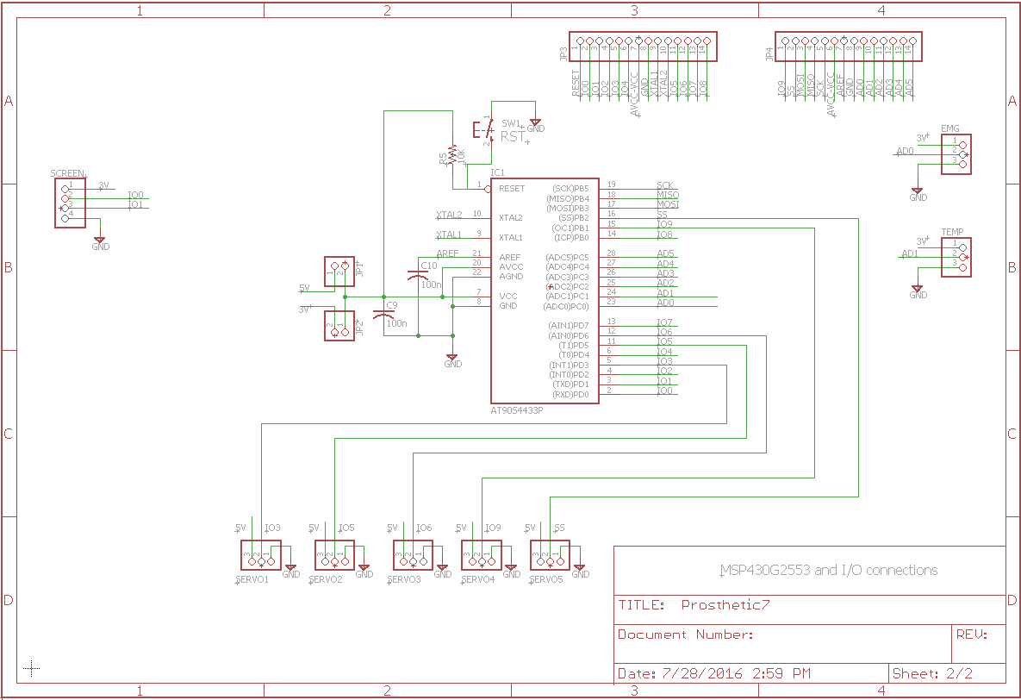
Figure 8.2.b. Final Design Schematic

9. Administrative

Upon the conclusion of Senior Design I, the actual construction of the arm will be conducted. In order to coordinate our efforts, a milestone chart has been put together to ensure the completion of the project is timely and ready to go for the final presentation. There are essentially 3 large components that will be conducted.
The first, is ensuring that each individual component works with the microcontroller. For example, we must verify the functionality of the servos and the communication between them. Second, we must verify the functionality of all components in the project with the printed PCB. Technically, if it works on the breadboard flawlessly, it should work fine on the printed PCB.
Finally, there must be testing conducted to ensure each component works as it was designed and works in the real world. Some ideas always seem feasible and on paper, but when they’re implemented, they don’t always work as they should.
We hope to have everything completed roughly 2 weeks before the final presentation. This time is allocated to verify that if something fails, we have time to troubleshoot and get the component working before the final presentation is set to occur.
We also allow this time to add any other features that we may be interested in adding to our final design and project. Lots of features are discussed in this paper such as Bluetooth and Wi-fi and could potentially be added if there’s time left over. There’s also room for growth within the touchscreen.
Important features such as a full featured calendar, input/output reading relative to the servos, and battery information can all be presented on the screen. These features will all be considered if there’s time left within the summer semester.
Our group has decided to take Senior Design II in the summer which limits the amount of time we have to complete the project. The summer semester lasts approximately 12 weeks whereas a typical fall or spring schedule can usually last up to 15 weeks.
Because of this significant reduction, we have carefully planned out when and how things will be completed. In the below table, significant milestones have been identified and dates in which they need to completed are marked.
It’s important to note that these are primarily significant, critical milestones. Things like “mounting servos into arm” are not included and would simply be extraneous information and therefore, excluded from are milestone chart.

9.1. Milestone Chart
In this section we will discuss the Milestones that we have achieved so far as well as the milestones that we will be achieving in the near future. A milestone chart has been designed and can be viewed in table 9.1.a. below:

 | Date Expected for Completion
Full Arm Constructed | May 20th, 2016
Servo Operation Code  - Ensuring microcontrollers are speaking with microcontroller – verifying code | May 27th, 2016
EMG Operation Code  - Ensuring EMG is working as expected and communicating with servos | May 27th, 2016
Touchscreen Operation Code  - Begin preliminary touchscreen operation and verify microcontroller compatability | June 3rd, 2016
PCB Full Layout Design Printed  - Have full PCB printed by OSH Park | June 5th, 2016
Hand Motions Confirmed  - Point  - Peace Sign  - Number 4 Symbol | June 10th, 2016
Hand Motion via Touchscreen  - Allow touchscreen to control servo control | June 10th, 2016
EMG Sensor Testing  - Ensure EMG is moving servos | June 17th, 2016
Potential Proximity Sensor Tests  - Will depend on troubleshooting of other elements | June 17th, 2016
Touchscreen Features Implemented  - Clock  - Hand Motion Icons  - Proximity Sensor Data | June 24th 2016
Ensure PCB layout works with all components  - See above for full operation details | August 1st, 2016
Table 9.1.a. Final and complete milestone chart of the entirety of the project

Testing and troubleshooting will be layered throughout each component. For example, while the touchscreen is being programmed for each hand motion, testing will be done to ensure smooth operation of each hand motion.

9.2. Budget

As discussed in this paper so far, one of our project specifications is to design, implement, and integrate all the electrical and electronic devices and elements with one financial goal in mind. We need to implement everything while using as little monetary consumption as possible.

To achieve the goal of minimum monetary consumption, we have used ASME’s printing lab as they charge the least compared to their competitors as they only charge for weight, time, and filaments used as compared to their competitors who charge for the length, width, height, weight, filaments used, and total time to print the objects.

In addition to that, we have set out a budget of five hundred dollars in our project’s requirement specification and after purchasing all the materials needed, we didn’t even spend half of the budget set at the beginning of this project design. The total cost of the whole of the arm will be viewed and discussed in section 9.2.1.

9.2.1. Total cost Table
We went out of our way to find parts that required as little money as possible and that included finding parts that would be shipped to us for free.
We surpassed our initial budget constraint and in fact made it possible to even implement and integrate many more electrical and electronic devices and elements into this project, where the only constraint to implementing all these extra elements and devices would be the time they all need to be implemented and integrated into our complete and final design along with sufficient time to be able to build a prototype as well as test everything to make sure they all work in tandem.
The whole of financial consumption as well as the shipping and handling fees incurred can be viewed in figure 9.2.1.a. below where we display the cost of each individual part bought as well as the total cost of the printed arm.

Part | Cost ($) | Shipping Fee
Arm | 130 | 0
Servos | 28.86 | 0
Tenergy | 34.9 | 0
Charger | 15.99 | 0
MSP432 | 7.6 | 0
Strings | 15.42 | 7.71
Myoware | 37.95 | 4.6
Electrodes | 17.95 | 5.44
LCD | 89 | 24.99
Total Cost |  | $306.42
Table 9.2.1.a. Total cost table to produce our project

10. Conclusion
Following the design procedure discussed in this paper and implementing and integrating all the electrical and electronic elements and devices would eventually achieve the purpose of this project. The entirety of this project was designed and will be implemented in the next semester to achieve the desired design requirements as well as the design’s required specifications.
The assembly of the arm will be integral as all the electrical and electronic devices will be integrated in the hollow spaces provided in the arm itself. The assembly procedure will not be as straight forward as one would think as several mechanical tools will be used to expand holes so that screws and bolts would eventually fit into the arm in order to hold some parts together.
Furthermore, super glue will be used as a precautionary measure in order to have the arm sturdy and firm in order to withstand some pressure and have a decent amount of physical endurance.
The second part to discuss is the servo motors. They will be used to control the motor functions of the arm itself. They will be the building blocks for any mechanical movement of all fingers as well as the arm wrist. The battery we have purchased and will be implementing is a Tenergy one that will provide a minimum of an hour of mechanical use on one charge. We have also purchased a charger to provide the user with a rechargeable bionic appendage.
The MCU was the hardest electronic element to decide on as there are several if not thousands of designs available as of today. We have decided on using and implementing the MSP432 Microcontroller that will realistically control every aspect of our design. It will control the motor speed, precise, and power. It will control the LCD screen and what will be displayed on it such as the user interface and the buttons to control how many or if all the fingers would flex or not. It will also control any additional sensors that we will implement into our design.
The LCD screen is a module that we have purchased that is implemented into the design and controlled by our MCU as mentioned above. It will be used to provide the user with an easy way to communicate and control all mechanical aspects of the arm. The last part to conclude on is the Myoware Muscle sensor.
It will be integrated and implemented into our design as well as controlled by our MCU. It will have electrodes connected to it to be able to detect muscle release and contraction. The Myoware module will transmit the analog muscle signal to the MCU where it will be then converted to digital in order for the MCU to interpret the incoming signal.
After fully designing the arm we have learned multiple things about the project and our goals. First off we are very satisfied with our overall design of the arm and are looking forward to moving on to prototyping the arm next. Secondly there are the things we learned while designing the arm. We learned several things from the different parts of our design that we hope to implement into future projects and in future iterations of this one.
One of the first parts of the project we learned from was the choosing of our components. Overall even though we managed to pick all components that were relatively inexpensive and are easy to use we still learned about possible better options that we could have chosen. For instance we could have easily gone with a less expensive and easier to use microcontroller as the MSP432 is way above the specs for what we needed it to do. Another thing we learned from choosing components is how to make sure that we pick compatible components. Going into the project we were very unsure if compatibility of components was going to be an issue but as we progressed through choosing them we learned through trial and error that it very much is an issue.
Another part of the project that we learned from was in designing the program for the microcontroller. In the design phase for the program we learned how to design a program that meets all of the requirements without wasting memory or including unnecessary functions. Also from designing the program we learned that the most important thing we need for the development of a program for this type of project is drivers and libraries to run other components of the arm. Without them the program would run too slowly and would take up to much memory to fit on the microcontroller.
We also learned a great deal from the building of our PCB schematic for the microcontroller. Going in to the project we thought that we could just put things onto a board and were done. But as we got into developing our PCB we found that many things we tried would not work due to either being a digital or analog signal or things being to close that they would create interference.
Another section from the project we learned from was the design of the overall requirements for the arm. At first we thought we could do anything, but as we designed more and more into it we have come to the conclusion that we might have overdone it with somethings. One of the big things we believe we have overdone is what we would like the touchscreen to do. We think that all of the requirements for our touchscreen controller will be out of reach do to both time and memory constraints.
Over all the project looks to be on track for success assuming we potentially cut out parts that are a little over the top. We have learned a fair bit from the design part alone and we are looking forward to building the arm. We also believe that as we build and test the arm we are going to learn much more about our limitations and the limitations of the components we have chosen to use.
Throughout the collegiate coursework, lots of theoretical design and analysis is introduced, but the design phase or real world application of electrical engineering is sometimes missed. With this project, we’ve gotten a hands on opportunity to discuss with real-world engineers, work in a team setting, apply theoretical knowledge to real-world and write a paper discussing our findings. All these ideas come together to truly provide the student a capstone for everything that has been learned throughout the 4 year degree.
Working in a group is a critical part of any engineering project so it’s important to have the opportunity to do so while in college. We were able to delegate specific tasks to each team member and apply different portions of the project to the member’s skill sets. Deadlines were set and each member was expected to meet the dates that were provided. If a team member wasn’t able to complete their portion of the project, other team members were expected to pick up the slack and complete the work regardless of the situation or why the team member wasn’t able to complete their portion of the project. When 4 people write a paper, it can introduce challenges with ensuring redundancies and similar information. Special care was taken in assigning each portion of the paper so the paper flows as seamless as possible without the reader realizing there are multiple authors throughout.
When writing the paper, our group used pictures and tables from outside sources. It was required that we ask for permission to use their work and insert their approval within this paper. These kinds of ideas apply throughout the corporate world and it was a valuable life lesson in ensuring that everyone’s work is properly cited and formatted. It also provides learning skills in sending professional emails to, on occasion, large employers or corporations that we could someday work for.
A significant amount of research and effort describes the work put into designing and engineering our Senior Design project. Our group hopes that because of the work put into the project during Senior Design I, Senior Design II is efficient and streamlined to reduce the amount of troubleshooting throughout the semester. One of our primary goals throughout the semester was to ensure that our hand mechanics were complete before we began Senior Design II. We were able to have the arm printed with more than enough time this semester. We also planned and designed our schematic so that we can simply breadboard our design right away. Each component for the project has also already been purchased and inspected so that construction can begin right away. The financing portion of the project is complete as well. One of our team members ordered and purchased each of the components and the rest were able to reimburse and split the total amount evenly.
All of the components of the project have really come together during our design phase. From the 5 servo design choice to the LCD touchscreen, our group believes that our project will really stand out from other groups designing prosthetic limbs, particularly groups working with Limbitless. Senior Design II will demonstrate everything we’ve worked for this semester and our hope is that Senior Design II will really be able to provide a true capstone for the entirety of the Electrical Engineering degree here at The University of Central Florida.
The over cost of the arm was less than our group had previously anticipated. This design showed our group that the 3d arm can at a very low cost. A lot testing has to be done in order to prove that the prosthetic arm can indeed withstand shock and normal activities during the day. The battery for the arm proved to be very important due to the amount of servos in the prosthetic arm. Even though our group bought NiMH, Li-ion would have best fit our current design. The battery is overall better than all the batteries that were researched. When working with the ABS printed parts, our group noted that the some 3D printed parts had imperfections and had to be repaired using ABS cement.

Appendix A
Acronyms:
ASME: American Society of Mechanical Engineers
EMG: Electromyogram
PLA: Polylactic Acid
ABS: Acrylonitrile Butadiene Styrene
MCU: Micro Controller Unit
IDE: Integrated Development Environment
CCS: Code Composer Studios
GSM: Global System for Mobile Communications
FDMA: Frequency Division Multiple Access
TDMA: Time Division Multiple Access
OFDM: Orthogonal Frequency Division Multiplexing
CCK: Complementary Code Keying
WAN: Wide Area Networks
FHSS: Frequency Hopping Spread Spectrum
SIG: Special Interest Group

Appendix B
Permissions:
Advancer Technologies:
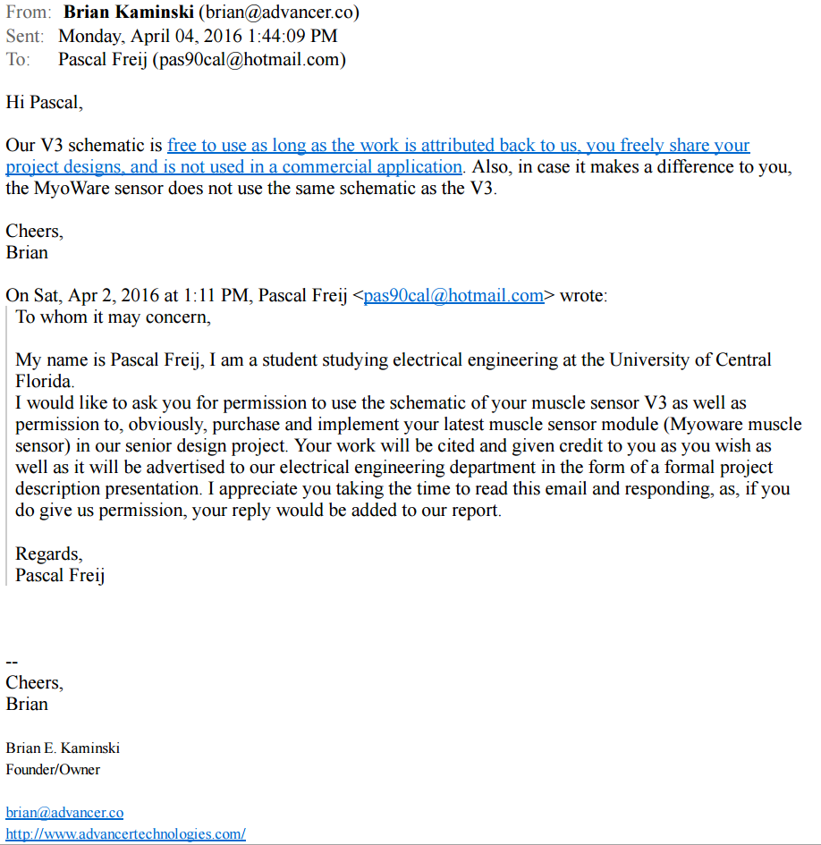

Giorgos Lazaridis:

Elecfreaks

Traxxas


Vizic Technologies:
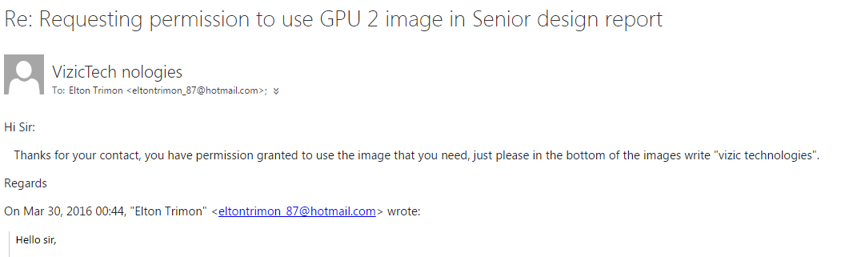
Tenergy
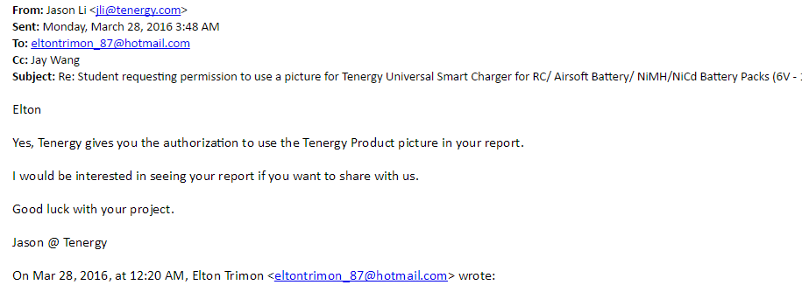

Appendix C
References:
OSHA STD 01-12-002. (1987, 09 21). Retrieved 03 26, 2016, from Occupational Safety & Health Administration: https://www.osha.gov/pls/oshaweb/owadisp.show_document?p_table=DIRECTIVES&p_id=1703
RN-42. (2011, June 21). Retrieved April 08, 2016, from Spark Fun: http://cdn.sparkfun.com/datasheets/Wireless/Bluetooth/Bluetooth-RN-42-DS.pdf
TI SimpleLink™ CC3000 Module – Wi-Fi 802.11b/g Network Processor. (2012, November). Retrieved April 07, 2016, from SparkFun: http://cdn.sparkfun.com/datasheets/Wireless/WiFi/cc3000.pdf
Espressif Smart Connectrivity Platform: ESP8266. (2013, Octoboer 12). Retrieved April 07, 2016, from Nurd Space: https://nurdspace.nl/images/e/e0/ESP8266_Specifications_English.pdf
ISO 15066. (2016). Retrieved 03 26, 2016, from International Organization for Standardization: https://www.iso.org/obp/ui/#iso:std:iso:ts:15066:ed-1:v1:en
Bluetooth Mate Silver. (n.d.). Retrieved April 08, 2016, from Spark Fun: https://www.sparkfun.com/products/12576
Bluetooth SMD Module - RN-41. (n.d.). Retrieved April 08, 2016, from Spark Fun: https://www.sparkfun.com/products/12575
Brain, M., Wilson, T. V., & Johnson, B. (n.d.). How WiFi Works. Retrieved April 04, 2016, from How Stuff Works: http://computer.howstuffworks.com/wireless-network.htm
Chandler, M. (n.d.). Electrical and Electronic Engineering: What's the difference? Retrieved March 31, 2016, from Brightside: http://www.brightknowledge.org/knowledge-bank/engineering/careers-in-engineering/electrical-and-electronic-engineering-whats-the-difference
Davies, J. H. (2008). MSP430 Microcntroller Basics. New York: Elsevier.
Electricity and Electronics. (n.d.). Retrieved March 31, 2016, from Encyclopedia: http://www.encyclopedia.com/doc/1G2-3401801342.html
Global System for Mobile Communications (GSM). (n.d.). Retrieved April 02, 2016, from The Network Encyclopedia: http://www.thenetworkencyclopedia.com/entry/global-system-for-mobile-communications-gsm/
GSM (Global System for Mobile Communications). (n.d.). Retrieved April 03, 2016, from Mobile Comms Technology: http://www.mobilecomms-technology.com/projects/gsm/
Lazaridis, G. (2009, June 19). How RC Servos Work. Retrieved April 02, 2016, from PCB Heaven: http://pcbheaven.com/wikipages/How_RC_Servos_Works/
Mary, R. (n.d.). Bluetooth Technology. Retrieved April 05, 2016, from Engineers Garage: http://www.engineersgarage.com/articles/bluetooth-technology?page=1
Nayar, V. (2016, 08 25). Open Bionics Is Developing A Cheap 3D-Printed Prosthetic Arm. Retrieved 03 27, 2016, from Tech Times: http://www.techtimes.com/articles/79273/20150825/open-bionics-3d-printing-prosthetic-arm-indiegogo.htm
RN-41 Class 1 Bluetooth Module. (n.d.). Retrieved April 08, 2016, from Spark Fun: http://cdn.sparkfun.com/datasheets/Wireless/Bluetooth/rn-41-ds-v3.41r.pdf
Ryder, J. D. (n.d.). Electrical and Electronics Engineering. Retrieved March 31, 2016, from Britannica: http://www.britannica.com/technology/electrical-and-electronics-engineering
SaBLE-x. (n.d.). Retrieved April 12, 2016, from LSR: https://www.lsr.com/downloads/products/337-0147.pdf
Semiconductor, N. (2014, July 14). A Short History of Bluetooth. Retrieved April 04, 2016, from Nordic Semi: https://www.nordicsemi.com/eng/News/ULP-Wireless-Update/A-short-history-of-Bluetooth
Staff, T. S. (2014, July 17). Wireless Revolution: The Hustory of WiFi. Retrieved April 03, 2016, from The Suit Magazine: http://www.thesuitmagazine.com/technology/web-a-internet/22360-wireless-revolution-the-history-of-wifi.html
Steeper Group. (2015). bebionic. Retrieved 03 27, 2016, from bebionic.com: http://bebionic.com/the_hand
Tanenbaum, A. S., & Wetherall, D. J. (2010). Computer Networks. In Computer Networks, Fifth Edition (pp. 194-196). Prentice Hall.
Wi-Fi. (n.d.). Retrieved April 04, 2016, from Encyclopaedia Britannica: http://www.britannica.com/technology/Wi-Fi
Wi-Fi Module - ESP8266. (n.d.). Retrieved April 07, 2016, from Spark Fun: https://www.sparkfun.com/products/13678
XBee Wi-Fi. (n.d.). Retrieved April 08, 2016, from Spark Fun: http://cdn.sparkfun.com/datasheets/Wireless/WiFi/ds_xbeewifis6b.pdf
Tenergy. Tenergy Universal Smart Charger for RC/ Airsoft Battery/ NiMH/NiCd Battery Packs (6V - 12V)” http://www.amazon.com/Tenergy-Universal-Charger-Airsoft-Battery/dp/B003MXMJX8/ref=sr_1_1?ie=UTF8&qid=1460564052&sr=8-1&keywords=tenergy+charger
Janet Tobiassen Crosby, 2014. “What Makes Batteries Toxic?”http://vetmedicine.about.com/od/toxicology/f/Beware-Of-Batteries.htm
Duracell. DURACELL 9V NiMH Rechargeable Battery.” http://www.amazon.com/DURACELL-9V-NiMH-Rechrgeable-Battery/dp/B0002FQXJK/ref=sr_1_1?ie=UTF8&qid=1460565412&sr=8-1&keywords=DURACELL+9V+NiMH+Rechargeable+Battery
Tenergy. “Tenergy Centura 9V 200mAh Low Self-Discharge NiMH Rechargeable Batteries (2pcs card)” http://www.amazon.com/Tenergy-Centura-Self-Discharge-Rechargeable-Batteries/dp/B003QUNYQI/ref=sr_1_2_a_it?ie=UTF8&qid=1461426963&sr=8-2&keywords=NiMH+9+volt+battery+tenergy
EBL. “EBL 840 9V Li-ion Ni-MH Battery Charger with 600mAh Lithium-ion Rechargeable 9 Volt Batteries (2 Pack)” http://www.amazon.com/EBL-Battery-Lithium-ion-Rechargeable-Batteries/dp/B00ER10DZ0/ref=sr_1_5?ie=UTF8&qid=1461427194&sr=8-5&keywords=ebl+lithium+ion+rechargeable+batteries
SunLabz. “SunLabz® 9V Rechargeable Batteries (8 Pack) Ultra-Efficient NiCd 120mAh” http://www.amazon.com/SunLabz%C2%AE-Rechargeable-Batteries-Ultra-Efficient-120mAh/dp/B00SJBODTG/ref=sr_1_1_a_it?ie=UTF8&qid=1461427321&sr=8-1&keywords=NiCad+9+volt
Tenergy. “Li-Ion 18650 7.4V Tenergy 2200mAh Rechargeable Battery module with PCB" http://www.amazon.com/Li-Ion-Tenergy-2200mAh-Rechargeable-Battery/dp/B002Y2LJW0/ref=sr_1_1?ie=UTF8&qid=1461427527&sr=8-1&keywords=Lithium-Ion+2200+RC+battery
Tenergy. “7.2V Tenergy 3800mAh Flat NiMH High Power (38A Drain Rate) Battery Pack with Tamiya connector for RC Cars and Sumo Robots” http://www.amazon.com/Tenergy-3800mAh-Battery-Tamiya-connector/dp/B0037U4Q8M/ref=sr_1_6?ie=UTF8&qid=1461427741&sr=8-6&keywords=NiMH+Rc+battery
Tenergy. “7.2V Tenergy 5000mAh Flat NiMH High Power Battery Packs with Tamiya Connector for RC cars” http://www.amazon.com/Tenergy-5000mAh-Battery-Tamiya-Connector/dp/B002PEBM8S/ref=sr_1_5?ie=UTF8&qid=1461427926&sr=8-5&keywords=NiMH+Rc+battery+5000
Jessica Dolcourt, 2015. “Magnetic fields make wireless charging a whole lot cooler (hands-on)” http://www.cnet.com/news/qualcomm-wipower-hands-on/
Margaret Rouse, 2005. “stepper motor” http://whatis.techtarget.com/definition/stepper-motor
Ottobock. “Prosthetic Gloves for the Michelangelo Hand” http://media.ottobock.com/_web-site/prosthetics/upper-limb/_general/files/axonskin_information_for_specialist_dealers.pdf
Advancer Technologies. “3-lead Muscle / Electromyography Sensor for Microcontroller Applications” https://github.com/AdvancerTechnologies/MyoWare_MuscleSensor/raw/master/Documents/AT-04-001.pdf
Inmoov “Hand and Forarm” http://inmoov.fr/hand-and-forarm/
Pixnor® “Pixnor UNO R3 2.8 TFT Touch Screen with SD Card Socket for Arduino Board Module” http://www.amazon.com/Pixnor-Screen-Socket-Arduino-Module/dp/B00YXM9QPQ/ref=sr_1_1?ie=UTF8&qid=1460052116&sr=8-1&keywords=Pixnor+UNO+R3+2.8+TFT+Touch+Screen
4D Systems, 2013 “uLCD-70DT 7.0” DIABLO16 Intelligent Display Module” http://cdn.sparkfun.com/datasheets/LCD/Color/uLCD-70DT_datasheet_R_1_0.pdf
Vizic Technologies. “SMART GPU 2 2.4” TOUCH” http://media.wix.com/ugd/f7ab2a_ef89bc59f25c5fd5995ae98d7688a4d9.pdf
Texas Instruments. “LM89” http://www.ti.com/product/lm89
Texas Instruments. “LM90” http://www.ti.com/product/lm90
Traxxas. “E-MAXX Brushless TELEMETRY/Sensor Wires (heat temp rpm 6522 E-revo Traxxas #3908” http://www.amazon.com/MAXX-Brushless-TELEMETRY-Sensor-Traxxas/dp/B0128NOGPQ?ie=UTF8&keywords=Traxxas%20heat%20sensor&qid=1461429649&ref_=sr_1_1&sr=8-1

